AFT GUILD, LOCAL 1931
AMERICAN FEDERATION OF TEACHERS
AFL-CIO

(FACULTY)

WITH

GROSSMONT-CUYAMACA COMMUNITY COLLEGE DISTRICT

FOR THE PERIOD

October 1, 2025 – June 30, 2028

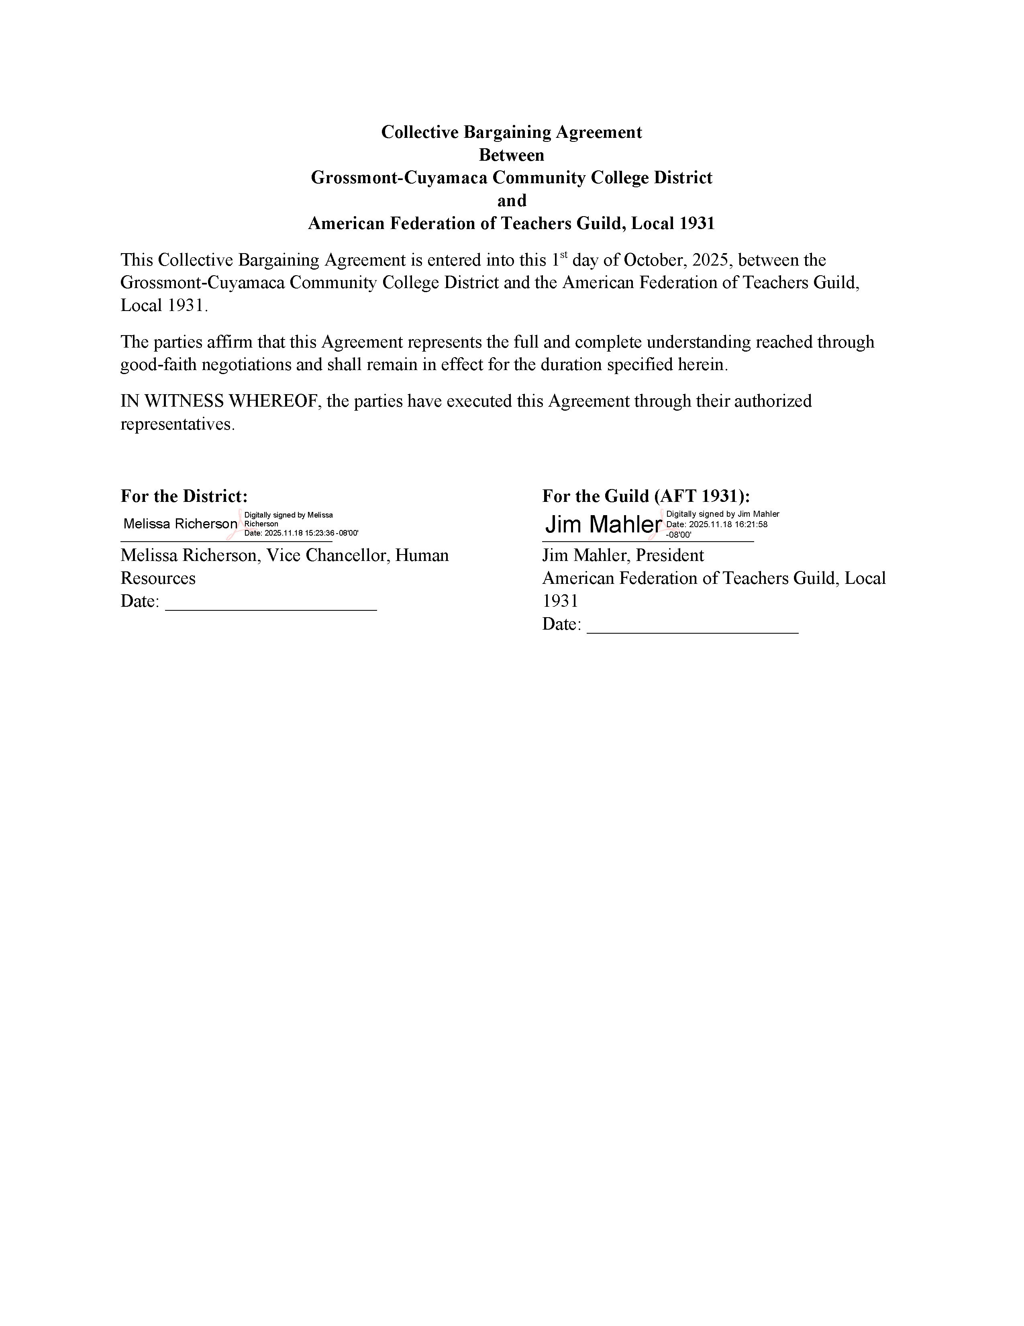

Table of Contents
ARTICLE I – RECOGNITIONS, DEFINITIONS, AND MEMBERSHIP 6
1.1 Recognition 6
1.2 Definitions 6
1.3 Payroll Deduction 6
1.4 Notice to AFT 7
1.5 Non-Interference 7
1.6 District Initiated Union Related Communications 7
ARTICLE II – AFT/DISTRICT RELATIONS 8
2.1 Consultation 8
2.2 Access to Information 8
2.3 Use of Facilities 8
2.4 Reassigned Time 9
2.5 Academic Freedom/Freedom of Expression 10
2.6 Contracting Out 10
2.7 Restricted Contract Faculty 10
2.8 Clearing Rosters of Inactive Enrollments 10
ARTICLE III – DISTRICT RIGHTS AND EFFECT OF AGREEMENT 11
ARTICLE IV – GOVERNANCE AND PARTICIPATION 12
4.1 Reassigned Time 12
4.2 Evaluation/Assessment of Department Chairs 12
4.3 Election of Department Chairs 13
4.4 Recall of Department Chair 14
4.5 Selection of Program Coordinators 15
4.6 Compensation for Department Chairs and Program Coordinators 15
4.7 Departmental Program Review 16
4.8 Chairing a Faculty Search Committee: 16
ARTICLE V – EVALUATION PROCEDURES AND TENURE PROCESS 17
5.1 Purpose and Guidelines 17
5.2 Frequency & Timelines 18
5.3 Evaluation Components 19
5.4 Summary Reports and Summary Ratings 22
5.5 Evaluative Criteria and Instruments 23
5.6 Evaluation of Tenure-Track Faculty for Tenure 23
5.7 Evaluation of Tenured Faculty 26
5.8 Evaluation of Part-Time Faculty and Early Retirement Incentive Program Participants 27
5.9 Evaluation of Temporary Restricted Contract Faculty (non tenure-track faculty with restricted funding) 28
5.10 Districtwide Faculty Review Committee 29
ARTICLE VI – PERSONNEL FILES & PRIVACY 30
ARTICLE VII – WORKING CONDITIONS 32
7.1 Tenured/Tenure-Track Counseling Faculty 32
7.2 Tenured/Tenure-Track Learning Resource Faculty 32
7.3 Other Tenured/Tenure-Track Non-Classroom Faculty 33
7.4 Tenured/Tenure-Track Instructional Faculty 33
7.5 Contract Instructional Faculty 35
7.6 Order of Assignments 35
7.7 Semester Teaching Load 35
7.8 Overload Banking 37
7.9 Number of Class Preparations and Consecutive Assignments 37
7.10 Large Course Equivalency (LCE) 38
7.11 Large Class Compensation and Teaching Assistants 40
7.12 Reduced Load for Tenured Faculty 42
7.13 Transfer 42
7.14 Academic Calendar 43
7.15 Graduation 44
7.16 Distance Education 44
7.17 HyFlex Assignments 45
ARTICLE VIII – FACULTY SERVICE AREAS, ASSIGNMENT, REASSIGNMENT, TRANSFER, LAYOFF, AND REEMPLOYMENT 48
8.1 Faculty Service Areas 48
8.2 Layoff and Reductions in Force 48
8.3 Retraining 49
8.4 Assignment 49
8.5 Reassignment of Faculty 49
8.6 Transfer of District Administrators to Faculty Positions 50
8.7 Change in the meaning and interpretation of the word "Discipline" 50
ARTICLE IX – COMPENSATION AND BENEFITS 51
9.1 Compensation 51
9.2 Benefits 51
9.3 Regulations Governing Initial Salary Placement On Salary Schedule For Tenure-Track Employees. 52
9.4 Regulations Governing Initial And Subsequent Salary Placement On Salary Schedule For Part-Time Academic Employees 55
9.5 Faculty Purchases From District Vendors 59
9.6 Adjunct Faculty Healthcare 59
9.7 Multi-District Part-Time Faculty Healthcare Reimbursement 60
9.8 Computer Loan Program 61
9.9 Campus Closure 61
ARTICLE X – RETIREMENT (applies to tenured faculty who are CalSTRS members only) 62
10.1 Pre-Retirement Work Load Reduction (Ref. Education Code 87483) 62
10.2 Re-Employment for Retired Tenured Faculty 62
10.3 Early Retirement Incentive (ERI) For Tenured Faculty 63
ARTICLE XI – PART-TIME FACULTY 65
11.1 Intent 65
11.2 Definitions 65
11.3 Priority of Assignment (POA) 65
11.4 Compensation for Shared Governance Committee Work 68
11.5 Reductions in Priority of Assignment 68
11.6 Facility Access 70
11.7 Retirement Program 70
11.8 Part-Time Hiring for Tenure-Track Faculty Vacancies 70
11.9 State Disability Insurance for Part-Time Faculty 70
11.10 Paid Office Hours 71
ARTICLE XII – SUMMER AND INTERSESSION 73
12.1 Summer and Intersession 73
ARTICLE XIII – LEAVES OF ABSENCE 74
13.1 Sick Leave 74
13.2 Sick Leave Donations for Catastrophic Illness or Injury 75
13.3 Personal Necessity Leave 76
13.4 Bereavement Leave 77
13.5 Personal Leave 77
13.6 Professional Opportunity Leave 78
13.7 Military Leave 78
13.8 Judicial Leave 79
13.9 Legislative Leave 80
13.10 Coaching Leave 80
13.11 Family Care Leave 80
13.12 Pregnancy Disability Leave 83
13.13 Paid Parental Leave 85
13.14 Industrial Accident and Illness Leave 85
13.15 Physical Examinations and Vaccinations 86
ARTICLE XIV – SABBATICAL LEAVE 87
14.1 Philosophy 87
14.2 Purpose 87
14.3 Eligibility and Indemnity Bond 87
14.4 Length of Leave 88
14.5 Application Procedure 88
14.6 Selection Procedure 88
14.7 Notification Procedure 89
14.8 Report on Sabbatical Leave Activities 90
14.9 Compensation 90
14.10 Sabbatical Leave Committee 91
ARTICLE XV – PROFESSIONAL GROWTH ACTIVITIES & INTELLECTUAL PROPERTY RIGHTS 92
15.1 Professional Growth Activities 92
15.2 Academic Course Work for Tenured/Tenure-Track Faculty Only 92
15.3 Other Professional Growth Activities for Tenured/Tenure-Track Faculty Only 92
15.4 Intellectual Property Rights 93
ARTICLE XVI – DISTRICT APPROVED TRAVEL 100
16.1 Procedure for Off-Campus Activities 100
ARTICLE XVII – SAFETY 101
17.1 Unsafe Working Conditions 101
17.2 Personal Safety 101
17.3 Discipline of Students 102
17.4 Campus Safety 102
ARTICLE XVIII – GRIEVANCES 104
18.1 Purpose 104
18.2 Definitions and Limitations 104
18.3 Conciliation Procedure 104
18.4 Level I- Grievance Procedure 104
18.5 Level II - Grievance Procedure 105
18.6 Level III - Grievance Procedure 105
18.7 Level IV - Grievance Procedure 105
18.8 Grievance Process Policies 106
ARTICLE XIX – DISCIPLINE AND DUE PROCESS FOR TENURE/TENURED-TRACK FACULTY 108
19.1 Definitions and Rights 108
19.2 Due Process 109
19.3 Video Cameras 111
ARTICLE XX – SAVINGS CLAUSE and SUPPORT OF AGREEMENT 113
ARTICLE XXI – NOT-FOR-CREDIT AND CCAP INSTRUCTORS 114
ARTICLE XXII – DURATION AND CONDITIONS 115

APPENDICIES

APPENDIX A – SALARY SCHEDULES 1
APPENDIX B – FRINGE BENEFITS 5
APPENDIX C – EVALUATION FORMS 7
APPENDIX D – REASSIGNED TIME AND STIPENDS FOR DEPARTMENT CHAIRS AND PROGRAM COORDINATORS 19
APPENDIX E – DISCRETIONARY REASSIGNED TIME 23
APPENDIX F – APPLICATIONS FOR SALARY ADVANCEMENT 26
APPENDIX G – UNIT MEMBER JOB DESCRIPTIONS 29
APPENDIX H – ADJUNCT/OVERLOAD FACULTY LOAD DETERMINATION 59
APPENDIX I – EXCEPTIONS TO FTEF LOAD DETERMINATION FORMULA 61
APPENDIX J – ADJUNCT OFFICE HOUR FORM 62
APPENDIX K – COUNSELING MEMORANDUM OF UNDERSTANDING 63
APPENDIX L – LEAVES TABLE 64

ARTICLE I – RECOGNITIONS, DEFINITIONS, AND MEMBERSHIP

1.1 Recognition

The Grossmont-Cuyamaca Community College District Governing Board recognizes the American Federation of Teachers, Local 1931, CFT, AFT, AFL-CIO, herein referred to as "AFT," as the Exclusive Representative of the employees in the unit as defined in subsection 1.2 in accordance with the certification issued by the Public Employment Relations Board July 7th, 2009, Case No. LA-DP-369-E pursuant to a Board-conducted secret ballot election. Additionally, the District recognizes the Guild as the exclusive representative of the Continuing Education non-credit faculty in accordance with PERB Case No. LA-UM-863-E, dated February 28, 2013, the not-for-credit instructors in accordance with the parties’ settlement agreement dated February 27, 2014, and the athletic assistant coaches in accordance with PERB Case No. LA-UM-1043-E, dated May 10th 2023.

1.2 Definitions

The Unit represented by AFT shall include all employees in academic positions assigned to the college, continuing education, or community service programs, including all temporary, contract, and regular faculty members (as defined by the Education Code), whether full or part-time, including those with classroom and non-classroom assignments. Excluded from this unit are all classified, supervisory, management, and confidential employees as defined in the Education Code and the Educational Employment Relations Act (EERA).

“Adjunct faculty” or “part-time faculty” shall include non-credit and not-for-credit faculty non-tenure-track faculty throughout this Agreement unless otherwise noted.

1.3 Payroll Deduction

The District shall deduct monthly dues in accordance with the AFT provided dues structure from the salary of union members to be remitted monthly to AFT, subject to the following:

1.3.1 All unit members with an active assignment are eligible for membership in the Guild. Union dues shall only be deducted from Guild members in good standing, as determined by the Guild, whose monthly gross earnings are $450 (four hundred and fifty dollars) or greater in the corresponding monthly pay period. Any questions from unit members concerning the amount of deduction shall be referred to the Guild.

1.3.2 The District shall not be obligated to put into effect any new, changed, or discontinued deduction until the pay period fifteen days after receiving written notification from the AFT. Upon the reinstatement of any employee, or upon the recalling of any employee from layoff status, the District will resume Guild Union dues if dues were being deducted as of their last pay period in active status.

1.3.3 AFT shall notify all unit members and the District of any dues changes. Changes to the dues structure is limited to one time per fiscal year, and shall be implemented sixty (60) calendar days following written notification from AFT.

1.3.4 It is agreed that the District assumes no obligation to, in any manner, enforce the provisions of the above sections beyond implementing any valid and un-revoked payroll deduction authorization.

1.3.5 The District, at no cost to the employee, shall permit payroll deductions as authorized in writing by the employee for all such purposes delineated in Education Code § 87040, in addition to and including deductions for annuities, charities, and professional dues.

1.4 Notice to AFT

The District shall notify AFT of all new hires as soon as practical, but no later than 30 calendar days from their hire date. The District shall also notify AFT of the dates and times of new employee orientations, and allow AFT time on the new employee orientation agenda to make a presentation. The District shall also provide a packet prepared by AFT to new unit members containing contact and introductory information about the AFT.

1.4.1 The District shall provide AFT the name, job title, department, last four digits of social security number, and work location of new unit members within the first 30 days of employment. In addition, the District shall provide the address, personal cellular telephone number, and personal email address of new unit members on file with the District unless the unit member has requested this information be withheld to preserve personal privacy.

1.5 Non-Interference

The District agrees that it will not deter or discourage unit members, or applicants to become unit members, from becoming or remaining members of the Guild, or from authorizing representation by the Guild, or from voluntarily authorizing Guild dues deductions.

1.6 District Initiated Union Related Communications

The District will not initiate any type of mass or individual communication to Guild unit members concerning their rights to join or support the Guild, or to refrain from joining or supporting the Guild, unless the Guild has expressly pre-approved the communication in writing.

ARTICLE II – AFT/DISTRICT RELATIONS

2.1 Consultation

2.1.1 The Governing Board and AFT, recognizing the importance of frequent communications in maintaining a cooperative relationship, agree to schedule meetings between AFT officers or their designee(s), and the Chancellor or designee(s), and College Presidents or designee(s) at frequent intervals. Other meetings with Deans and Directors shall be by mutual consent. The meetings shall not be for the purpose of negotiating working conditions or specific individual grievances, but to discuss and resolve mutual issues germane to AFT/District relationships.

2.1.2 The District and AFT, at the request of either party, shall consult on matters pursuant to the consultation provisions of California Government Code § 3543.2

2.1.3 Nothing herein may be construed to limit the right of any employee or employee organization to consult with the District on matters outside the AFT's legally defined scope of representation.

2.2 Access to Information

2.2.1 Upon request, AFT and the District shall provide one another information required for compliance with California Government Code § 3540 through 3549.3.

2.2.2 Upon request, AFT shall be provided nonconfidential information, within a reasonable amount of time from the date of the request. AFT shall pay any reasonable copying costs associated with providing requested information if electronic copies cannot be provided.

2.2.3 The District shall provide AFT, within thirty (30) days after the beginning of each semester or intersession, the names of the employees in the bargaining unit, including employee ID, last four digits of social security number, home address, phone numbers, email addresses, job title, discipline, work location, salary placement, and hire date. The District shall also notify AFT within 30 days of the hire or termination of any employee subsequent to the reporting dates.

2.2.4 The District shall provide AFT two copies of all tentative, preliminary, and final budgets and shall seat at least one AFT representative on the District Budget Committee and District Executive Council.

2.2.6 If employee organizations are given a designated seating place at District Governing Board meetings, AFT shall have the same right. The AFT President, or designee, shall have the right to address the Governing Board on appropriate agenda items in accord with the Governing Board procedures.

2.3 Use of Facilities

2.3.1 Unit members may conduct AFT sponsored or approved business during appropriate times. These activities shall not abrogate personal rights, shall be performed in a responsible manner, and shall not interfere with District operations.

2.3.2 An authorized AFT representative may request the use of a specific District facility, specifying time, place, and type of sponsored or approved activity to be conducted. The request shall be granted upon verification that the activities and use of facilities will not conflict with prior commitments for the facility, school programs, and/or duties of unit members. Denial by the District of a request shall be in writing and shall include a rationale for the decision.

2.3.3 The District shall provide adequate bulletin board space for AFT sponsored or approved communications. AFT shall have the right to use District mail distribution services in accord with the standards detailed in subsection 2.3.1.

2.3.4 The District shall provide for the full-time use of AFT one double-occupancy office on the Grossmont College campus and one single-occupancy, or one-half of one double-occupancy office on the Cuyamaca College campus. AFT shall reimburse the District for long-distance and toll calls initiated by AFT.

2.3.5 The District shall provide one single office on each campus for full-time use of the Academic Senate.

2.3.6 All faculty shall be provided a District email account. District emails to faculty will be sent to District email accounts. Faculty are responsible for reviewing District communications to their District email account. Faculty shall be allowed to forward emails from their District account to their personal email account.

2.3.7 Faculty who have assigned office space on campus shall have access to that space when the campus is open. Faculty who need to access their office during times when the campus is closed and in cases of emergency may contact Campus and Parking Services to inquire if access can be granted.

2.4 Reassigned Time

2.4.1 The District shall provide 4.0 FTEF reassigned time per semester to AFT for employee representation business including, but not limited to, the handling of grievances and negotiations.

2.4.2 AFT shall have the right to purchase additional reassigned time for the conducting of AFT activities. AFT shall compensate the District for this reassigned time at a rate equal to Step 8 rate of the Part-time Salary Schedule.

2.4.3 The District shall provide reasonable paid reassigned time for negotiation sessions and the processing of grievances.

2.4.4 AFT shall notify the Director of Employee and Labor Relations in writing 45 days prior to the commencement of classes for any semester during which reassigned time is to be utilized.

2.4.5 The District shall provide 1.0 FTEF reassigned time per semester for each of the two Academic Senate Presidents.

2.5 Academic Freedom/Freedom of Expression

2.5.1 Consistent with Board Policies 3905, 4030, and 4035 the District is committed to an academic environment that embraces the principles of academic freedom and freedom of expression. This commitment is based upon the value that free expression is essential to excellence in teaching, learning, critical inquiry and service to the community.

2.5.2 Academic freedom and freedom of expression afford the faculty the right to speak freely and write, without unreasonable restrictions or prejudices; and evaluate and be evaluated fairly and objectively, based upon academic merit in accordance with the constitutional protections of free speech.

2.6 Contracting Out

2.6.1 The District agrees to meet and confer with AFT over any proposal to contract out services performed by bargaining unit classifications.

2.7 Restricted Contract Faculty

2.7.1 Faculty hired under a restricted contract who are not on a tenure-track are entitled to all of the collective bargaining agreement rights of Tenured/Tenure-Track faculty with the exception of the due process rights of tenured faculty if the specifically-funded projects to which they are assigned are terminated. This statement in no way confers tenure-track status upon restricted contract faculty.

2.8 Clearing Rosters of Inactive Enrollments

2.8.1 All faculty are responsible for clearing their rosters of all enrolled inactive students as soon as they determine the student is not participating in the course. Drop rosters must be submitted before 12:00 midnight preceding the census date (or as soon as possible thereafter in the event of system outages). Subsequent to the census date, faculty must remain vigilant and drop students as soon as they determine the student is not participating in the course, up until the withdrawal deadline.

ARTICLE III – DISTRICT RIGHTS AND EFFECT OF AGREEMENT

3.1 This agreement expresses the entire understanding between the Governing Board and AFT and supersedes all previous agreements between them, whether written or oral, including all previous side letters not specifically incorporated herein. It also supersedes any rules, regulations, policies, or practices of the Governing Board that are contrary to, or inconsistent with, its terms.

3.2 If any provision of this Agreement is held invalid, such invalidity shall not affect any other provision of the Agreement as long as it can be effective without the invalid provision. To this end, the provisions of this Agreement are severable.

3.3 It is understood and agreed that the District retains all of its powers and authority to direct, manage, and control District operations as provided by law, except as modified by this Agreement. Included in, but not limited to, those duties and powers are the exclusive right to: determine its organization; direct the work of its employees; determine the times and hours of operation; determine the kinds and levels of services to be provided and the methods of providing them; establish its educational policies, goals and objectives; ensure the rights and educational opportunities of students; determine staffing patterns; determine the number and kinds of personnel required; maintain the efficiency of District operations; provide final approval of curricular changes as per Board Policies; build, move or modify facilities; establish budget procedures and determine budgetary allocations; determine the methods of raising revenue; and take action in the event of an emergency where exists a risk to health or safety. In addition, the District retains the right to hire, classify, assign, evaluate, promote, terminate, and discipline employees subject to the terms of this Agreement.

The exercise of the foregoing powers, rights, authority, duties, and responsibilities of the District; the adoption of policies, rules, regulations, and practices in furtherance thereof; and the use of judgment and discretion in connection therewith, shall be limited only by the terms of this Agreement, and then only to the extent such terms are in conformance with law.

This section shall not be subject to the grievance procedure.

ARTICLE IV – GOVERNANCE AND PARTICIPATION

4.1 Reassigned Time

In the collegial governance of the District, faculty play an important leadership role which may sometimes best be facilitated by reassignment from the primary load of 1.0 FTEF. Such assignments shall not be made to assume administrative duties. Faculty serving in a temporary interim or acting administrative assignment shall be compensated according to the terms and conditions of that unit's collective bargaining agreement or handbook, and shall not be considered a member of the faculty bargaining unit for the duration of said interim assignment.

All activities determined by the District that require reassignment of faculty from their primary load shall be fully described, including expected length of assignment and criteria for evaluation, in accordance with Article V. Responsibilities of Department Chairs and Instructional Program Coordinators are described in Appendix G. Proposed assignments shall be reviewed by the Reassigned Time Review Committee (RRC) for recommendation to the Chancellor regarding the appropriateness of the proposed assignment to a faculty leadership role.

4.1.1 Faculty Reassigned-Time Review Committee (RRC) – Discretionary Assignments

The Reassigned-Time Review Committee shall be considered a subcommittee of the Collective Bargaining Committee. It shall be comprised of three (3) representatives appointed by AFT and three (3) representatives appointed by the Chancellor. The Chairperson shall be designated by the committee. The committee shall review all proposed reassignments for faculty in accordance with Section 4.1. and make a determination regarding load value of proposed assignments. (See Appendix E for discretionary reassigned time application.)

Load value determinations for reassigned time assignments, other than department chairs and coordinators, shall be based upon procedures agreed upon between AFT and the District. Load values for department chairs and coordinators shall be based upon the values specified in Appendix D. Determination of the RRC shall be final and not subject to the grievance procedures under this Agreement (Article XVIII).

4.2 Evaluation/Assessment of Department Chairs

4.2.1 Prior to the beginning of each academic year, the Dean will meet with the department chair to assess the upcoming priorities, goals, and objectives of the department. At the conclusion of each academic year, the Dean will also discuss with the department chair the chair’s previous year’s performance.

4.2.2 If the overall assessment by the Dean concludes that the department chair is in need of development in their role as chair, the Dean will provide specific written suggestions for improvement to the department chair. In this case, a follow-up meeting with the chair, Dean, and Vice President will be scheduled at the conclusion of the ensuing semester. The department chair, at their option, may have an AFT representative attend this meeting. The purpose of this follow-up meeting will be to assess the chair’s level of improvement during the past semester.

4.2.3 If the Vice President determines as a result of this follow-up meeting that the department chair is still in need of development in their assignment as chair, the Vice President may send a letter to the voting members of the department recommending against the re-election of the department chair. The letter to the voting members of the department shall simply state: “Based upon assessments from your department’s Dean, in addition to discussing these results with the department chair, I recommend against the re-election of (name) as department chair.”

4.2.4 None of the conclusions drawn from the preceding process may be placed in the department chair’s official personnel file, nor may any of these findings impact the evaluation of the department chair as a regular department faculty member in concert with the procedures set forth in Article V of this Agreement.

4.3 Election of Department Chairs

4.3.1 Each department shall have a chairperson. The term of office of the department chair and any Assistant Department Chair, will commence July 1 and will run through June 30 two (2) years hence. Assistant Department Chairs shall also be elected following these provisions. “Co-chairs” may be elected following these procedures as they apply to department chair, but they must operate and run as a team.

4.3.2 Department chair elections will be held during the month of October in even numbered years for the term which will begin the following July 1.

4.3.3 Announcement of the specific date of election shall be made no earlier than one (1) month, nor any later than two (2) weeks prior to the date of election. Announcement of election must be communicated via email to District assigned email addresses to each voting member of the department. Elections may be held remotely, however an in-person election meeting is preferred.

4.3.4 The election shall be coordinated by a voting member of the department other than the current Chair or the candidate(s). This person shall be identified as the Election Chair concomitant with the election announcement. If the department cannot identify an Election Chair, an AFT representative may be assigned to act as the Election Chair.

4.3.5 Candidates who wish to run for Chair must submit a statement declaring their candidacy to the Election Chair no later than one (1) week prior to the date of the election. If neither the incumbent chair or assistant chair(s) submit a declaration of candidacy by the deadline, the deadline for candidate submission shall be extended by one week. In the event that there is only one candidate who has declared their candidacy for a particular position, there is not a need for an election for that position.

4.3.6 Voting shall be by secret ballot (proxy ballots are acceptable). All ballots shall list the names of announced candidates in lottery order and shall provide a space for a "write-in" candidate's name.

4.3.7 Ballots shall be cast, counted, and announced at the department election meeting or at the conclusion of the online remote voting period. In the case of an online remote election, the opportunity for voting shall span at least four business days. In the case of more than two candidates running for Chair, if one candidate does not receive greater than fifty percent (50%) of the vote, the top two candidates receiving the most votes will contest in a run-off election during the same department election meeting, or within one week if the election was held electronically.

4.3.8 All tenured and tenure-track faculty are eligible to vote according to the principle of one (1) person - one (1) vote, regardless of the percentage of assignment. For departments with three (3) or more tenured and tenure-track faculty, the current department chair will only vote in the case of a tie. Adjunct faculty who have qualified for Priority of Assignment and hold at least a 0.50 FTEF average assignment (during the fall semester when voting is taking place and the previous spring semester) in that department shall also be eligible to vote.

In the case of a tie vote when there is no current chair due to resignation, recall, retirement, etc.; the election chair shall break the tie by lot.

4.3.9 Each tenured and tenure-track faculty member shall be eligible to vote in only one (1) department, that in which they hold the largest percentage of assignment (overload assignments are not to be counted in this formula).

4.3.10 For departments with three (3) or more tenured faculty, Chairs may be elected only from the full-time tenured ranks of the faculty. For departments with fewer than three (3) tenured faculty, Chairs may be elected from the tenure-track ranks as well. The tenured ranks shall be defined as those faculty holding tenure as of the beginning of the Chair term for which they are to serve. Departments with only two (2) eligible tenured or tenure-track faculty who are also the only two voting members of the department shall rotate the position of department chair every two (2) years unless otherwise specified by written mutual agreement between the two (2) faculty members. In cases where there are no tenured or tenure-track faculty available or willing to serve as chair, adjunct faculty members with POA may be elected to serve as chair.

Assistant Department Chairs may be elected from among either tenured or tenure-track faculty.

4.3.11 A faculty member may run for Chair only in the department where they hold the largest percentage of their tenured/tenure-track assignment (overload assignments are not to be counted in this formula).

4.3.12 If any Chair steps down or must take an extended leave of absence for any reason prior to completion of their term, an election for interim Chair shall be held within one (1) month of the announcement of vacancy, following all of the procedures specified in 4.2.3 through 4.2.11 above. The Interim Chair shall serve the remainder of the term of office of the Chair they replace.

4.3.13 The provisions of Section 4.2 of this Article shall not be grievable. If disputes arise as to the applications of the provisions of Article 4.2, the AFT Guild will adjudicate them.

4.4 Recall of Department Chair

4.4.1 For the purposes of this entire Section 4.3, the department chair does not have voting rights nor is to be considered as a voting member of the department. Voting department faculty (as defined in 4.2 above), any time after a Chair has served one (1) full semester in office, may petition for recall of the department chair. (The one (1) full semester waiting period does not apply to Chairs who are serving a consecutive term.)

4.4.2 A petition for recall must state the reasons for the action and must be signed by a simple majority of voting department members.

4.4.3 A petition meeting these specifications shall be presented to the appropriate AFT Guild tenured/tenure-track Vice President and the appropriate college Vice President, who will be jointly responsible for conducting a recall election within two (2) weeks of receipt of said petition.

4.4.4 The ballot shall simply state: "Should __________________ continue to serve as department chair; YES_____ NO_____." Voting shall be by written, secret ballot (written proxy ballots are acceptable). Ballots shall be cast, counted, and announced at the department recall election meeting by the appropriate AFT Guild tenured/tenure-track Vice President and the appropriate college Vice President. Remote or electronic voting shall not be allowed.

4.4.5 If, and only if, a two-thirds majority of all eligible voting department faculty vote "NO," the Chair will be removed from office. The appropriate AFT Guild tenured/tenure-track Vice President and the appropriate college Vice President will then jointly arrange for an interim election under the terms of 4.2.12 above.

4.4.6 None of the aforementioned materials will be placed in the Chair's campus-based evaluation file, nor official personnel file. All written material relating to the above process must be destroyed after completion of the recall election.

4.4.7 The aforementioned procedures may be utilized to recall an Assistant Department Chair or “Co-Chairs” as well.

4.4.8 The provisions of section 4.3 of this Article shall not be grievable. If disputes arise as to the applications of the provisions of Article 4.3, the AFT Guild will adjudicate them.

4.5 Selection of Program Coordinators

4.5.1 A Program Coordinator is defined to be the faculty program leadership position that is required by an outside accrediting or specialized licensing agency.

4.5.2 Program Coordinators will be selected by the appropriate administrator.

4.5.3 Faculty who are assigned as a Program Coordinator may be reassigned at any time by the District to an available regular faculty assignment.

4.6 Compensation for Department Chairs and Program Coordinators

4.6.1 See Appendix D for Reassigned Time for Department Chairs and Program Coordinators during their contract year.

4.6.2 Each Chair/Coordinator shall have the option of selecting one of the following methods for compensation of the FTEF calculation from the formula.

4.6.2.1 Reassigned Time

4.6.2.2 A portion of the FTEF may be banked.

4.6.3 Assignments under Department Chair or Program Coordinator duties approved by the appropriate administrator(s) during summer or intersession, shall be compensated at the faculty member’s non-classroom rate of pay, up to the maximum number of hours permitted per department as delineated in Appendix D. If any period of time during summer or intersession is a part of the unit member’s normal contractual assignment, this provision shall not apply for that period of time which is a part of the unit member’s normal contractual assignment.

4.6.4 Ten-month Department Chairs and Program Coordinators shall also automatically receive as additional compensation the stipend amount listed in Appendix D payable on June 30th of each fiscal year in recognition of their additional duties and responsibilities while serving as Chair or Coordinator. The stipend, in addition to the hourly compensation described in 4.5.3 above, shall apply to the department, to be shared among the Assistant or co-chairs if applicable, as they mutually agree. If mutual agreement regarding each person’s share cannot be reached, the AFT Guild will adjudicate the dispute. This section shall not be grievable.

4.7 Departmental Program Review

Semester in which program review is scheduled: 0.20 FTEF Reassigned Time

4.8 Chairing a Faculty Search Committee:
Announcement/Recruitment Semester 0.05 FTEF Reassigned Time
Screening Semester 0.10 FTEF Reassigned Time

Faculty shall not Chair Classified Search Committees.

ARTICLE V – EVALUATION PROCEDURES AND TENURE PROCESS

5.1 Purpose and Guidelines

5.1.1 The principal purposes of the evaluation process are:

5.1.1.1 To recognize and acknowledge good performance.

5.1.1.2 To help employees who are performing satisfactorily to continue their own professional development.

5.1.1.3 To identify performance that needs improvement and assist employees in achieving improvement.

5.1.1.4 To document unsatisfactory performance.

5.1.2 The evaluation process should be effective in yielding a useful and substantive assessment of performance. It should be useful:

5.1.2.1 To the evaluee, in identifying areas of strength and weakness related to their job performance.

5.1.2.2 To the institution, in facilitating the achievement of the highest possible standards of performance.

5.1.3 The evaluation process includes:

5.1.3.1 Contributions by the evaluee, students, administrator, and peer(s).

5.1.3.2 Clear and relevant criteria related to the evaluee’s current job description and their currently assigned duties.

5.1.3.3 Objective methodologies applied in a timely fashion in accordance with the procedures delineated herein.

5.1.3.4 Acknowledgment of good performance, a process of remediation, and justification for the renewal or termination of employment.

5.1.4 The evaluation and tenure processes shall be free from unlawful discrimination on the basis of any protected classification as well as, any political party, social, or community organizational affiliation, or concurrent employment in the District by members of the same family as per Board policy.

5.1.5 The evaluation may be based upon information obtained through the use of recording devices only with the prior written permission of the evaluee.

5.1.6 Evaluative comments must be supported by the direct observations of currently assigned job duties, as well as other documented information since any prior evaluation.

5.1.7 Only signed and substantiated materials of complaint or commendation shall be used in the evaluation process or referred to in any evaluation records. The evaluee shall be notified within ten (10) working days by the appropriate administrator of any commendation/complaint made for/against the evaluee that may affect the evaluation process. No administrative disciplinary action shall be taken prior to consultation with the evaluee. The evaluee shall have the opportunity to comment upon, agree with, or dispute such commendations/complaints in writing and have them attached thereto. Once substantiated by the appropriate administrator, any commendation/complaint deemed relevant to the evaluation/tenure process shall be forwarded to the Department Chair/Coordinator for adjunct faculty evaluations, the Dean or appropriate manager conducting tenured faculty evaluations, or in the case of tenure-track faculty, to the chair of the Tenure Review Committee.

5.1.8 Anonymous written comments included in the formal student evaluation instrument shall not be used in determining the final evaluation score. Anonymous student comments are solely intended for the edification of the evaluee and should not be shared in any way with other faculty or management.

5.1.9 A unit member may authorize, in writing, an AFT representative to review their completed evaluation/tenure documents. The authorized representative shall have all of the same privileges of inspection that are a right of the evaluee.

5.1.10 Timelines for evaluations in this Article assume that assignments are a full semester in length. Where this is not the case, the appropriate administrator, in consultation with the Department Chair, will make reasonable modifications to the timelines and will be responsible for seeing that the revised schedules are administered as consistently as possible throughout the college.

5.1.11 The evaluation process should be considered a formative, not a punitive process, and shall not be used to address issues which should be more appropriately addressed under the disciplinary process of Article XIX.

5.1.12 All dates in this Article which reference the “start of the semester” shall refer to the first day of instruction (not including professional development week), and all dates which reference the “end of the semester” shall refer to the last day of instruction (including finals week if one exists) for the assignment in question.

5.2 Frequency & Timelines

5.2.1 Frequency

Unit Members will be evaluated based on the following schedule:
- Adjunct and Early Retirement Incentive Faculty Members – First semester of hire, once every six semesters thereafter.
- Adjunct Faculty may also be evaluated in the semester prior to gaining Priority of Assignment, or if they are assigned in a new modality or new course they had not taught before. Failure to evaluate an adjunct faculty member does not negate their right to qualify for Priority of Assignment.
- Tenure-Track Faculty Members – every fall semester each year for four (4) years.
- Tenured Faculty Members – once every three years, preferably in the spring semester.

5.2.2 Off-Schedule Evaluations
The appropriate administrator or Department Chair/Coordinator may initiate additional evaluations including the appropriate other evaluators as delineated in Articles 5.6-5.8, if there is a documented purpose for them, but not based on anonymous complaints or hearsay.

Faculty members may also request a peer-only off cycle evaluation.

5.2.3 Student Evaluations and Peer/Manager Observations
Student evaluations and peer/manager observations may take place beginning the fifth week of instruction and must be completed three weeks before the last day of instruction. For non-instructional faculty, or for short term courses, these evaluations and observations shall commence as deemed appropriate by the evaluation committee.

5.2.4 Completion of the Process
A copy of the manager and peer evaluation shall be sent to the evaluee within two weeks of the evaluation observation. All evaluation procedures and forms shall be completed with the Summary Report submitted to the President via the appropriate Vice President, with a copy to the evaluee, within three (3) weeks of the completion of all observations. Should the manager or peer evaluator fail to complete or sign the evaluation form(s) within the timelines delineated in this Article, the summary report shall be submitted to the Vice President without the manager or peer’s evaluation and the evaluee’s summary rating shall be weighted accordingly under section 5.4. Failure of the evaluee to meet the timelines delineated in this Article shall not prohibit the evaluation from being finalized without their input and placed in the evaluee’s personnel file.

5.2.5 Unsatisfactory Evaluation
In the event that an unsatisfactory evaluation triggers a meeting to develop a written plan specifying the requirements for improvement and follow-up per 5.6.2, 5.7.4, or 5.8.4 as applicable, the meeting shall take place no later than the last day of instruction of the semester during which the evaluation occurred.

5.3 Evaluation Components

For purposes of evaluation, a "review" is defined as an observation of a teaching situation (laboratory, lecture, online) or other student contact situation (counseling, library orientation, etc.) for at least fifty (50) minutes (in the case of counseling observations, this time may be shortened to forty-five (45) minutes) and an assessment of compliance with the evaluee's responsibilities as stated in the job description and their currently assigned duties. Additional reviews by any Committee member may be scheduled.

In cases where the evaluee or one of the peer members believes that the appropriate manager or peer may not be able to perform an objective evaluation due to perceived bias, the evaluee may ask the appropriate Vice President to appoint a replacement. The evaluee’s claim of perceived bias must be verifiable with concrete evidence. The burden of proof of alleged bias remains with the evaluee. The evaluee may appeal the decision of the Vice President in writing to the Chair of the District Faculty Review Committee (Article 5.10) within 10 working days of receipt of the decision.

Except as noted under section 5.3.3.3, all faculty members’ evaluations shall consist of the following:

5.3.1 Peer Component. In accordance with § 87663 of the California Education Code, a "peer review" of faculty performance shall be included in every evaluation.

5.3.1.1 For purposes of evaluation, a "peer" is defined as a tenured faculty member who is qualified in the same faculty service area (FSA) as the evaluee. When the evaluee is being evaluated for an online assignment, the peer evaluator(s) should also have experience in online assignments. When a subject matter expert cannot be found within the District, a peer shall be drawn from a related discipline at either college OR a peer with the subject matter expertise can be selected from outside of the District. In both cases, the peer selected must be approved by the appropriate manager and department/program chair. If agreement cannot be reached, the appropriate Vice President shall make the determination.

5.3.1.2 In cases where the peer does not complete the evaluation, the management component of the evaluation process shall count additionally in place of the peer component.

5.3.2 Management Component.

For purposes of evaluation, the "manager" is defined as the supervisor who has direct authority over the evaluee at the time the evaluation occurs (except in cases where a replacement is identified by the Vice President following the provisions of the second paragraph of Section 5.3 above).

A management review of faculty performance should be included in every evaluation, with the exception of part-time faculty and tenured faculty evaluations as specified in sections 5.7.2.1 and 5.8.2.1. In cases where the appropriate manager cannot complete the evaluation, the peer component (or the average of the peer components) of the evaluation process shall count additionally in place of the management component.

The manager’s evaluation may include written, documented evidence from the Department Chair or Program Coordinator of satisfactory or unsatisfactory performance of the evaluee. It may also include input from any other manager with oversight over the evaluee.

5.3.3 Student Component

5.3.3.1 Instructional Faculty

Student evaluations will be conducted in every class section, including distance education classes, for all faculty, as soon as the parties can implement a practical system for doing so. In the interim, student evaluations will be conducted for those faculty currently undergoing a formal evaluation following past practices.

Instructional Faculty should adopt the following practices to increase the response rate of their student evaluations:
- Embed your evaluation as an assignment in Canvas. If students see this in the context of a regular class assignment, even if it's not graded, they are more likely to do it.
- Make the survey a “prerequisite Canvas assignment.” Thus, students are not able to open their Canvas assignment without taking the survey first.
- Explain the importance of the student evaluation and/or make an authentic request for students to do it. Even a sentence or two of context can be helpful as motivation.
- Remind students several times to do the evaluation. This can be accomplished in Canvas by sending reminder announcements and also by embedding the evaluation assignment in several sequential modules.
- Allocate time during in-person classes for students to do the evaluation. 10 minutes or so is sufficient.
- Leave the room during in-person classes to help students feel more at ease in doing the evaluation and also because that signals its importance and anonymity.
- Provide a QR code link. This makes it easier for students to link directly to the evaluation webpage. This can be projected on the screen in in-person classes and can also be posted in Canvas along with a regular hyperlink.
- Do a student evaluation in every section, every semester. This helps in two ways. First, it makes the evaluation part of the normal routine for both the instructor and students, which increases the likelihood that it will actually be done. And second, it compensates for the low individual evaluation response rate by providing more evaluation opportunities and higher statistical significance from sampling a wider variety of sections.
- For all students who were absent on that day (or for all students who didn’t have a smartphone in class), send them the link and encourage them to take the survey.
A minimum of 35% of the students enrolled in the instructors’ courses as of the census date must be submitted in order for the student component to be valid as part of the evaluation scoring. If this threshold is not reached, there shall be no student evaluation score included in the Summary Rating and the summary score will be based on the weightings as noted in 5.4.5 or 5.4.6 as applicable.

The parties agree to meet and confer in an attempt to devise a method to improve student response rates.

Evaluations may be administered via a confidential electronic survey process, or in-person by a peer evaluator, management evaluator, or designated faculty member provided compensation is given at the faculty member's non-classroom hourly rate. Days and hours selected shall not interfere with scheduled examinations or other in-class assignments where the entire class period is needed for pedagogical reasons, and will be coordinated wherever possible with management or peer evaluations.

Student Evaluation Forms may be found in Appendix C.

5.3.3.2 Non-instructional Faculty

A student component shall be included in the evaluation of non-classroom faculty. It is the intent of the District and the AFT to design an evaluation process appropriate to the student contact situation. Student Evaluation forms and instructions for administration may be found in Appendix C.

5.3.3.3 The student component may be excluded from the evaluation process by agreement among the evaluee, Department Chair/Program Coordinator, appropriate administrator(s) and appropriate Vice President. In such cases, each of the peer and management components shall be weighted as noted in 5.4.5 or 5.4.6 as applicable.

5.3.4 Self-Evaluation/Personal Statement by the Evaluee

Completion of a written self-evaluation is required for all tenure-track faculty. Completion of a written self-evaluation is voluntary for all other faculty.

All faculty are required to acknowledge by checking the appropriate box on the evaluation form at the time of signing the summary report that they have participated in the assessment of student learning outcomes and discussions with colleagues about using the information to improve teaching and learning.

This self-evaluation should reference the performance standards as they appear on the “Faculty Appraisal Form.” The self evaluation shall state the goals the faculty member set for him/herself since the last evaluation cycle, shall explain the extent to which the goals were met, and shall establish goals for the next evaluation cycle. On such a statement, a candidate may wish to explain institutional limitations on their activity (such as no funding for conference travel, no reassigned time for project completion, etc.).

The Self-Evaluation/Personal Statement component is not weighted on the Summary Form.

The Self-Evaluation/Personal Statement shall be due by the end of the 8th week of the semester.

5.4 Summary Reports and Summary Ratings

5.4.1 In the remainder of this Article, references are made to Summary Reports and Summary Ratings. Summary Ratings are to be assigned by peer(s) and a manager on a nine-point scale, and will be calculated as statistical averages of student responses. Whereas the Evaluation Forms themselves call for a response to a statement from “Strongly Agree” to “Strongly Disagree,” it is understood that there will be nine points on the scale (1.0, 1.5, 2.0, 2.5, 3.0, 3.5, 4.0, 4.5, 5.0) for that response and the Summary Rating will be represented as a number from 5 (Strongly Agree) to 1 (Strongly Disagree) according to which point is selected by the evaluator, or, in the case of Student Evaluations, according to the statistical average of the points selected. (See Appendix C for all forms.)

5.4.2 A Summary Report will be compiled at the end of each evaluation. At a minimum, a Summary Report shall contain:

- a statistical summary of the student evaluations and a calculated Summary Rating except where excluded per section 5.3.3.3.;

- one (1) Evaluation Form, including comments and the individual evaluation summary rating (and recommendations if applicable) from each peer or management evaluator, each with an assigned Summary Rating;

- a cover sheet containing Student, Peer, and Management Summary Ratings, and an overall Summary Rating based on their weighting;

- the evaluee's self-evaluation, if applicable.

(Additional elements are required in the Summary Report for tenure-track faculty, and are specified in Section 5.6.2).

5.4.3 Weighting of the Summary Ratings for Tenure-Track faculty shall be:
Student: 40%
Peer 1: 20%
Peer 2: 20%
Manager: 20%

5.4.4 Weighting of the Summary Ratings for Tenured and Part-Time faculty shall be:
Student: 40%
Peer: 30%
Manager: 30%

5.4.5 When a student component is not included, weighting of the Summary Ratings for Tenure-Track faculty shall be:
Peer 1: 33.33%
Peer 2: 33.33%
Manager: 33.33%

5.4.6 When a student component is not included, weighting of the summary Ratings for Tenured and Part-Time faculty shall be:
Peer: 50%
Manager: 50%

5.5 Evaluative Criteria and Instruments

The categories for evaluation are listed on the Evaluation Form (see Appendix C), and are represented in the content of the Student Evaluation Form. Both are based on the evaluee's responsibilities as stated in the official job description.

5.5.1 In the event that a faculty member is assigned duties other than those in the official job description, the faculty member will be evaluated according to criteria appropriate to those assignments as determined by the evaluee and their evaluators.

5.6 Evaluation of Tenure-Track Faculty for Tenure

Tenure Review Coordinator

A position of Tenure Review Coordinator shall be established at each college, appointed by each college’s Academic Senate, with the length of term, including whether or not to have term limits, established respectively by each senate. The Tenure Review Coordinator shall be a tenured faculty member. The Tenure Review Coordinator shall coordinate all tenure review activities, including training of Tenure Review Committee members, and implementation of tenure and evaluation policies detailed in this Agreement. Compensation in the form of reassigned time for the Tenure Review Coordinator shall be determined by the District Faculty Reassigned Time Review Committee.

5.6.1 Tenure Review Committee Responsibilities

5.6.1.1 A Tenure Review Committee shall be formed for each tenure-track faculty member and shall be composed of the appropriate manager and two (2) tenured faculty members.

5.6.1.2 In accordance with the definition of “peer” in Section 5.3.1.1, two (2) tenured faculty members shall be selected by the tenured faculty of the department where the evaluee is assigned to serve as peer evaluators. If there are not enough tenured peer evaluators available to serve, the Dean in conjunction with the Department Chair will select the peer evaluators.

5.6.1.3 The Chair of the Committee shall be elected by the Committee, and shall be a tenured faculty member.

5.6.1.4 All Committee members shall have completed an in-service training session jointly sponsored by the District, the AFT, and the Academic Senate specifically designed for Tenure Review Committee members before beginning their evaluation duties.

5.6.1.5 Any Committee member may, at their discretion, submit a written minority report.

5.6.1.6 The Tenure Review Committee Chair shall be responsible for: (1) calling all meetings; (2) coordinating activities of the Committee; (3) representing the Committee to the Tenure Review Coordinator; (4) informing all committee members of relevant deadlines; and, (5) other officially designated duties.

5.6.2 Evaluation Procedures

5.6.2.1 The Tenure Review Committee shall meet to determine the plan for completing the evaluation process in a timely manner and to review the process with the evaluee. The evaluee shall receive, from the committee chair, copies of the blank evaluation instruments at this meeting.

5.6.2.2 The evaluee will provide the committee with the relevant written materials (or provide access to their learning management system container) as specified below prior to the end of the 6th (sixth) week of the semester (or equivalent for short-term classes). For instructional faculty, these shall include a syllabus, specifying dates for scheduled exams and chapters or topics to be covered, lesson plans, sample tests, quizzes, grading system, etc. For non-instructional faculty, these shall include all materials deemed appropriate by the committee.

5.6.2.3 The Peers and Manager will summarize their observations and evaluations on the Evaluation Form.

5.6.2.4 The Peers and Manager will each give the evaluee a single Summary Rating on a nine-point scale.

5.6.2.5 The Summary Report shall contain all elements of section 5.4

5.6.2.6 If there are recommendations for improvement on either the Peer or Manager Evaluations, the evaluee shall respond in writing to those recommendations. The evaluators and evaluee may develop a written plan specifying the requirements for improvement of performance and follow-up, if deemed appropriate. The response shall be filed with the evaluation committee members within ten (10) working days of the evaluee’s receipt of the preliminary Summary Report from the Tenure Review Committee.

5.6.2.7 The Tenure Review Committee shall submit its final summary report to the evaluee, including any written responses from the evaluee, and must recommend to the President that the evaluee:

5.6.2.7.1 Be granted status as a tenured faculty member starting with the next academic year.

5.6.2.7.2 Be continued as a contract faculty member for the next academic year (or the next two academic years as the result of a second year review).

5.6.2.7.3 Be continued as a contract faculty member for the next academic year subject to the conditions specified in the Summary Report, which may include re-evaluation during the following spring semester.

5.6.2.7.4 Not be rehired, based on justifications specified in the Summary Report.

NOTE: Sections 5.6.2.7.1 through 5.6.2.7.4 are not applicable for third year tenure-track candidates.

5.6.2.8 An Overall Summary Rating of less than 3.50 shall constitute grounds for exercising options in subsections 5.6.2.7.3 or 5.6.2.7.4 (not applicable for third year tenure-track candidates). However, in exceptional circumstances, an overall summary rating of less than 3.50 need not be the sole basis upon which to exercise these options.

5.6.2.9 For all tenure-track faculty other than third year candidates, the College President shall send a written notice via US mail, courier service, or personal delivery to the evaluee informing the evaluee of the President's decision no later than one week prior to the convocation date of the Spring semester. In the event the President's decision is not to renew a contract faculty member or not to grant tenure, the President shall include the evaluee's appeal rights in this notice, including the right to appeal in writing to the Chair of the District Faculty Review Committee (Article 5.10) within ten (10) working days of receipt of said notice. In the event that the President’s final decision overturns the recommendation of the Tenure Review Committee which was to deny a tenure-track contract renewal, the Tenure Review Committee must complete a written plan for improvement for the evaluee to be followed during the following spring and fall semesters.

5.6.2.10 Pursuant to Education Code §87610.1 (b) through §87610.1 (e), a first, second, or fourth year tenure-track faculty member whose employment is terminated may grieve the decision following the grievance procedures delineated in Article XVIII based on the grounds listed in Education Code §87610.1 (b).

5.7 Evaluation of Tenured Faculty

5.7.1 Peer Component

5.7.1.1 The selection of the Peer Reviewer shall be made by the appropriate administrator and Department Chair/Coordinator from a list of three (3) peers, as defined in section 5.3.1.1, chosen by the evaluee. If agreement cannot be reached, the appropriate Vice President shall make the determination.

5.7.1.2 The Peer Review of a tenured faculty member shall be: a "review" as defined in subsection 5.3., employing the Evaluation Form appropriate to the position title (see Appendix C). The evaluator will complete an evaluation form, including comments and the individual evaluation summary rating (and recommendations if applicable).

5.7.2 Management Component

5.7.2.1 Management shall only be required to participate in every other cycle of the evaluation of tenured faculty following the same guidelines as those specified for Peer Reviewers in 5.7.1.2.

5.7.3 Student Component

5.7.2.2 Student Evaluations of tenured faculty undergoing evaluation shall follow the guidelines specified in section 5.3.3.

5.7.4 A Summary Report

A summary report shall be prepared by Management and the Peer Evaluator as specified in section 5.4.

5.7.4.1 If there are recommendations for improvement on either the Peer or Manager Evaluations, the evaluee shall respond in writing to those recommendations. The response shall be filed with all of the evaluators within ten (10) working days of the evaluee’s receipt of the Summary Report.

5.7.4.2 An Evaluation Summary Rating of 1.50-3.49 may, and an Evaluation Summary Rating of 1-1.49 shall, initiate a process whereby the evaluators and the evaluee meet and develop a written plan specifying the requirements for improvement of performance and follow-up.

5.7.4.3 An Evaluation Summary Rating of 1.50-3.49 may, and an Evaluation Summary Rating of 1-1.49 shall, initiate another evaluation to be conducted within two (2) semesters after the semester in which the unsatisfactory rating was incurred. The follow-up evaluation shall be conducted by the same evaluators whenever possible.

5.7.4.4 Following an Evaluation Summary Rating of 3.50 or higher on a follow-up evaluation, the District shall place a letter in the evaluee's personnel file stating that the previous Evaluation Summary Rating has improved to an acceptable level.

5.7.4.5 In the event that requirements for improvement of performance detailed in the Plan For Improvement remain unresolved as determined by the follow-up evaluation of the original Evaluation Summary Rating of 3.49 or lower, then all future proceedings shall be conducted according to the procedures stipulated in Education Code, § 87600 et. seq.

5.8 Evaluation of Part-Time Faculty and Early Retirement Incentive Program Participants

5.8.1 Peer Component

5.8.1.1 For purposes of evaluation, a "peer" is defined as the Department Chair/Coordinator or tenured designee consistent with the definition stipulated in Subsection 5.3.1.1. If no tenured faculty members as per 5.3.1.1 exist, then a tenure-track faculty member in the discipline may serve as the peer.

The selection of the Peer Reviewer shall be made by the appropriate administrator and the Department Chair/Coordinator, from a list of three (3) peers, as defined in section 5.3.1.1, chosen by the evaluee. The names of peers submitted must agree to be willing to serve prior to submission of their name. If the names of three peers are not submitted in a timely manner, the appropriate administrator and Department Chair/Coordinator will select the Peer Reviewer. If agreement cannot be reached, the appropriate Vice President shall make the determination.

5.8.1.2 For purposes of evaluation, a "review" is defined in Subsection 5.3. The evaluator will summarize observations on the Evaluation Form and will give the evaluee a single summary rating on a nine-point scale.

5.8.2 Management Component

5.8.2.1 At the discretion of the manager, evaluation of part-time faculty shall include a Management Component, as specified in Section 5.3.2. Guidelines shall be the same as those specified for Peer Reviewers in Section 5.7.1.2.

5.8.3 Student Component

5.8.3.1 Student Evaluations of part-time faculty shall follow the guidelines specified in Section 5.3.3.

5.8.4 A Summary Report shall be prepared by the appropriate administrator or designee as specified in section 5.4.

5.8.4.1 In the event that an evaluee receives recommendations for improvement on either the Peer or Manager Evaluations, the evaluee shall respond in writing to those recommendations with a copy sent to all evaluators. The response shall be filed with the appropriate administrator within ten (10) working days of the evaluee’s receipt of the Summary Report.

5.8.4.2 For part-time faculty members who do not have Priority of Assignment:

An Evaluation Summary Rating of 3.49 or lower shall constitute grounds for either:

5.8.4.2.1 Non re-hire in a subsequent semester, OR

5.8.4.2.2 A written plan for improvement. The evaluators and evaluee shall develop a written plan specifying the requirements for improvement of performance and follow-up. A follow-up evaluation shall be conducted by the same evaluator(s) in the subsequent semester.

5.8.4.3 For part-time faculty members who have Priority of Assignment or are participants in the tenured faculty Early Retirement Incentive program:

An Evaluation Summary Rating of 3.49 or lower shall result in a written plan for improvement by the peer evaluator in consultation with the department chair and evaluee, in addition to the requirement of a follow-up evaluation in the subsequent semester by the same evaluator(s).

If the subsequent semester Evaluation Summary Rating is also 3.49 or lower, the adjunct faculty member shall not be re-hired. The evaluee may appeal this decision of non-renewal to the College President.

In cases where the evaluation results in a summary rating of less than 2.0, the adjunct faculty member shall not be re-hired. The evaluee may appeal this decision of non-renewal to the College President.

5.8.4.4 Following an Evaluation Summary Rating of 3.50 or higher on a follow-up evaluation, the District shall place a letter in the evaluee's personnel file stating that the previous Evaluation Summary Rating has improved to an acceptable level.

5.9 Evaluation of Temporary Restricted Contract Faculty (non tenure-track faculty with restricted funding)

5.9.1 A temporary restricted contract faculty member shall be evaluated at least once (1) each year for four (4) years. For the first four years, the evaluation shall be administered in accordance with the procedures as specified in section 5.6, with the exception that the evaluee is not eligible for tenure. Thereafter, the temporary contract faculty member shall be evaluated at least every three (3) years. These evaluations shall be administered in accordance with section 5.7, with the exception that the evaluee is not eligible for tenure.

5.9.2 By the last day of instruction of the fall semester the Tenure Review Committee must recommend to the President that the candidate:

5.9.2.1 Be continued as a restricted contract faculty member for the next academic year.

5.9.2.2 Be continued as a restricted contract faculty member for the next academic year subject to the conditions specified in the Summary Report.

5.9.2.3 Not be rehired, based on justifications specified in the Summary Report.

5.10 Districtwide Faculty Review Committee

5.10.1 No later than December 1st of each year, the composition of The District Faculty Review Committee (FRC) shall be determined and consist of:

Chairperson (and one alternate) - To be designated by the Chancellor: 1
Representative – One to be designated by each Faculty Senate: 2
Representative - One to be designated by each College President: 2
Representative - To be designated by AFT Guild: 1
TOTAL: 6

The Chairperson shall not be assigned to the same campus as the appellant. All appointments shall be for two (2) year terms, and shall be subject to renewal.

5.10.2 The charge of the District Faculty Review Committee shall be to hear appeals regarding non-renewal or denial of tenure (Articles 5.6.2.7.3, 5.6.2.7.4), claims of perceived bias (Article 5.3), denials of course work for professional growth, or denials of professional growth activities (Article XV).

5.10.3 FRC recommendations will be forwarded to the Chancellor for final action. In the event that the Chancellor’s final decision overturns the recommendation of the Tenure Review Committee which was to deny a tenure-track contract renewal, the Tenure Review Committee must complete a written plan for improvement for the evaluee to be followed during the following spring and fall semesters.

In cases of a tie vote, the Chancellor shall break the tie.

All FRC decisions will be explained in writing and submitted to the appellant by the chair of the FRC.

If after two academic years following the ratification of this Agreement, the District believes this Article 5.10 is not operating as intended, the parties shall either re-open negotiations on this topic or return to the status quo of the previous Agreement.

ARTICLE VI – PERSONNEL FILES & PRIVACY

6.1 There shall be only one official personnel file for each unit member and it shall be maintained at the District Personnel Office.

6.2 Official personnel files shall be kept in confidence in the District Office of Human Resources and shall be available for inspection only by the unit member, a representative of the AFT (with the unit member's written authorization), or authorized administrative employees of the District when necessary in the proper administration of the District's affairs or the supervision of the faculty member, or as required by law, warrant, subpoena, or court order.

6.2.1 A representative of the unit member's choosing may accompany the unit member in this review.

6.2.2 This review shall be made in the presence of the manager or designee responsible for the safekeeping of this file.

6.2.3 All ratings, reports, or records that were obtained prior to the employment of the unit member, or were prepared by identifiable interview committee members before or after employment, shall not be available for inspection by the unit member.

6.2.4 This examination shall take place at a time when the unit member is not required to render service to the District and during the normal business hours of the District Personnel Office.

6.2.5 The opening of a unit member's file by non-personnel office employees will be in accordance with Education Code § 87031. The date, time, and identity of the person(s) and the reasons for opening the file will be noted. This information becomes part of the unit member's personnel file.

6.3 Information of a derogatory nature, except material mentioned in subsection 6.2.3 above, shall not be entered or filed until a unit member is given notice, furnished a copy of the material which includes the source/originator, and given a period of thirty (30) calendar days to review and respond in writing. Written documents (letters, notes, etc.) without the signature of the source shall not be entered into the Personnel File.

6.3.1 The unit member's review of such material may take place during normal business hours of the District.

6.3.2 The unit member shall have the right to answer in writing any complaints or other derogatory material to be filed and such answers shall be attached to the original document that is to be filed. The unit member shall have the right to obtain copies of any materials contained in their personnel file that is available for inspection.

6.4 The unit member shall have the right to place material in their file that relates to performance and evaluation.

6.5 Pursuant to Education Code § 87675 no document contained in the personnel file older than 4 years old may be introduced as evidence in a discipline or dismissal hearing. Upon the request of the faculty member, all materials they deem derogatory, after remaining in the official personnel file for a period of four (4) years, shall be placed in a separate restricted access folder which shall be retained in the official personnel file. This restricted folder shall not be opened except with prior notice to the faculty member.

6.6 If any email messages of an individual unit member are going to be accessed by the District, the District must first notify the unit member regarding the proposed access unless the access would compromise an ongoing investigation. In cases where the District maintains that prior notice of accessing the emails would compromise an ongoing investigation, the District shall notify the unit member no later than 30 (thirty) days following the conclusion of the investigation. Email messages that are part of the regular and on-going business practices of the District (such as computer maintenance) are not subject to this provision.

6.7 The District shall provide to the Guild and the affected unit member a copy of any manner of public records act request it receives which specifically names a unit member within ten (10) days of the receipt of said request.

6.8 If the District needs access to the faculty member’s learning management system (LMS), they shall notify the Guild in advance except in the following cases:

- As part of a law enforcement investigation or judicial order;
- As part of a formal evaluation process;
- Long term illness or leave where the instructor’s return date is unknown and they are not able or available to provide access. Upon approval of the Dean, student records and assignments may be accessed, but all materials developed by the faculty member shall remain the sole property of the absent faculty member and shall not be utilized without express permission of the faculty member.
- Technical issues with the functioning of the learning management system container that can be addressed and resolved by District support staff.
- Access to student records and enrollment data with the sole purpose of discovering fraudulent enrollments.

ARTICLE VII – WORKING CONDITIONS

7.0 Faculty assignments shall be scheduled Monday through Saturday. Unit members may only be assigned on Saturdays by mutual agreement between the unit member and their Dean. All unit members are expected to work forty (40) hours per week which shall predominantly be devoted to direct student contact for the purpose of instruction, academic counseling, or learning resource assistance as delineated below.

7.1 Tenured/Tenure-Track Counseling Faculty

7.1.1 Counseling faculty are employed for a basic work week of forty (40) hours to be comprised of counseling and other related duties. Each counselor will be assigned thirty (30) hours per week, of which twenty-five (25) will include direct student contact, as defined in the official job descriptions.

Five (5) hours of Related Duties shall be conducted within the thirty (30) hours of assigned time and may include serving on a committee, serving as a faculty advisor of a student club, or other appropriate related duties as defined in the Counselor job descriptions. These five (5) hours of Related Duties shall be shown as assigned time on the weekly counseling schedule (e.g. SARS Grid). Each counselor shall determine the duties to be performed during these five (5) hours, with the exception of department or division meetings which may be scheduled by the appropriate manager during this time.

At their discretion, the appropriate manager may schedule department, division, or other critical meetings which require the presence of a counselor during any portion of the weekly thirty (30) hours of assigned time.

The manager shall have right of assignment in finalizing the student counseling schedule with input from counseling faculty and department chair to ensure sufficient time is spent on direct student contact. The student counseling schedule need not be the same at both colleges.

7.1.2 The standard work year for tenured/tenure-track counseling faculty shall be 1,158 hours, not to exceed 193 days, annually (July 1-June 30).

7.1.3 Counseling faculty may be assigned, at the discretion of their immediate manager, up to one day of remote work per week. At the discretion of the Vice President of Student Services, counseling faculty may be assigned more than one day of remote work per week.

7.2 Tenured/Tenure-Track Learning Resource Faculty

Learning Resource faculty are employed for a basic work week of forty (40) hours to be comprised of thirty (30) hours of Learning Resource duties such as:

- Working with students in analyzing and understanding assignments;
- Directing students in devising and executing a search strategy;
- Recommending sources in various subjects to students and provide instruction in the use of reference materials;
- Guiding and assisting other faculty in selecting materials;
- Conferring with classroom faculty on library orientation activities for their classes;
- Performing information searches when appropriate and prepare bibliographies;
- Planning and preparing displays and exhibits;
- Performing other duties as detailed in the job description found in Appendix G.

The remaining 10 hours shall be spent on other duties such as serving on Campus/District committees, serving as a faculty advisor of a student club, or other duties related to the job description found in Appendix G.

The days, hours, and assignments of Learning Resource faculty shall be scheduled by the appropriate administrator or designee after consultation with the unit member and department chair. Learning Resource Faculty shall not be required to work more than 193 days annually (July 1-June 30) as part of their contractual assignment unless agreed to by the unit member and their manager.

7.3 Other Tenured/Tenure-Track Non-Classroom Faculty

Other non-classroom faculty are employed for a basic work week of forty (40) hours to include thirty (30) hours of scheduled duties, as assigned by the Dean or appropriate administrator, including but not limited to:

- Conducting Diagnostic Services
- Providing Educational Services
- Participating in Curriculum Development
- Conducting Evaluations
- Participating Program Development
- Performing other duties as detailed in the job description.

Scheduling shall be done by the appropriate administrator or designee after consultation with the unit member. The remaining 10 hours shall be spent on other duties such as serving on Campus/District committees, serving as a faculty advisor of a student club, or other duties related to the job description found or agreed upon by the Dean or appropriate administrator. Other non-classroom faculty shall not be required to work more than 193 days annually (July 1-June 30) as part of their contractual assignment unless agreed to by the unit member and their manager.

7.4 Tenured/Tenure-Track Instructional Faculty

7.4.1. The assignment of the days of service for each academic year shall be determined by the school calendar adopted by the Board of Trustees after consultation with AFT.

7.4.2. The forty (40) hour workweek for teaching faculty shall be comprised of lecture hours or their equivalent, office hours, unscheduled preparation hours, and other related duties as defined in the job description.

Twenty (20) hours per week shall consist of duties directly related to instruction, which shall include:

- Classroom instruction;
- Clinical or lab instruction/supervision;
- Office hours for students

The remaining ten (10) hours of the thirty (30) on campus hours per week, may include other non-instructional duties such as, attendance and participation in faculty, division or committee meetings; serving as a student club advisor; participation in orientations, commencement and professional development activities; outreach with other educational institutions, organizations, businesses or industry partners; participation in program and subject area improvement tasks; and completing assessment and peer evaluations.

7.4.3 Each full-time tenure/tenure-track instructor shall be present on campus a minimum of thirty (30) hours per week to perform the duties listed in subsection 7.4.2 above. Tenured/tenure-track faculty who teach a portion of their 1.0 FTEF load in a Distance Education format do not need to be on campus for those teaching hours. The remainder of their thirty (30) hour per week on-campus requirement must be met on-campus (any remaining teaching assignments, office hours, committee work, and other related duties as defined in the job description) unless an exception is approved by the appropriate Vice President.

Tenured/tenure-track faculty who have less than a 1.0 FTEF teaching assignment (sum of Distance Education plus On-Campus assignments) may reduce each component of the aforementioned on-campus requirements proportionately, but shall be required to be on campus, unless an exception is approved by the college Vice President. (Example: A faculty member who is reassigned as the Department Chair receiving 40% reassigned time with a 60% teaching assignment shall hold three hours of office hours per week and are obligated to be on-campus six hours per week to fulfill duties unrelated to being department chair.)

7.4.4 The unit member’s teaching assignment shall be determined by the appropriate administrator or designee after consultation with the unit member and Department or Program Chair.

7.4.5 In addition to the assigned lecture hours or equivalent, each full-time instructor shall schedule five (5) office hours per week at times most convenient to meet student needs. For faculty teaching online courses, a proportion of their office hours may be conducted in an online format corresponding to the percentage of their online assignment upon approval by the Dean. Office hours shall be scheduled for the purpose of consulting with and assisting students. Each scheduled period of office time shall be not less than twenty-five (25) minutes of duration. By the end of the first week of instruction of each semester, the instructor shall prepare and submit their proposed schedule of office hours to the appropriate division administrator of their division for approval. The administrator shall retain a copy of the approved schedule of office hours for each instructor in the division. The instructor shall post their approved office hours and teaching schedule near the instructor’s office as soon as practical at the beginning or prior to the start of each session, but no later than the end of the first week of classes.

7.5 Contract Instructional Faculty

"Contract Instruction" means educational services that are provided by the District (or a foundation created for the benefit of or on behalf of the District) for remuneration under contracts with businesses or other agencies that are normally performed by employees of the District who possess certification qualifications.

7.5.1 Personnel hired to teach contract instruction courses will be paid as per the appropriate step on the Full or Part-time Salary Schedule as applicable and shall be subject to the provisions of the Education Code and this Agreement as it relates to working conditions.

7.5.2 Unit members who are qualified to teach such contract instruction courses on the basis of their experience, education, and formal performance evaluations shall have employment preference. However, except in unusual circumstances, and then only with the agreement of the unit member and the AFT, a contract or regular certificated employee shall not be assigned to perform contract instructor work as a part of their normal load.

7.5.3 Contract instruction courses shall not replace or duplicate instruction contained in a regular program offered within the District, unless such replacement is agreed upon in writing with AFT. Such agreement must be reached in advance of the course or program being offered.

7.6 Order of Assignments

Assignments shall be made in the following order: a) Tenured/Tenure-Track, b) Tenured Early Retirement Incentive, c) Tenured/Tenure-Track Overload in the faculty member’s primary discipline, d) Pre-2015 Tenured Retirees (one assignment), e) Priority of Assignment (POA)Part-Time Faculty, f) Part-Time Faculty who have not yet qualified for POA.

7.7 Semester Teaching Load

7.7.1 A full-time teaching load shall be defined as accumulated course FTEF values equal to 1.00 for a semester or 2.00 for an academic year (two semesters exclusive of Summer school and/or intersession).

7.7.1.2 No unit member shall be assigned more than 1.40 FTEF each fall or spring semester, unless an exception is approved by the appropriate Vice President. All exceptions approved by the Vice President, along with the rationale used as the basis for their approval, shall be provided to AFT each semester.

7.7.2 Effective Fall Semester, 2019: The FTEF system is based on a fifteen (15) hour full time load for lecture hours and a seventeen (17) hour full time load for lab hours. All new or modified course FTEF assignments are to be negotiated. Courses which do not follow this formula are listed in Appendix I. The AFT and the District shall consider the determinations made by the curriculum committees for the purposes of course credit/student hours to be advisory only. The basic formula for FTEF values is as follows:

Lecture 0.06667 FTEF/designated hour.
Lab 0.0588/designated hour.

7.7.3 Where a full-time unit member is unable to meet 1.0 FTEF in any given semester, the following options are available by mutual agreement between the unit member and the appropriate administrator:

7.7.3.1 Replace a non-contract part-time instructor in a regularly scheduled class.

7.7.3.2 Replace an instructor in an overload assignment.

7.7.3.3 Maintain a 2.0 FTEF for the academic year by averaging fall and spring assignments within the academic year or use the unit member’s overload banked time, if any.

7.7.4 Coaching Assignments

7.7.4.1 “Coaching” assignments shall be considered as academic assignments only when the employee is listed as the instructor of record for an athletics class associated with the competitive team.

7.7.5 Cooperative Career Education/Work Experience, Community Service Learning, Internship, and Field Experience Assignments.

7.7.5.1 In accordance with the plan filed by the District with the Chancellor’s Office of the California Community Colleges, the following activities shall be scheduled with/or completed relative to each student enrolled. Activities listed below marked by an asterisk are to be conducted in person:

- *On-campus conference with student for one-half (1/2) hour;
- *First on-the-job employer/instructor conference for one (1) hour;
- Mid-semester in-service preparation and record review for one-half (1/2) hour;
- *Second on-the-job employer/instructor conference for one (1) hour;
- *Second on-campus student conference for one-half (1/2) hour;
- End of semester in-service preparation and record review for one-half (1/2) hour.

7.7.5.2 The course FTEF value for the above listed assignments shall be .0109 FTEF/student for whom a “Community Service Learning/Work Experience Agreement” has been completed, signed, and photo copy submitted with a Work Experience Agreement Transmittal Form to the Division Dean’s Office during the 6th week of the semester or by the 3rd week of term if a first or second eight-week course (1/3 of the term of the course).

7.7.5.3 Up to a maximum of .218 FTEF may be assigned to an instructor during any academic term for work experience or similar courses. However, the maximum total FTEF of these assignments may be exceeded with the approval of the instructor, the division Dean, and the Vice President.

7.7.5.4 A tenured/tenure-track faculty member may accept such assignments only on an overload basis in addition to their regular load.

7.8 Overload Banking

The parties agree to Overload Banking as follows:

7.8.1 Program applies to full-time tenured classroom and non-classroom faculty only. However, tenure-track faculty may bank time to be used once they receive tenure.

7.8.2 A maximum of .40 FTEF may be banked per semester

7.8.3 A unit member may not bank more than 1.0 FTEF in total.

7.8.4 A unit member’s load may be reduced by the maximum of 1.0 FTEF in a semester, only once every five (5) years.

7.8.5 Current teaching load must be at least 1.0 FTEF prior to any banking credit being given.

7.8.6 Banked time can only be used when a suitable part-time replacement is available and the department chair or coordinator and the college President, or designee, agree the excellence of the program can be maintained with replacement faculty.

7.8.7 Faculty utilizing their banked leave shall retain their full seniority, service credit, and health benefits while on banked leave.

7.8.8 Any unused banked overload leave to be paid out will be paid at the overload rate in effect at the time the leave was initially banked. If only a portion of the banked leave is requested to be paid out, the earliest banked leave shall be paid first. The unit member may submit a written request for the payout with a 45 day advance written notice to the payroll department. If the unit member leaves the bargaining unit due to retirement, transfer, promotion, or separation from District employment then all of the banked leave shall be paid out at the overload rate in effect at the time the leave was initially banked.

7.9 Number of Class Preparations and Consecutive Assignments

7.9.1 Normally, a teaching load shall consist of no more than three (3) separate preparations. The necessity to exceed this number of preparations shall be limited to the need to achieve a full teaching assignment. The unit member may waive this restriction with agreement of the Dean. In cases where a unit member cannot make their 1.0 FTEF load, additional preparations may be assigned.

Preparations shall be defined as a different catalog course number, course term length, or type of course modality (e.g., HyFlex/Distance Education vs. on-campus).

7.9.2 For full-time tenured/tenure-track faculty members who have a teaching assignment which includes evening classes (exclusive of overload assignments), there shall be a minimum of twelve (12) hours between the end of the last evening class and the beginning of the first class the following day. For full-time learning resource faculty who are scheduled to work in the library in order to maintain library operations, there shall be a minimum of twelve (12) hours between the end of the faculty member’s scheduled work shift in the library and the beginning of the first scheduled work shift in the library the following day. The unit member may waive this restriction.

7.9.3 Consecutive Class Assignments

1) Consecutive lecture or lab classes within the same day shall be limited to a maximum of two (2) class periods back-to-back.

2) The unit member may waive these restrictions with agreement of the Dean.

7.9.4 The District shall make no reduction in the hours of paraprofessional assistance available for any department unless such reduction is agreed to by AFT.

7.10 Large Course Equivalency (LCE)

Definitions:
- "Classroom maximum" refers to the number of seats officially assigned to a classroom, not to exceed the occupancy required by the fire code. If the District intends to reduce this number to less than the fire code maximum, the parties shall meet and negotiate in order to determine the appropriate classroom maximum based on physical space limitations, program needs, and legal requirements.
- “Course” refers to an individual offering of a single course section assigned to an instructor.
- "Course maximum" refers to the maximum enrollment agreed to for a specific course section, which in no case shall be allowed to exceed the posted fire code maximum.
- "LCE Date" refers to the census date per Title 5, § 58004(c)(3) for census based courses, or the date closest to the twenty percent (20%) point of the course meeting schedule for non-census based courses.
- LCE does not apply to courses where the start date coincides with the end date of the course (one day courses).

7.10.1 Large Course Equivalency shall be computed for compensation purposes as follows:

7.10.1.1 The LCE factor shall be computed based on the course enrollment at the LCE Date as defined above. At no time shall course enrollment exceed the classroom maximum as defined above in 7.10. Unit members must submit their drop rosters before 12:00 midnight preceding the census date (or as soon as possible thereafter in the event of system outages) to be eligible to receive the LCE. Enrollments greater than 59 need pre-approval by the appropriate Vice President in order to qualify for a higher level LCE factor. The enrollment as of the LCE Date shall be displayed online for all courses and shall be available to be viewed by all unit members.

7.10.1.2 Large Course Equivalency (LCE) factors shall be based on the following enrollments as of the LCE Date:

Number of Students LCE Factor
49 or fewer 0.0
50 to 59 0.2
60 to 69 0.3
70 to 79 0.4
80 to 89 0.7
90 to 99 0.8
100 to 110 0.9
111 to 119 1.0
120 to 129 1.4
130 to 139 1.5
140 to 149 1.6
150 to 159 1.7
160 to 265 2.1
266 to 359 2.3
360 or more 2.5

7.10.2 The LCE compensation shall be calculated as follows: LCE factor from 7.10.1.2 times the unit member's classroom $/per .01 FTEF value (as determined by the step placement of the unit member on the Adjunct/Overload Salary Schedule) times the FTEF value of the course, times one hundred (100). [Example: An enrollment of 55 students as of the LCE Date for a 0.20 FTEF course with a $175 $/per .01 FTEF value results in compensation of: 0.2 (LCE Factor from 7.11.1.2) X $175 ($/per .01 FTEF value) X 0.20 (FTEF of course) x 100 = $700 LCE Payment.]

This compensation is exclusive of the normal salary for the instructor whether part of load, overload, or part-time. Eligible faculty shall be notified that they will be receiving their Large Course Equivalency compensation no later than ten (10) working days after the LCE Date.

7.10.3 Payment of the large course compensation shall be a one-time payment, included in the monthly pay warrant. The District shall use all reasonable efforts to issue payment in the month subsequent to the LCE Date provided the unit member signs off and returns the LCE agreement form in a timely manner.

7.10.4 Course Maximums

7.10.4.1 Course maximums shall be subject to negotiation.

7.10.4.2 At no time shall course enrollment exceed the classroom maximum as defined above in 7.10.

7.10.4.3 The purpose of establishing course maximums is efficient use of classrooms while giving consideration to educational concerns and constraints.

7.10.4.3.1

- Set general lecture and online course maximums at fifty (50) students or at classroom maximum¹, whichever is lower.
- Set large lecture and online course maximums (over 50) on agreement of appropriate administrator and instructor up to the classroom maximum¹.
- Set mathematics and literature course maximums at forty-five (45) students or at classroom maximum¹, whichever is lower.
- Set English and other composition course maximums at thirty-five (35) students or at classroom maximum¹, whichever is lower.
- Set ESL course maximums at twenty-five (25) students.
- Set laboratory section maximums to the number of stations in the room as defined by facilities and/or equipment.
- Set lecture course maximums with concomitant laboratory set to the number of laboratory room stations with the exception of combined lecture courses which break into multiple lab sections.
- Set Communication course maximums at thirty (30) students.
- Set World Languages, including ASL, course maximums at:

30 for 120s
30 for 121s
30 for 220s
25 for 221s
20 for 250s
20 for 251s

- Set Exercise Science course maximums at fifty (50) students, or at room size, whichever is lower, for the following courses: ES 005, 006, 023, 185.
- Course maximums for credit and noncredit based cooperative work experience, community service learning, internships, clinicals, extra-curricular teams, and/or performance classes, not subject to number 6 above, are not necessarily related to a specific classroom. Course maximums for such assignments shall be established upon agreement of the unit member and their appropriate manager.

Footnote 1: At no time shall course enrollment exceed the classroom maximum as defined above in 7.11.

7.11 Large Class Compensation and Teaching Assistants

7.11.1 Load Reduction or Banking

Upon mutual agreement of the instructor and appropriate Vice President or their designee, an instructor teaching a course of 120 students or more shall qualify to reduce their load during either the current or the subsequent semester by the FTEF value of the large course. By electing this option, the instructor will forgo the Large Course Equivalency (LCE-7.10) Compensation from the large course.

7.11.1.1 The course enrollment shall be computed based on the LCE Date as defined in Article 7.10.

Unit members must submit their drop rosters before 12:00 midnight preceding the census date (or as soon as possible thereafter in the event of system outages) to be eligible to receive the load reduction or banking.

7.11.1.2 If an instructor elects to bank the LCE, the banked value shall be computed as follows:

No. of Students Reduce or Bank

0 to 119 0
120 to 265 Equal to FTEF value of course.
266 to 359 Equal to two times FTEF value of course.
360 or more Equal to three times FTEF value of course.

Any banking must adhere to the parameters set forth in Article 7.9 of the Agreement.

7.11.2 Teaching Assistant Program

7.11.2.1 Teaching assistants shall be selected by the instructor. This compensation is not available as additional faculty salary.

7.11.2.2 Eligibility for the Teaching Assistant Program shall be determined based on the course enrollment at LCE Date as defined in Article 7.10. Courses where the start date coincides with the end date of the course (one day courses) are not eligible for Teaching Assistant hours. Enrollments greater than 59 need pre-approval by the appropriate Vice President in order to qualify for a higher level of assistant hours. Unit members must submit their drop rosters before 12:00 midnight preceding the census date (or as soon as possible thereafter in the event of system outages) to be eligible to receive the Teaching Assistant Program. Eligible faculty shall be notified that they will be receiving Teaching Assistant hours no later than ten (10) working days after the LCE Date.

Footnote 1: At no time shall course enrollment exceed the classroom maximum as defined above in 7.10.

7.11.2.3 The number of teaching assistant hours shall be determined by the number of students enrolled in the course on the LCE Date according to the following schedule:

Number of Students Assistant Hours

0 to 44 0
45 to 54 30
55 to 64 40
65 to 74 50
75 to 84 60
85 to 94 70
95 to 104 80
105 to 124 90
125 to 144 100
145 or more 110

7.11.2.4 The Teaching Assistant Program is intended to provide supplemental discretionary resources for use as may be determined by faculty to be most supportive to classroom instruction. Options for use may include, but are not limited to: teaching assistants, department tutors, departmental clerical, or supplies and equipment. These resources are not intended to supplant other existing college resources, but are intended to be supplemental to such programs. Department members may pool the resources they would have been entitled to for Teaching Assistant hours in order to purchase supplies and equipment which are directly related to instructional support and student success. Any purchases shall be subject to approval by the Dean and the Vice President of Administrative Services. Faculty may elect to share their Teaching Assistant hours with other faculty within their department at their discretion.

7.12 Reduced Load for Tenured Faculty

7.12.1 Tenured unit members are eligible for a reduction in workload. (For workload reductions immediately preceding retirement, see ARTICLE X - RETIREMENT.)

7.12.2 A reduced workload request shall be initiated by the employee and be forwarded through customary channels for the Governing Board approval.

7.12.3 Request for a reduced load shall be submitted prior to March 1 for the following academic year and prior to September 15 for the following Spring semester. A decision to grant or deny the request shall be transmitted prior to May 31 for the following academic year and prior to December 1 for the following Spring semester.

7.12.4 Unit members on a reduced workload shall be treated as tenured full-time employees regarding class assignments, scheduling, and class sizes. Unit members teaching one-half of a full-time load may fulfill their assignment in either the Fall or Spring semester. Unit members on reduced load shall meet other contractual obligations in proportion to their workload. Their salary and fringe benefits shall be as follows:

7.12.4.1 The salary shall be in direct proportion to workload and with agreement of the District, prorated over twelve (12) months.

7.12.4.2 The employee shall retain all rights and benefits of a full-time employee, including all fringe benefits. Healthcare benefits will continue provided their annualized assigned load (fall/spring) is 0.50 FTEF or greater.

7.12.4.3 The employee and the District shall make contributions to their Retirement System in proportion to the load worked. The employee shall receive proportionate retirement service credit.

7.13 Transfer

7.13.1 Where necessary, the District has the right to transfer unit members between campus sites to areas they meet Minimum Qualifications. Prior to the implementation of an administrative transfer the unit member shall be given written notification and reasons for the transfer twenty-one (21) calendar days prior to the effective date of the transfer. Transfers shall not be punitive. The unit member may elect to waive the twenty-one (21) day requirement.

7.13.2 The District shall seek volunteers prior to implementing an administrative transfer. If qualified volunteers are not approved by the District, and other criteria being equal, the most junior unit member shall be transferred.

7.13.3 Tenured unit members shall have the right to apply for transfer by contacting Human Resources prior to the closing date on the position announcement. If a unit member's qualifications and experience are acceptable and comply with the requirements for the vacancy, the District may approve such a transfer.

7.13.4 Unit members shall not be excluded from competing for the position once advertised. If the unit member is not granted a requested transfer, reasons for the decision in writing shall be provided if a written request is made. However, such reasons may be deferred until the completion of outside District advertising and applicant interviews have been completed.

7.13.5 A tenured/tenure-track unit member unable to obtain a full load at their college of assignment shall receive the balance of their load in a fair and equitable manner at another college in the District. The time period detailed in subsection 7.13.1 shall not apply in this case.

7.13.6 The District may re-assign a unit member from one assignment to another at the same campus site, provided the unit member meets Minimum Qualifications for the assignment. Changes in assignment shall be made after consultation with the unit member. The time periods detailed in 7.13.1 do apply here unless the reason for the re-assignment is due to an unforeseen event, in which case the unit member shall be given a seven (7) calendar day notice.

7.14 Academic Calendar

7.14.1 For tenured/tenure-track faculty the academic calendar shall consist of a minimum of 165 teaching days and twenty (20) hours per academic year of professional development. The professional development hours may be fulfilled at any time during the academic year in accordance with professional development guidelines.

Adjunct faculty in the credit program must complete one hour of professional development for each hour of their weekly assignment (for example, an adjunct faculty member with a three hour lecture assignment must complete three hours of professional development for the semester).

Adjunct faculty must submit all documents which demonstrate evidence of completion of their professional development activities no later than the last day of the twelfth (12) week of instruction each semester. Tenured/Tenure-Track faculty must submit all documents which demonstrate evidence of completion of their professional development activities no later than the last day of the twelfth (12) week of instruction the spring semester each year. The first week of instruction is defined as the first week of the semester when classes are offered for purposes of this section.

The Faculty Professional Development Committees shall recommend activities for the professional development program during flex week. The AFT and the District shall agree on the particular activities during the designated days for professional development which unit members will perform in-lieu-of classroom instruction.

Instructional faculty on reassigned time, or who have less than a 100% classroom assignment, shall have their staff development obligation proportionately reduced to reflect only the portion of their assignment which is in the classroom.

Professional development hours performed in excess of fall semester requirements may be rolled over to the subsequent spring semester. In no case may any excess hours be rolled from one fiscal year to the next.

7.14.2 Classes may be offered outside of the normal academic year (e.g., Summer and/or Intersession) and these sessions may be of variable length. Hours of instruction shall be established by the District in accord with regulatory, financial and instructional requirements.

7.15 Graduation

Both parties recognize the importance of the graduation process. AFT, in conjunction with the District, shall encourage unit members to attend Commencement Exercises.

7.16 Distance Education

7.16.1 Distance education includes, Hyflex, Hybrid and online classes as defined by Title 5 where the instructor and student are separated by distance and interact through the assistance of technology. For all courses offering distance education components there shall be regular and substantive interaction between the faculty member and the students as required by Title 5, Accreditation, and GCCCD Standards.

7.16.2 The determination of which courses in the curriculum may be offered in a distance education format, in addition to instructor/student contact requirements, shall be in accordance with the Title 5 California Code of Regulations.

7.16.3 All distance education instructors, prior to their first assignment, shall complete District provided training in distance education pedagogy, distance education learning management systems, and accessibility standards or demonstrate mastery or competencies in these areas as approved by the appropriate Dean or designee. Certifications of completion from other Community College Districts within the San Diego and Imperial Counties of distance education training shall be accepted as equivalent. Such training, or any training needed to make the unit member proficient in a new distance education learning management system, shall be compensated either via the unit member’s professional development obligation or at the unit member’s non-classroom rate of pay, at the option of the unit member with approval of the Dean.

A unit member who, during employment with the District, is required to complete any of the aforementioned training in order to receive approval to instruct a distance education course shall be reimbursed for the cost of tuition, books or materials, and/or training fees, if any. The unit member shall first notify their Dean of the anticipated costs and receive the approval of the Dean for reimbursement before the training begins.

7.16.4 A distance education assignment will count toward the faculty member’s load as would the comparable regularly scheduled, traditionally delivered, course assignment.

The first time (and only the first time) an instructor teaches a distance education class, as defined in 7.16.1, they will receive additional compensation of 40 hours at their non-classroom rate of pay. Eligibility is restricted to unit members who have not previously received additional compensation for their first time teaching in a distance education environment.

7.16.5 No unit member shall be assigned more than 0.70 FTEF in a distance education environment, unless an exception is approved by the appropriate Vice President. All exceptions approved by the Vice President, along with the rationale used as the basis for their approval, shall be provided to AFT each semester. For purposes of this calculation, Hybrid course assignments shall be considered 100% distance education, Hyflex courses shall be considered 100% in-person on-campus.

7.16.6 The District shall provide training, logistical, instructional, and technical support to faculty with distance education assignments.

7.16.7 Distance education or remote work assignments shall ensure that the location is an appropriate professional workspace providing stable technology performance and adequate confidentiality measures have been taken.

7.17 HyFlex Assignments

7.17.1 Assignments will be voluntary for all faculty. Faculty will not be sanctioned or adversely evaluated in any way for refusing a HyFlex assignment. The Dean will determine and communicate the need for HyFlex assignments in writing to their faculty members via a department-wide communication. Faculty may volunteer for these assignments by contacting their Dean or Chair but may not be individually solicited by either the Dean or the Chair.

7.17.2 A HyFlex assignment will count toward the faculty member’s load as would the comparable regularly scheduled, traditionally delivered, course assignment. HyFlex assignments count as on-campus load for purposes of Article 7.16.5.

7.17.3 All faculty scheduled to teach a HyFlex course will need to have completed the distance education certification process as delineated in 7.16.3 two weeks prior to the first day instruction.

7.17.4 The District will provide three hours of one-time training (the first time a HyFlex course is taught only) to ensure proficiency and the faculty member shall be compensated at their non-classroom rate of pay for these three hours of training. In addition, faculty will receive a one-time stipend of $750 the first time they are assigned a HyFlex course.

7.17.5 Prior to or on the first day of instruction, students will be provided a form to sign for their agreement that no part of the video or audio recording or livestream may be rebroadcast, shared, published, copied, or otherwise used in any way outside of the direct learning experience of the individual student, except as necessary to provide reasonable auxiliary aids and academic adjustment to a student with a disability as proscribed by law. Students who are added after the start of the semester will receive the form by the end of the first week. The form can be digitally signed by the student.

7.17.6 The notice will specify that violation of the terms of enrollment is a violation of the Student Code of Conduct, and is grounds for discipline, up to and including expulsion. The written notice will advise students that they must accept the terms of the agreement and send/bring a picture of the signed acceptance to the instructor no later than the end of the first week of instruction. This information will also be included in the course syllabus.

7.17.7 The faculty member shall have no obligation or responsibility to perform any additional work required to ensure accessibility compliance, beyond what would be expected to meet accessibility requirements for any other class offered by the college.

7.17.8 The District shall be responsible for ensuring courses offered in a HyFlex modality meet all applicable laws, regulations, and accreditation standards, including applicable provisions of Title 5 of the California Code of Regulations.

7.17.9 The District shall also provide all necessary on-site equipment to conduct the distance education portion of the HyFlex course.

7.17.10 No part of the video or audio recording or livestream may be used as evidence in or to initiate any type of disciplinary proceeding against the faculty member, nor shall it be accessed and or utilized to view or review any part of the course for any reason, including response to a complaint.

7.17.11 Only registered students may attend the course or access the livestream of the course in accordance with District policy pertaining to enrollment in any class offered by the college.

7.17.12 Managers, staff, or peer faculty may not enroll as a student, for purposes of monitoring the class or faculty performance, nor may they access the HyFlex course in any way without the faculty member’s express permission.

7.17.13 The faculty member of record's grading and attendance policies, including virtual attendance, will be determined by the faculty member, provided they fall within the parameters of the State Chancellor's Office Attendance and Accounting Manual.

7.17.14 The faculty member may elect to identify certain course meeting dates where in-person attendance is required of the enrolled students (for exams, presentations, etc.) These dates should be communicated with the students as far in advance as possible via the schedule of classes.

7.17.15 Class caps may not exceed the class size of a similarly situated class being taught via a traditional in-person modality.

7.17.16 The District will ensure that there is support personnel with expertise in HyFlex hardware and software and related technologies to assist with the HyFlex course management as needed.

ARTICLE VIII – FACULTY SERVICE AREAS, ASSIGNMENT, REASSIGNMENT, TRANSFER, LAYOFF, AND REEMPLOYMENT (applies to tenure-track/tenured faculty only)

8.1 Faculty Service Areas

8.1.1 Pursuant to the provisions of Education Code § 87743.3 each faculty member shall qualify for one or more faculty service areas (FSA) at the time of initial employment. A faculty member shall be eligible for qualification in any faculty service area in which the faculty member has met both minimum qualifications pursuant to Education Code § 87356 and district competency standards, if applicable, as established by the Academic Senates. After initial employment, a faculty member may apply to the district to add faculty service areas for which the faculty member qualifies.

8.1.2 Faculty Service Area (FSA) Standards

All faculty shall be granted an FSA in the discipline(s) in which the faculty member:

8.1.2.1 Meets the Minimum Qualifications as adopted by the Board of Governors, or has been awarded an equivalency to the minimum qualifications for the discipline according to the process as established through joint agreement between the Academic Senate and the Grossmont-Cuyamaca Community College District Governing Board to teach in or serve the discipline, or:

8.1.2.2 Possesses a valid lifetime credential authorizing service in the discipline.

8.1.3 A faculty member may add any discipline for which they are qualified and competent as defined by subsection 8.1.2 by contacting Human Resources and submitting the appropriate documentation. The same process for verifying minimum qualifications or equivalency for faculty is used when the request is made to add any discipline following the criteria established by the Academic Senates.

8.1.4 The District shall maintain and update a master list of the disciplines for which each faculty member is qualified. This list will be provided AFT no later than the start of the third week of instruction of the Spring Semester of each year. Each faculty member can review their FSA(s) in Workday. In the event of a layoff or reduction in force, faculty members must have an opportunity to update disciplines for which they meet minimum qualifications or apply for equivalency in other disciplines according to district process. The District shall provide to AFT a printed list of (a) all qualified faculty members and (b) all administrators who have retreat rights as provided under the Education Code.

8.2 Layoff and Reductions in Force

8.2.1 The District shall not reduce the number of tenure-track/tenured faculty members due to a decline in enrollment or the reduction or elimination of a particular kind of service except according to the following procedures:

8.2.1.1 Faculty members affected by the reduction shall be notified in writing before March 15 preceding the academic year in which the reduction is to become effective. This notice shall be by registered or certified mail to the most recent address on file with the District Personnel Office with a copy sent to AFT.

8.2.1.2 No tenured faculty member shall be terminated under this section while any probationary faculty member, any employee with less seniority (as specified in the Education Code), or any part-time faculty member is retained to render service in a discipline in which the faculty member meets the Faculty Service Area standards as defined in subsection 8.1.2.

8.2.1.3 In any reduction in faculty, the District shall (1) make assignments or reassignments in a manner such that faculty members shall be retained to render any service that their seniority and qualifications entitle them, and (2) consider all disciplines for which a faculty member qualified in the year preceding the academic year in which the reduction is to become effective, provided that the documentation for the addition of such FSA is received by the Personnel Office prior to February 15 as provided in 8.1.3.

8.2.1.4 Terminations under this section shall be in the inverse order in which faculty members began their tenure-track service in the District. Terminations may be discipline or FSA specific.

8.2.1.5 The District shall notify AFT and the unit member in advance of the scheduled Board action authorizing the proposed layoff in accordance with Education Code § 87740. Said notice shall include the affected unit member’s seniority listing, including original hire date, listing of all current FSAs held by the unit member, and a listing of all other faculty including hire dates who possess the same FSAs.

8.3 Retraining

8.3.1 When a faculty member is laid off because of a selective reduction in a program(s) or the exercise of retreat rights by an administrator, they shall be entitled to up to one year of reassigned time to upgrade training. Such retraining shall occur in the discipline that is agreed to by the faculty member and the District in consultation with the Academic Senate at that college. Upon obtaining a new FSA, the faculty shall apply for re-assignment per section 8.5 with no loss in seniority.

8.4 Assignment

8.4.1 Faculty members shall be assigned only to those disciplines or courses for which they meet the FSA standards as stipulated in subsection 8.1.2.

8.5 Reassignment of Faculty

8.5.1 Faculty who have established qualification and competency under the provisions of subsection 8.1 shall have the right to request reassignment to any discipline or course for which they meet the competency standards.

8.5.2 Requests shall be forwarded through the immediate line administrator to the appropriate Vice President. After consulting with the faculty member and the appropriate chair/coordinator of the old and new disciplines, the Vice President shall act upon the request, granting it in whole or in part or denying it.

8.5.3 Upon advising the affected faculty member, the administration has the right to reassign any faculty member to a discipline or course for which FSA standards have been established under the provisions of subsection 8.1.2 provided the reasons for such reassignments are given to the faculty member on request.

8.6 Transfer of District Administrators to Faculty Positions

8.6.1 District educational administrators have retreat rights to a first year probationary faculty position (unless previously tenured within the District) as specified in the Education Code. Educational administrators who were previously tenured within the District maintain their tenured status.

8.6.2 Educational administrators retreating to a faculty position must possess the minimum qualifications/equivalency for the discipline to which they are to be assigned as per section 8.1.2.

8.6.3 The right of an educational administrator to retreat to active status as a faculty member shall not result in the layoff of any tenure-track or tenured faculty member, unless the reason for the retreat action is as a result of a Board approved layoff action. In that case, any potential faculty layoffs resulting in the retreat of the administrator will follow the provisions of Section 8.2 above.

8.7 Change in the meaning and interpretation of the word "Discipline"

Sections of this Article that address reassignment, layoff, transfer, and reductions in force shall not be changed by virtue of regulations adopted by the Board of Governors regarding a working definition of the word “discipline” as it relates to minimum qualifications and competencies without AFT having first had the opportunity to negotiate such changes.

ARTICLE IX – COMPENSATION AND BENEFITS

9.1 Compensation

9.1.1 Unit members shall be paid in accordance with provisions of the appropriate salary schedule in Appendix A.

9.1.2 Nursing faculty who are responsible for making hospital assignments for students will be paid for two (2) hours of lab time. Lab hours will be included on the faculty member’s hire letter.

9.1.3 Tenured/tenure-track Nursing, Respiratory Therapy, Occupational Therapy Assistant Program, and Cardiovascular Technology faculty shall receive a $1,000/month market additive for each month of their ten-month contract year ($10,000 per year). Adjunct Nursing, Respiratory Therapy, Occupational Therapy Assistant Program, and Cardiovascular Technology faculty shall receive a market additive of $20/hour.

9.1.4 The Head Coach of each sport shall receive an $8,000 stipend annually.

9.1.5 The Speech and Debate team coach shall each receive an $8,000 stipend annually.

9.1.6 Unit members who have an assignment at a physical location other than the main Cuyamaca or Grossmont campus shall have a 10% additive added to their compensation for that off-campus assignment. This provision shall not apply to contract or regular high school teachers who teach at their home high school campus.

9.1.7 Should the Dean determine an adjunct faculty member is needed on a hiring committee, the Dean will make the request for an appointment to the Academic Senate. Adjunct faculty members shall be compensated at their non-classroom hourly rate of pay, not to exceed 32 hours per committee assignment.

9.2 Benefits

The parties agree to maintain their participation in the Voluntary Employee Benefits Association (VEBA) which began in January, 2013.

9.2.1 Upon receipt of the recommendation of the Benefits Committee that includes options, the District and the AFT agree to meet and negotiate benefit programs.

9.2.2 The Benefits Committee will review current and proposed health plans. The Benefits Committee may make recommendations regarding plan design. Recommendations from the Benefits Committee are proposed to bargaining unit representatives and to representatives of the Governing Board for review and negotiated agreement prior to implementation.

9.2.3 Exclusive of long-term disability and life insurance, the District shall pay the premiums for the fringe benefits in force for tenured/tenure-track faculty as detailed in Appendix B for retired tenured unit members, including current eligible retirees who have minimum of fifteen (15) years of service credit in CalSTRS or CalPERS and have also reached the minimum age required to retire from the state pension plan the retiree is enrolled in (CalSTRS or CalPERS). The District shall discontinue paying health benefit premiums for the retiree and eligible dependents effective when the retiree becomes eligible for Medicare. However, at their expense a retiree may continue the coverage they were enrolled in prior to becoming eligible for Medicare at the premium level prescribed by insurance companies and governmental regulations as a member of the District’s benefits program.

9.2.4 Where a full-time covered unit member or retiree eligible for paid benefits dies, the District shall pay the premiums for health, dental, and prepaid prescription insurance for the surviving spouse or domestic partner and eligible dependents for two (2) years from the date of the death of the unit member. The spouse or domestic partner and eligible dependents may have the option of continuing the benefits at their expense at the premium level prescribed by insurance companies and governmental regulations as a member of the District’s benefits program.

9.2.5 The District and AFT agree to participate on the Grossmont-Cuyamaca District Fringe Benefits Committee. The GCCCD Fringe Benefits Committee makes recommendation to the Collective Bargaining Agents. AFT shall have up to four (4) representatives on the Benefits Committee.

9.2.6 Any Committee member may place an item on the committee meeting agenda.

9.2.7 The District shall provide, at no cost to the unit member, parking, parking permits, and activator card, if applicable. Parking permits shall be valid for three years for all faculty. Upon termination unit members shall be required to return their parking permit. Parking facilities, where practical, shall be in close proximity to the unit member's work area. These parking benefits shall be available to retirees. AFT and the District shall work collaboratively to explore ways employees can be encouraged to use public transportation at a discounted rate.

9.2.8 Unit members can take credit District offered classes without paying enrollment fees. The District will waive health fees and enrollment fees. All student rep fees and other fees mandated by the state or Governing Board ratification will be collected. Enrollment is to take place no sooner than the last day of registration before classes begin. At such time that the District adopts a change in the current District procedure, said new procedure will equally apply to AFT unit members.

9.3 REGULATIONS GOVERNING INITIAL SALARY PLACEMENT ON SALARY SCHEDULE FOR TENURE-TRACK EMPLOYEES.

9.3.1 Regulations for Step Placement

9.3.1.1 Credit for previous academic work experience shall be limited to a maximum placement of Step 10. Each year of full-time teaching or non-classroom experience as a faculty member in an educational environment shall count for one step on the schedule. Credit will not be given for practice or cadet teaching.

9.3.1.2 "Full-time experience" (or its equivalent) shall mean employment for at least one (1) academic year of full-time work in an educational environment as defined by the former employing educational institution(s). Full-time assignments (equivalent full-time educational experience) with a single employer of 75% or more of an academic year, or multiple employers where the experience totals to 75% or more of an academic year, will be counted as one year of previous academic work experience. Such experience must be that which usually requires meeting Minimum Qualifications per the State Chancellor’s Office guidelines.

9.3.1.3 Normally, one step is allowed for each one year of work experience or military service in any branch of the U.S. Armed Forces directly related to the subjects to be taught by an instructor. Only one step may be allowed for each two years of experience if the experience is only indirectly related to the teaching responsibilities of the individual. Full-time work experience with a single employer of nine months or more will be counted as one year of work experience.

9.3.1.4 Allied Health Instructors shall receive two steps for each year of full time clinical work experience, not to exceed Step 10.

9.3.1.5 Minimum initial placement shall be on the sixth step. Maximum initial placement shall be on the tenth step. Tenured/tenure-track faculty members must serve, be in paid status, or on an approved leave, for 75% or more of the preceding assigned work year to receive credit for subsequent step movement on the salary schedule, effective each July 1.

9.3.2 Regulations for Initial Class Placement

Tenure-track faculty are initially placed on the salary schedule according to the following rules. Subsequent salary class advancement after initial placement for tenured/tenure-track faculty will also follow these rules with the stipulation that all additional units earned or work experience must be completed after the date of hire. Tenured/tenure-track faculty may also advance in salary class by virtue of completion of Professional Growth activities as delineated in Articles 15.2 and 15.3.

9.3.2.1 Units to be credited for placement on the salary schedule will include all upper division and graduate semester units earned subsequent to the date of conferment of the bachelor’s degree. Lower division semester units earned subsequent to the date of conferment of the bachelor’s degree, which make a definite contribution to teaching competence, may also be credited.

9.3.2.2 All units considered for placement on the schedule must be from an institution accredited by the Western Association of Colleges and Universities or another regional accrediting association and must be recognized by the California State Department of Education and the California Community College Chancellor's Office.

9.3.2.3 Degrees from a college or university outside of the United States must be evaluated, at the expense of the applicant, by a professional association which is a member of the National Association of Credential Evaluation Services (NACES). The evaluation must be a detailed report including course designations (lower and upper division) in the report. Transcript evaluation is at the expense of the applicant and applicants assume all responsibility for the evaluation services.

9.3.2.4 One semester unit of college or university work or its equivalent on other academic scheduling such as the Quarter System shall be recognized as the standard unit for determining salary placement.

9.3.2.5 Employees hired in disciplines which the master's degree is not generally expected may also use any continuing education credit hours which have been completed. One unit credit will be given for every 15 hours of credit instruction for courses which indicate a significant contribution to the discipline for which hired.

9.3.2.6 In disciplines requiring the Master's Degree, faculty shall be eligible for initial placement in Class II, III, IV, V, or VI provided the faculty member has completed at least:
20 semester units for Class II;
30 semester units for Class III;
40 semester units for Class IV;
50 semester units for Class V;
60 semester units for Class VI;
in the same discipline (or closely related) of the faculty member’s assignment subsequent to the awarding of the faculty member’s bachelor's degree. Credit received for practice teaching in an individual's teaching field(s) and for education methods courses in their teaching field(s) may apply to this requirement.

Effective no later than July 1, 2026, the following salary schedule rules will take effect. Until that time, the status quo will remain in effect.

EXPLANATION OF CLASSES FOR EMPLOYMENT IN DISCIPLINES REQUIRING THE MASTER'S DEGREE:

Class I Members of academic staff not eligible for higher class placement.
Class II Bachelor's Degree plus 30 semester units* including Master's Degree.
Class III Bachelor's Degree plus 45 semester units* including Master's Degree.
Class IV Bachelor's Degree plus 60 semester units* including Master's Degree.
Class V Bachelor's Degree plus 75 semester units* including Master's Degree.
Class VI Bachelor's Degree plus 90 semester units* including Master's Degree.
Class VII Earned Doctorate (Ph.D., Ed.D., or M.D.)

EXPLANATION OF CLASSES FOR EMPLOYMENT IN "DISCIPLINES IN WHICH THE MASTER'S DEGREE IS NOT GENERALLY EXPECTED OR AVAILABLE,” AND ALLIED HEALTH DISCIPLINES:

Class I Vocational employees not qualified for higher class placement.
Class II Associate Degree and six years of work experience directly related to the faculty member's assignment, OR a Bachelor’s Degree¹ and two years of work experience directly related to the faculty member's assignment.
Class III Any combination of 15 semester units* or two years of work experience directly related to the faculty member's assignment in addition to the qualifications needed to meet qualifications for Class II.
Class IV Any combination of 15 semester units* or two years of work experience directly related to the faculty member's assignment in addition to the qualifications needed to meet qualifications for Class III.
Class V Any combination of 15 semester units* or two years of work experience directly related to the faculty member's assignment in addition to the qualifications needed to meet qualifications for Class IV.
Class VI Any combination of 15 semester units* or two years of work experience directly related to the faculty member's assignment in addition to the qualifications needed to meet qualifications for Class V.
Class VII Earned Doctorate (Ph.D., Ed.D., Psy.D., D.B.A, M.D., or equivalent Doctorate degree which requires original research, and the completion and defense of a doctoral dissertation.)

Footnote 1: In any of the Allied Health disciplines enumerated in Section 9.1.3 above, a Bachelor’s Degree and two years of work experience directly related to the faculty member's assignment shall place the faculty member in Class VI.

Employees hired in disciplines which the master's degree is not generally expected may also use any continuing education credit hours which have been completed. One unit credit will be given for every 15 hours of credit instruction for courses which indicate a significant contribution to the discipline for which hired.

*May include all upper division and graduate semester units and those lower division semester units which make a definite contribution to teaching competence, provided they are earned subsequent to the date of conferment of the bachelor's degree.

9.4 REGULATIONS GOVERNING INITIAL AND SUBSEQUENT SALARY PLACEMENT ON SALARY SCHEDULE FOR PART-TIME ACADEMIC EMPLOYEES

Upon initial hire, part-time faculty shall be placed on the appropriate salary class which reflects the faculty member’s educational and/or work experience as of the date of hire as defined by the following salary classification rules.

Initial salary schedule placement is contingent upon receipt of all official transcripts verifying academic degrees and units completed and verification of employment to substantiate initial class placement within 90 calendar days of the unit member's acceptance of their initial employment offer as a new employee in the District. If these materials are received more than 90 calendar days following the unit member's acceptance of their employment offer the class placement shall become effective the first of the month following acceptance and verification of this information by Human Resources.

Initial Step Placement for all Part-Time/Adjunct Employees shall be on Step 1, regardless of prior experience. Subsequent step movement will occur after the successful completion of each two (fall/spring or spring/fall) semesters.
Subsequent salary class movement after the date of hire shall become effective the first of the month following the submission and verification by the personnel office of the relevant official transcripts or work experience verifications.

Class I: Applies to non-credit part-time faculty only. Non-credit faculty must meet statewide minimum qualifications as per Title 5 for non-credit programs¹ in order to receive an assignment. In cases where the non-credit minimum qualifications for the particular assignment area are identical to those of the credit minimum qualifications for that assignment area, the faculty member shall begin in Class II upon meeting minimum qualifications.

Class II: Credit faculty meeting Minimum Qualifications: must meet statewide Minimum Qualifications² for credit programs in order to receive an assignment.

Non-credit faculty with assignments in disciplines where a master’s degree is generally available as per the statewide Minimum Qualifications handbook²: 15 units of upper division and/or graduate coursework in addition to the coursework needed to meet minimum qualifications for Class I, plus possession of a master’s degree. The master’s degree and the 15 units of upper division or graduate coursework must all be in the same discipline (or closely related) of the faculty member’s assignment.

Non-credit faculty with assignments in disciplines where a master’s degree is generally not available as per the statewide Minimum Qualifications handbook²: Two years of full-time work experience in addition to the work experience needed to meet minimum qualifications for Class I. The work experience must be directly related to the faculty member's assignment.

Class III: Credit faculty with assignments in disciplines where a master’s degree is generally available as per the statewide Minimum Qualifications handbook²: 15 units of upper division and/or graduate coursework in addition to the coursework needed to meet minimum qualifications for Class II. The 15 units of upper division or graduate coursework must all be in the same discipline (or closely related) of the faculty member’s assignment.

Credit faculty with assignments in disciplines where a master’s degree is generally not available as per the statewide Minimum Qualifications handbook²: Two years of full-time work experience in addition to the work experience needed to meet minimum qualifications for Class II. The work experience must be directly related to the faculty member's assignment.

Non-credit faculty with assignments in disciplines where a master’s degree is generally available as per the statewide Minimum Qualifications handbook²: 15 units of upper division and/or graduate coursework in addition to the coursework needed to meet the requirements for Class II. The 15 units of upper division or graduate coursework must all be in the same discipline (or closely related) of the faculty member’s assignment.

Non-credit faculty with assignments in disciplines where a master’s degree is generally not available as per the statewide Minimum Qualifications handbook²: Two years of full-time work experience in addition to the work experience needed to meet the requirements for Class II. The work experience must be directly related to the faculty member's assignment.

Class IV: Credit faculty with assignments in disciplines where a master’s degree is generally available as per the statewide Minimum Qualifications handbook²: 15 units of upper division and/or graduate coursework in addition to the coursework needed to meet minimum qualifications for Class III. The 15 units of upper division or graduate coursework must all be in the same discipline (or closely related) of the faculty member’s assignment.

Credit faculty with assignments in disciplines where a master’s degree is generally not available as per the statewide Minimum Qualifications handbook²: Two years of full-time work experience in addition to the work experience needed to meet minimum qualifications for Class III. The work experience must be directly related to the faculty member's assignment.

Non-credit faculty with assignments in disciplines where a master’s degree is generally available as per the statewide Minimum Qualifications handbook²: 15 units of upper division and/or graduate coursework in addition to the coursework needed to meet the requirements for Class III. The 15 units of upper division or graduate coursework must all be in the same discipline (or closely related) of the faculty member’s assignment.

Non-credit faculty with assignments in disciplines where a master’s degree is generally not available as per the statewide Minimum Qualifications handbook²: Two years of full-time work experience in addition to the work experience needed to meet the requirements for Class III. The work experience must be directly related to the faculty member's assignment.

Class V: Credit faculty with assignments in disciplines where a master’s degree is generally available as per the statewide Minimum Qualifications handbook²: 15 units of upper division and/or graduate coursework in addition to the coursework needed to meet minimum qualifications for Class IV. The 15 units of upper division or graduate coursework must all be in the same discipline (or closely related) of the faculty member’s assignment.

Credit faculty with assignments in disciplines where a master’s degree is generally not available as per the statewide Minimum Qualifications handbook²: Two years of full-time work experience in addition to the work experience needed to meet minimum qualifications for Class IV. The work experience must be directly related to the faculty member's assignment.

Non-credit faculty with assignments in disciplines where a master’s degree is generally available as per the statewide Minimum Qualifications handbook²: 15 units of upper division and/or graduate coursework in addition to the coursework needed to meet the requirements for Class IV. The 15 units of upper division or graduate coursework must all be in the same discipline (or closely related) of the faculty member’s assignment.

Non-credit faculty with assignments in disciplines where a master’s degree is generally not available as per the statewide Minimum Qualifications handbook²: Two years of full-time work experience in addition to the work experience needed to meet the requirements for Class IV. The work experience must be directly related to the faculty member's assignment.

Class VI: Credit faculty with assignments in disciplines where a master’s degree is generally available as per the statewide Minimum Qualifications handbook²: 15 units of upper division and/or graduate coursework in addition to the coursework needed to meet minimum qualifications for Class V. The 15 units of upper division or graduate coursework must all be in the same discipline (or closely related) of the faculty member’s assignment. Earned doctorate (Ph.D., Ed.D., Psy.D., D.B.A, M.D., or equivalent Doctorate degree which requires original research, and the completion and defense of a doctoral dissertation) in the same discipline (or closely related) of the faculty member’s assignment.

Credit faculty with assignments in disciplines where a master’s degree is generally not available as per the statewide Minimum Qualifications handbook²: Two years of full-time work experience in addition to the work experience needed to meet minimum qualifications for Class V. The work experience must be directly related to the faculty member's assignment.

Non-credit faculty with assignments in disciplines where a master’s degree is generally available as per the statewide Minimum Qualifications handbook²: 15 units of upper division and/or graduate coursework in addition to the coursework needed to meet the requirements for Class V. The 15 units of upper division or graduate coursework must all be in the same discipline (or closely related) of the faculty member’s assignment.

Non-credit faculty with assignments in disciplines where a master’s degree is generally not available as per the statewide Minimum Qualifications handbook²: Two years of full-time work experience in addition to the work experience needed to meet the requirements for Class V. The work experience must be directly related to the faculty member's assignment.

Footnote 1: Title 5, §53412.
Footnote 2: Minimum Qualifications for Faculty and Administrators in California Community Colleges as published by the State Chancellor’s Office.

In all cases above, credit received for coursework taken in education methods shall be considered “closely related” to all disciplines.

Tenured/Tenure-Track Placement on Adjunct/Overload Salary Schedule

Step Placement: Tenured/Tenure-Track faculty shall be placed on the adjunct/overload schedule for overload assignments on the same salary step they are currently placed on the tenured/tenure-track schedule (up to the maximum step allowable on the adjunct/overload schedule). In cases where a newly hired tenure-track faculty member was previously placed on the adjunct/overload schedule on a higher step prior to becoming tenure-track by virtue of their years of adjunct faculty service within the District, the higher step placement shall become their initial step placement on the overload schedule for purposes of subsequent advancement on the adjunct/overload salary schedule. All tenured/tenure-track faculty advance one step per year of tenured/tenure-track employment.

Class Placement: Tenured/Tenure-Track faculty shall be placed on the adjunct/overload schedule for overload assignments on the salary class according to the following equivalencies (up to the maximum class allowable on the adjunct/overload schedule):

Tenured/Tenure-Track Class I & Class II is equivalent to Adjunct/Overload Class II
Tenured/Tenure-Track Class III is equivalent to Adjunct/Overload Class III
Tenured/Tenure-Track Class IV is equivalent to Adjunct/Overload Class IV
Tenured/Tenure-Track Class V is equivalent to Adjunct/Overload Class V
Tenured/Tenure-Track Class VI & VII is equivalent to Adjunct/Overload Class VI

9.5 FACULTY PURCHASES FROM DISTRICT VENDORS

9.5.1 Where allowed by the vendor, unit members may purchase medical, dental, or vision benefits coverage through any District offered plan by paying the full cost of the premium, at the premium rate required by the vendor applicable to the unit member's choice, for those unit members who do not qualify for District paid coverage.

9.5.2 Where allowed by the vendor, all unit members may purchase computer equipment and software by any vendor currently used by the District.

9.5.3 The District has no obligation to make any request of a vendor to offer purchases to faculty or at the cost offered by the vendor to the District.

9.6 ADJUNCT FACULTY HEALTHCARE

If the District receives less than 100% reimbursement from the State for its medical premium reimbursement expenses under this program the parties shall re-open negotiations on this Article 9.6 and Article 9.7. If the District receives less than 50% reimbursement from the State for its medical premium reimbursement expenses under this program then this Article 9.6 and Article 9.7 shall revert back to the Adjunct Healthcare Program which was in effect as delineated in the January 1, 2019 – June 30, 2021 Agreement.

9.6.1 Adjunct faculty shall be eligible for District-paid contributions toward family coverage for medical, vision, and dental premiums on the same basis as tenured/tenure-track faculty enrolled in those plans, provided they complete assignments that total forty percent (40%) FTEF or more for two (2) consecutive academic semesters.

9.6.2 Eligible faculty electing to participate in a plan option which exceeds the District contribution shall be required to contribute the difference through monthly payroll deductions.

9.6.3 The effective date of insurance for adjunct faculty and their dependents is the date when they complete an enrollment application where such date coincides with or follows the completion of two (2) qualifying consecutive academic semesters. Coverage continues as long as qualifying hours are served. For purposes of determining qualifications, summer or winter recess shall not represent an interruption.

9.6.4 Faculty members currently eligible for benefits if assigned as long-term substitute or leave replacement in lieu of their initial semester assignment shall have their long-term substitute or leave replacement hours counted towards their FTEF for purposes of benefit eligibility only. Retired tenured faculty members are not eligible for this program.

9.6.5 Adjunct faculty who had qualified for and received health care benefits under the Program and subsequently lose their benefits by dropping below the 40% FTEF requirement for Program eligibility, shall be eligible for reinstatement on the first day of the first full-month immediately following the semester census date at which time they were found to be working a 40% or greater assignment, following a one-semester or less gap (i.e., period of ineligibility) since their loss of eligibility. Individual faculty members must initiate a request with GCCCD Human Resources to have their benefits reinstated.

9.6.6 Adjunct faculty on medical leave shall have their benefits continue to the point of exhaustion of all paid leaves as per Article XIII, regardless of the end date of their assignment when they first went out on leave.

9.7 MULTI-DISTRICT PART-TIME FACULTY HEALTHCARE REIMBURSEMENT

9.7.1 Eligibility
To be eligible for health insurance reimbursement for a portion of their paid medical insurance premium, a Multi-District Part-Time Faculty Member must have met all of the following criteria over the past two consecutive fall/spring or spring/fall semesters:
- Served in more than one community college district;
- Not have held an assignment in any community college district with a health care program for part-time faculty in which their assignment equaled or exceeded 40% of the full-time equivalent tenured faculty assignment;
- Not have received coverage from any other employer sponsored plan, or as a covered dependent of anyone receiving coverage from an employer sponsored plan;
- Have purchased a healthcare plan covering themself and optionally any eligible dependents.

9.7.2 Certification
- A qualifying Multi-District Part-Time Faculty Member must provide documentation as requested by the District demonstrating they meet the eligibility requirements as stated in section 1) above, in addition to signing an affidavit provided by the District attesting to having met these requirements.

9.7.3 Reimbursement
- Upon receipt of evidence of the Multi-District Part-Time Faculty Member’s medical premium payment, the District shall issue a reimbursement equal to its share of this premium payment. The District’s share shall be determined by dividing the total health insurance premium paid by the multidistrict part-time faculty member by the total number of community college districts in which the multidistrict part-time faculty member currently holds an active assignment. The District’s share shall not exceed that which it would have paid if the Multi-District Part-Time Faculty Member had purchased the District’s equivalent medical plan offered by Kaiser.

9.8 COMPUTER LOAN PROGRAM

9.8.1 The District will provide computer purchase loans to tenured/tenure-track faculty and adjunct faculty members with Priority of Assignment in an amount not to exceed $3,000 (three thousand dollars) each. Unit members must submit a request to AFT to borrow from the Computer Fund an amount not to exceed $3,000 (three thousand dollars) for the purchase of computer equipment and/or software. The specific timelines/application forms and procedures will be announced by AFT to all unit members.

9.8.2 AFT will submit a list of the selected buyers to the District. Buyers will be notified by AFT that they have been selected to receive the interest free loan. The buyer must then submit a completed check request/payroll deduction form to the District within thirty (30) calendar days of the notification date. This form will be reviewed and approved by the District. Upon approval the buyer will be issued a check made out to the vendor as soon as practical.

9.8.3 The buyer will have the option to choose to purchase from any vendor currently used by the District or any outside vendor and then be reimbursed by the District.

9.8.4 Monthly re-payments will be determined by dividing the check amount by twelve (12). Payroll deductions will begin on the next available pay period following the date on the check. There will be no penalty for early payoff.

9.8.5 If the recipient of the loan separates from employment prior to repaying the entire amount of the loan, the remaining loan balance shall be deducted from the unit member's final pay warrant.

9.9 CAMPUS CLOSURE

In the event that the District orders the cancellation of a scheduled assignment due to a facility closure or disruption to services necessary for the safe and effective completion of an assignment (e.g. power, water, network, etc.), unit members shall be compensated without any loss in pay or use of accrued leave(s). Unit members required to work remotely due to a facility closure or disruption to necessary services shall be provided with the equipment necessary to perform their essential job functions. Unit members shall not be responsible for loss of productivity beyond their control while working remotely due to a facility closure or disruption to necessary services. Upon request of either party, the parties shall meet and negotiate the impacts and effects of any facility closures or service disruptions which last more than 30 consecutive calendar days during periods in which unit members are working.

ARTICLE X – RETIREMENT (applies to tenured faculty who are CalSTRS members only)

10.1 Pre-Retirement Work Load Reduction (Ref. Education Code 87483)

10.1.1 Full-time members of the bargaining unit may request the Governing Board to reduce their workloads. If such a request is granted, the individual's salary shall be reduced accordingly. Other benefits including retirement rights shall be retained as for a full-time employee. The workload reduction shall not be revoked without the mutual consent of the unit member and the District.

    - Tenured unit members must meet the following criteria to be eligible for workload reduction:

      - The unit member shall have a minimum of ten (10) full-time years of service with a minimum of five (5) consecutive years of full-time employment with the District immediately preceding the workload reduction. Sabbaticals and other approved leaves of absence shall not constitute breaks in service. Time spent on a sabbatical or other approved leave of absence shall not be used in computing the five-year full-time service requirement.

      - The unit member shall be fifty-five (55) years of age or over prior to the reduction in workload.

      - The period of workload reduction shall not exceed five (5) years. The faculty member must retire at the conclusion of their participation in this workload reduction program.

      - The minimum level of employment shall be the equivalent of one-half of the number of days of service or one-half of the annual teaching load required by the unit member's contract of employment the year prior to the reduction in workload.

      - The unit member shall be paid a pro-rata share of the salary they would have received in their former full-time position.

10.1.3 The District and unit member shall each contribute to CalSTRS the amount that would have been contributed had the unit member been employed full-time.

10.2 Re-Employment for Retired Tenured Faculty

A retired tenured unit member may be re-employed as a part-time faculty member for the District. The District and the retired unit member shall comply with the requirements of Education Code § 87408.5 which requires, as a condition of initial re-employment, a medical certificate showing that the retired unit member is fit to instruct or associate with students. The medical examination shall be conducted by a licensed physician not more than six months before the completion and submission of the certificate and shall be at the expense of the retired unit member.

Retired tenured faculty members who retire after November 1, 2014 and who return to work within the District outside of the Early Retirement Incentive program shall be considered part-time faculty members with no Priority of Assignment rights.

10.3 Early Retirement Incentive (ERI) For Tenured Faculty

10.3.1 Faculty members with ten (10) or more years of tenured/tenure-track service shall be eligible for employment at the time of retirement not to exceed thirty five percent (35%) in an academic year of a full-time load and subject to the maximum allowable CalSTRS or CalPERS earning limit. Faculty members must retire from their current retirement system to be eligible to participate in this program. Provided total annual earnings are less than the maximum allowable CalSTRS or CalPERS earning limit, faculty may, with approval of the Dean, increase their annual load to forty percent (40%), with the additional five percent being paid at the adjunct/overload rate of pay.

These assignments include an equivalent proportion of on-campus assigned time, off-campus time and office hours as delineated in Article VII.

10.3.2 As per the provisions of AB 340 (2012), faculty will be able to commence their post-retirement assignment at the beginning of the semester or session which is 180 days or more from the faculty member's retirement date.

In most cases, with a retirement date at the end of the semester, faculty will be eligible to begin their post-retirement assignment two semesters later (e.g., end of fall semester retirement date, assignment may resume beginning of subsequent fall semester, end of spring semester retirement date, assignment may resume beginning of subsequent spring semester.)

However, in certain cases where the faculty member retires early enough in the semester such that the 180 day period ends prior to the start of the subsequent semester, faculty will be allowed to resume working at the beginning of that subsequent semester or semester (e.g., a faculty member who retires on February 1 may resume work at the beginning of the fall semester since 180 days will have passed prior to the start of the fall semester).

In no cases will faculty be allowed to resume their duties after the semester or session has begun, even if the 180 day period would allow them to do so, unless a special written exception is made due to a justified business need of the campus and approved by the College President and the Vice-Chancellor of Human Resources.

Employment under the provisions of this Article may extend from the date of retirement for a maximum of ten (10) years.

10.3.3 At the time of submitting their retirement notice or anytime during the course of their early retirement service, faculty may request from their College President the option of either delaying the start date of their early retirement period of service or taking a leave of absence from the program. If approved by the College President, the faculty member must then give four (4) months’ notice prior to the semester the faculty member wishes to initiate or resume their early retirement assignment. Any delay in the initiation of the early retirement assignment will not diminish the number of years of early retirement eligibility for the faculty member. Once the faculty member has started the early retirement program, the faculty member will have ten (10) years of early retirement eligibility, including time taken on leave within this ten (10) year period.

10.3.4 Faculty serving under this provision shall be evaluated as a part-time faculty member following the provisions delineated for part-time faculty with Priority of Assignment under Article 5.8. Termination from this program will follow the provisions for part-time faculty with Priority of Assignment of Article 5.8 as well.

10.3.5 Faculty who have retired from District service under this provision shall remain on the current tenured/tenure-track salary schedule on the step equal to their last placement on the salary schedule prior to retirement. They will not be eligible for subsequent step or column movements, but will receive any on or off-schedule increases which may be negotiated subsequent to their retirement for that step.

10.3.6 Assignments for faculty serving under the provisions of this program shall be made following the assignment of tenured/tenure-track faculty, but before any overload or part-time faculty assignments are made.

10.3.7 Tenured faculty who retire after November 1, 2014 shall have no re-hire preference following either: a) the conclusion of their service in the Early Retirement Incentive program, or b) if they elect not to participate in the Early Retirement Incentive program.

ARTICLE XI – PART-TIME FACULTY

11.1 Intent

The intent of this article is to provide reemployment security for part-time temporary (adjunct) faculty members who meet minimum qualifications in their faculty service area. Those part-time faculty who are either current tenured/tenure-track or retired tenured District employees are not eligible to participate in this priority of assignment program. Scheduling of specific assignments shall be made by the appropriate Dean or other manager with assignment authority after consultation with the department chair and the part-time faculty member.

Assignments shall be made in the following order: a) Tenured/Tenure-Track, b) Tenured Early Retirement Incentive, c) Tenured/Tenure-Track Overload in the faculty member’s primary discipline, d) Pre-2015 Tenured Retirees (one assignment), e) Priority of Assignment (POA)Part-Time Faculty, f) Part-Time Faculty who have not yet qualified for POA.

Part-time assignments, as determined by the District, shall be temporary and paid at the appropriate rate established in this Agreement. All part-time faculty assignments are temporary in nature contingent on enrollment, funding, and program changes, and no part-time faculty member has a reasonable assurance of continued employment at any point in time, regardless of the status, the length of service, or priority of assignment seniority, of the part-time faculty member.

11.2 Definitions

The following definitions apply to this Article:

11.2.1 "Part-time faculty member" means any part-time temporary faculty member who is employed for no more than sixty-seven percent (67%), or the maximum load value as established in the California Education Code, of the annual load of scheduled duties for a full-time tenured classroom faculty member having comparable duties. The maximum allowable assignment (based on a 0.67 FTEF) for adjunct faculty non-classroom assignments during the period July 1 through December 31, or January 1 through June 30, shall be 387 assigned hours. If the maximum load value as established in the California Education Code increases, this number of maximum assigned hours shall increase proportionately.

11.2.2 “Priority of Assignment” (POA) means the preference for assignments accruing to a part-time faculty member as outlined in the following sections.

11.2.3 “Hire Date” is defined as the first day of paid service the part-time faculty member was hired in the current discipline or non-classroom area of assignment at a specific college without a break in service of 18 months or more.

11.2.4 “Seniority” is based on the “Hire Date” as defined above. Ties in seniority shall be broken by lot.

11.3 Priority of Assignment (POA)

Part-time faculty shall attain Priority of Assignment after having completed six (6) semesters of service (summer and intersession excluded) within a ten (10) semester period in a particular discipline at a particular college. Priority of Assignment rights shall automatically begin at the start of the seventh (7th) assigned semester.

Priority of Assignment will apply to each course or assignment in which the part-time faculty member has not received an unsatisfactory evaluation (3.49 or below) in their most recent evaluation for that course or assignment.

Once the part-time faculty member attains priority of assignment, they have priority of assignment at the FTEF level which is the average FTEF load of the past two semesters (semesters five and six). As a result of scheduling constraints, slight variances in the average FTEF up to a maximum 0.05 FTEF variance are allowed. Moving forward, POA rights will continue to be based on an annualized FTEF load.

Example: if an adjunct faculty member has a 0.60 FTEF load in semester five, and a 0.40 FTEF load in semester six, then they have POA rights to a 0.50 FTEF annualized load beginning semester seven.)

Once a part-time faculty member gains priority of assignment status, they will be offered assignments, in seniority order, based upon hire date from the set of assignments (discipline list) they have been assigned before, even if assigned that particular assignment just one time, provided the faculty member has not received an unsatisfactory evaluation (3.49 or below) in their most recent evaluation for that course or assignment.

Any new assignments completed subsequent to gaining POA rights without a negative evaluation shall also be added to the adjunct faculty member’s discipline list.

The discipline specific seniority list must be made available to any faculty member who requests it. The District shall endeavor to send to AFT a complete seniority listing of all POA adjunct faculty no later than May 1st of each year, beginning with July 1, 2026.

A part-time faculty member can gain additional FTEF via their priority of assignment by teaching any additional course section or accepting additional non-classroom assignments that they are offered based on vacancies or growth. Each semester, the District shall make reasonable efforts to increase adjunct faculty diversity towards addressing underutilization in race, ethnicity, gender identity, or ability status, as appropriate to the current demographics of the applicable department/discipline. To accomplish this goal, the appropriate manager may, at their option, exclude the greater of: ten percent (10%) of the total number of adjunct assignments (rounded to the nearest 0.20 FTEF) OR one (1) course section, OR eight (8) hours/week in a non-teaching area, from being selected by those adjunct faculty eligible for priority of assignments for the express purpose of hiring new adjunct faculty who have not previously held an assignment in the particular discipline during the past eighteen (18) months.

A part-time faculty member with priority of assignment in a particular course or assignment at a college shall be offered additional courses or assignments in which they have priority of assignment as those assignments become available due to growth or attrition (up to the maximum of sixty-seven percent (67%) FTEF or the maximum load value as established in the California Education Code for all courses or assignments on an annualized basis) before any part-time faculty member with less seniority in that particular discipline is offered an assignment.

Once a part-time faculty member has their FTEF increased, they then maintain priority of assignment at that new level of FTEF, averaged over the current and the prior semesters, up to a maximum of 67% (or the maximum load value as established in the California Education Code).

Any part-time faculty member, or full-time faculty member on overload, working in an assignment that is cancelled after the semester begins does not have the right to displace any other faculty member from any assignment.

11.3.1 If, during any particular semester, there are more part-time faculty members with priority of assignment in a particular course or assignment, than there are available assignments, the available assignments shall be offered to those part-time faculty members based on seniority for that particular course or assignment at their current POA load.

11.3.2 If a part-time faculty member has priority of assignment in more than one course, the assignment decision shall be made by the appropriate administrator after consultation with the faculty member either directly or via the department chair. If good-faith efforts to contact the faculty member prove unsuccessful, the administrator may make such assignment without prior consultation.

11.3.3 Nothing in this Article shall be construed to alter existing District policies and practices with respect to setting priority of overload assignments for tenured/tenure-track faculty members.

11.3.4 The District shall give each part-time faculty member with priority of assignment the opportunity to state their availability and assignment preference in writing. The District shall consider this information in preparing assignments.

11.3.5 If an assignment is canceled, said cancelation shall be communicated to the part-time faculty member, both orally and via email, within two working days of the cancelation. Part-time faculty shall be compensated for any class sessions taught and flex obligations completed prior to the cancellation.

Tenured faculty who retire after November 1, 2014 shall have no priority of assignment following either: a) the conclusion of their service in the Early Retirement Incentive program, or b) if they elect not to participate in the Early Retirement Incentive program. Tenured faculty who had retired prior to November 1, 2014 shall maintain their priority of assignment status for one assignment.

11.3.6 The extent of the assignment to be worked and the duration of the assignment shall be determined by the District subject to the preceding restrictions. Nothing in this section shall preclude management from offering additional assignments for which the adjunct faculty member is qualified to be assigned, but outside of their previous list of POA assignments. In seniority order, adjunct faculty with POA rights who do not have a maximum load shall be notified of additional assignments which become available after the first day of student enrollment/registration with as much advanced notice as is practicable.

If acceptance of an additional assignment increases a faculty member's annualized FTEF load, their POA rights to said load will be increased accordingly (up to the annualized maximum load). Any new assignments will also be automatically added to the adjunct faculty member’s POA list of assignments.

11.4 Compensation for Shared Governance Committee Work

Part-time faculty who are approved either by a college administrator or academic senate president to perform shared governance committee service shall be compensated for such service at a rate equal to Step one (1), Class two (2) of the Adjunct/Overload salary schedule. Faculty must present documentation of the committee assignment. Hours must be recorded on an hourly timesheet and submitted through the appropriate Dean’s office in accordance with the district monthly payroll timeline.

11.5 Reductions in Priority of Assignment

11.5.1 A part-time faculty member will lose priority of assignment if they decline all offered assignments for a semester. A part-time faculty member shall have their priority of assignment FTEF reduced by the amount of FTEF they decline to accept.

Exceptions: The provisions of Section 11.5.1 shall not apply if any one of the following conditions is met:

11.5.1.1 An assignment is cancelled for any reason other than misconduct or poor evaluation.

11.5.1.2 The faculty member and the Dean or other manager with direct hiring authority mutually agree that the faculty member is unable to accept or commence an assignment due to illness, injury, or other extenuating circumstances. If mutual agreement cannot be reached, the faculty member may appeal to the Vice President.

11.5.1.3 The faculty member submits a written request at least seven (7) calendar days prior to the first day of their assignment to the Dean or other manager with direct hiring authority stating that they are unable to accept an assignment during the upcoming semester but that they want to maintain their priority of assignment. If such a request is approved by the Dean, said approval may be given no more than two consecutive semesters every five (5) years unless a written exception is made by the Vice President.

11.5.1.4 The part-time faculty member declines to accept an assignment due to accepting an offer of assignment in an area where they have earned priority of assignment or service credit at the other college or in another department or program in the District.

11.5.1.5 If the part-time faculty member retires from CalSTRS, they may continue to work under the provisions of this Article.

11.5.1.6 If the part-time faculty member has not been an active employee in the District for a period of eighteen (18) months or longer they shall no longer be considered an employee of the District and shall lose all POA rights.

11.5.1.7 POA faculty who have all or part of their assignment removed by management after an assignment offer has been issued, and then decline a subsequent assignment offered to them, will not lose any POA rights within that discipline, unless such declination has taken place two or more semesters in a row.

11.5.2 In the event the percentage of FTEF assignment of an adjunct faculty member who has qualified for POA rights must be reduced due to program needs, the affected faculty member shall have the right to maintain their seniority and current percentage of FTEF assignment. These faculty will be contacted by the appropriate manager and advised of the assignments from their approved list which are either available or being held by an adjunct faculty member with less or no POA status. The affected adjunct faculty member will then be offered an assignment within their approved list of assignments. The intended result of this process shall be to displace the faculty member with the least (or no) POA rights.

In the event the above reduction must be made after the first day of instruction, the affected adjunct member shall not displace other adjunct faculty members until the subsequent semester but shall still maintain their seniority and POA FTEF load entitlement.

11.5.3 Course Revision, Renumbering, and Replacement

When current courses in an Adjunct Faculty member’s discipline list are revised, renumbered, or replaced by a similar course, POA in the course shall be maintained when:

The Curriculum Committee determines the course is equivalent to the prior version; or,

The revised, renumbered, or replacement course includes a limitation on enrollment such that students are not allowed to retake the course under the new number.

When current courses in an Adjunct Faculty member’s discipline list are revised, renumbered, or replaced by a similar course and the limitation on enrollment does not include the previous course, the new course shall not be added to the Adjunct Faculty member’s discipline list until they have successfully taught the course as a new assignment.

11.5.4 Termination

The priority of assignment of a part-time faculty member may be suspended or terminated if they do not, as evidenced by formal evaluation, meet the standards of performance or academic excellence that are required of faculty in the District. (See subsection 5.8.4.2 of this Agreement.)

11.5.4.1 The part-time employee may appeal such termination or suspension to the College President or their designee. The determination of the President or designee shall not be subject to review under the Grievance Article XVIII of this contract.

11.6 Facility Access

11.6.1 Office space shall be made available where part-time faculty can meet students and maintain files. Part-time faculty shall have equal access to common areas available to full-time unit members, e.g., faculty rest rooms, lounges, and workrooms. As the colleges expand and renovate existing facilities, those facilities which include office space for tenured faculty shall also include adjunct faculty work areas in the formulation of their space allocation plans. Such work areas shall include at a minimum: a work station or table, a chair, a visitor’s chair, nearby access to a phone, nearby access to a computer meeting current District standards with internet connectivity, and nearby access to a printer.

11.7 Retirement Program

The District and AFT agree that the Fringe Benefits Consortium ARS-3121 Plan will be provided as an alternative retirement plan for all part-time employees who are not members of CalSTRS or CalPERS effective January 1, 2014. (See Appendix B). Further, it is agreed that the 7.5 percent required contribution shall be divided equally (i.e., 3.75 percent) between the District and the employee.

The District shall ensure each adjunct faculty member who is eligible has been notified of their option to become a member of CalSTRS as per Education Code § 22455.5 (b). Written acknowledgment by the employee shall be maintained in the employee's official personnel file.

For purposes of calculating State Teachers Retirement System (STRS) service credit for classroom instructors, 1.0 years of service credit is achieved by working 525 hours in the academic year (15 hours per week X 35 weeks) and for non-classroom assignments it is 1,158 hours (6 hours per day x 193 days).

11.8 Part-Time Hiring for Tenure-Track Faculty Vacancies

At least six (6) part-time candidates, or all part-time candidates applying, whichever is less, shall be guaranteed an interview as tenure-track vacancies are announced.

In order to qualify for the guaranteed interview the part-time faculty member must hold an active assignment in the discipline at the same college where the position is being advertised, must have received a score of 3.50 or above on their most recent evaluation, and must meet the minimum qualifications for the position.

If there are more than six (6) part-time candidates who meet the above criteria, the selection committee shall decide which six (6) part-time candidates to interview.

11.9 State Disability Insurance for Part-Time Faculty

The parties agree to implement the State Disability Insurance (SDI) program for part-time faculty members if by majority vote the part-time faculty agree to fully fund this deduction. AFT will conduct the election on behalf of the part-time faculty members and certify the results to the District. Implementation of SDI shall not result in any cost to the District, other than personnel costs to set-up and maintain this program.

11.10 Paid Office Hours

Adjunct faculty who provide either face-to-face office hours or on-line synchronous office hour time will be eligible for compensated office hours subject to the following requirements:

- Each adjunct faculty member must submit a completed form (Appendix J) to the appropriate school Dean by no later than the last working day in October and the end of the first full week in April for the fall and spring semesters, respectively, or by the second week of the assignment, whichever is earlier. The faculty member must also include in the syllabus the number of office hours which they agree to hold during the semester, including the days, times, and places where the office hours will be held. The location of the office hours must be convenient to the students being served, and are subject to approval of the appropriate manager.

- A separate form must be submitted for each division/college where the faculty member has an assignment.

- The program does not apply to contract overload or ERI faculty.

- All payments will be made in the last pay period of the semester at the following rate:

- If the reimbursement rate from the State for the previous fiscal year is 70% or greater, the rate of pay for the subsequent fiscal year will be $65/hour.
- If the reimbursement rate from the State for the previous fiscal year is less than 70% but equal to or greater than 65%, the rate of pay for the subsequent fiscal year will be $60/hour.
- If the reimbursement rate from the State for the previous fiscal year is less than 65% but equal to or greater than 60%, the rate of pay for the subsequent fiscal year will be $55/hour.
- If the reimbursement rate from the State for the previous fiscal year is less than 60% but equal to or greater than 55%, the rate of pay for the subsequent fiscal year will be $50/hour.
- If the reimbursement rate from the State for the previous fiscal year is less than 55% but greater than 50%, the rate of pay for the subsequent fiscal year will be $45/hour.
- If the reimbursement rate from the State for the previous fiscal year is equal to or less than 50% the rate of pay for the subsequent fiscal year will be $40/hour.
- This program will not require the creation of additional office space.
- Hours available per FTEF:

SEMESTER FTEF | MAXIMUM NUMBER OF OFFICE HOURS  (Per semester from all combined GCCCD assignments)
.01 to .10 | 5
.11 to .20 | 10
.21 to .30 | 15
.31 to .40 | 20
.41 to .50 | 25
.51 to .60 | 30
.61 to .67 | 33.5

ARTICLE XII – SUMMER AND INTERSESSION

12.1 Summer and Intersession

12.1.1 Available Summer and Intersession (as defined in the Board approved academic calendar) faculty assignments shall be offered in the following order:
1) Each tenured/tenure-track faculty member shall be offered no more than the greater of .35 FTEF or one course section in their contract discipline, subject to the approval of the Dean;
2) Each adjunct faculty member with priority of assignment shall be offered not more than the greater of .35 FTEF or one course section (in seniority order) from among the available assignments in which they have priority of assignment, subject to approval of the Dean. Assignments may also be offered in the same discipline for which they have earned priority of assignment, but not gained priority of assignment for that particular assignment, provided the faculty member is qualified for the non-POA assignment as determined by the department chair/coordinator in consultation with the appropriate manager;
3) Each tenured/tenure-track faculty member shall be offered a second assignment in their contract discipline subject to approval of the Dean;
4) Each adjunct faculty member with priority of assignment shall be offered a second assignment (in seniority order) from among the available assignments in which they have priority of assignment, subject to approval of the Dean. Assignments may also be offered in the same discipline for which they have earned priority of assignment, but not gained priority of assignment for that particular assignment, provided the faculty member is qualified for the non-POA assignment as determined by the department chair/coordinator in consultation with the appropriate manager;
5) If there are still assignments available, they may go to any faculty member or new hire who meets minimum qualifications.

For the purposes of non-classroom assignments during summer or intersession, an "assignment" is considered to be six (6) hours per week.

In no case shall any faculty member receive more than .5 FTEF during the summer session, and no more than the greater of .35 FTEF during intersession, unless a specific exception has been granted by the appropriate Vice President.

12.2 Assignments during an intersession or summer school are not considered in the determination of what comprises a full-time assignment for a full-time faculty member as defined in Article VII and such assignments shall not be considered in computing load for part-time faculty pursuant to CA Education Code § 87482.5.

Intersession classes shall be those scheduled entirely during times of the year that are not part of the Board approved fall and spring academic semesters, excluding professional development week. The preceding does not apply to eleven or twelve month tenured/tenure-track assignments which are being performed as part of their contract obligation.

ARTICLE XIII – LEAVES OF ABSENCE

13.1 Sick Leave

13.1.1 Ten month tenured/tenure-track unit members shall earn one day of sick leave for each of the ten (10) months of contract service to a maximum of ten (10) days per year.

13.1.2 Eleven month tenured/tenure-track unit members shall earn one day of sick leave for each of the eleven (11) months of tenured/tenure-track service to a maximum of eleven (11) days per year.

13.1.3 Unit members with classroom part-time adjunct, overload, non-credit, or not-for-credit assignments, shall earn 1.6667 hours of sick leave for each hour/week of the unit member’s scheduled assignment based on the number of hours per week the course is scheduled to meet as stated in the college catalog description for a full semester length class. (Example: A three-hour-per-week full semester course earns 3 X 1.6667 = five (5) hours of sick leave for that assignment.) The preceding calculation applies regardless of the term length of the particular course assignment.

Unit members with non-classroom part-time adjunct, overload, non-credit, or not-for-credit assignments, including instructors in the American Collegiate English (ACE) program, shall earn sick leave at the rate of 5.7% of the number of hours submitted for each pay reporting period. (Example: A submission of 40 hours of non-classroom work earns 40 X 0.057 = 2.28 hours of sick leave for that time reporting period.)All unit members may access their full balance and allocation of sick leave, irrespective of what type of assignment it was earned from.

13.1.4 The District may require a medical or other acceptable verification within two weeks of the unit member’s return to work in cases of illness of a duration of more than five consecutive scheduled work days. The District may require a verification, without regard to the duration of consecutive absences, in cases of excessive absenteeism or abuse of leave.

Not less than three (3) workdays prior to returning from leaves of thirty (30) calendar days or more, unit members must provide a written clearance by the attending physician indicating recovery and fitness to resume a full range of normal duties. In cases of requests to return to work with temporary restrictions, the unit member must provide a detailed written medical statement not less than five (5) working days prior to the requested return date. Return to duty will be denied until such written clearance or medical statement is received and the unit member shall continue to use their accrued leaves or otherwise remain on an unpaid leave of absence.

13.1.5 Tenured/tenure-track faculty who exhaust their contract sick leave will utilize any hourly sick leave they have accumulated prior to being placed on half-salary sick leave status.

13.1.6 All unit members are eligible for half salary sick leave (HSSL) up to a maximum of one hundred (100) days of their assignment. Absence for any portion of a workday shall be considered as one complete day of half-salary sick leave. Unit members are eligible to be placed on half-salary sick leave status following the exhaustion of their full salary sick leave accrual, remuneration leave (if applicable), and their sick leave allotment for that fiscal year. The exact number of half salary sick leave days a unit member is eligible for will be computed by summing the total number of full salary sick leave days accrued, allotted, and used within the fiscal year, and then subtracting this total from one hundred (100). Unit members may continue on half-salary sick leave from one (1) fiscal year to the next and shall be eligible for a new entitlement of half-salary sick leave annually.

13.1.7 When a faculty member is on half-salary sick leave at the end of a fiscal year and continues to be absent due to illness into the next fiscal year, they shall be placed on full-salary sick leave to the limit of the new year's entitlement from the previous year and is eligible for a new entitlement of half-salary sick leave.

13.1.8 A substitute shall not be allowed to work for more than twenty days (20) of the established assignment of an absent instructor without becoming the instructor of record for the course. If at any time preceding the twenty day limit it is clear that the absent instructor will not be returning, the substitute instructor shall immediately become the instructor of record. As soon as the substitute instructor becomes the instructor of record for the course, they shall have the FTEF value for the remaining portion of the course added to their total load for the semester.

If the original instructor is able to return prior to the end of the assignment, they shall become the instructor of record as of the date of their return, and the FTEF value assigned to the substitute shall be reduced accordingly.

13.1.9 A full-time unit member who fulfills no contract duties on a given day because of illness shall be charged one day of sick leave for each day absent. Where less than the total scheduled duties for a day, other than related duties, are not fulfilled, the unit member shall be charged a half day of sick leave.

13.1.10 Absences for illness shall be reported as directed by the District.

13.1.11 Unit members shall be entitled to six (6) weeks (eight [8] weeks for C-Section deliveries) of paid leave for maternity leave starting at the date of birth of the child.

13.1.12 At the expiration of accrued sick leave, the unit member may be eligible for sick leave donations in certain cases from AFT as per Article 13.2. A leave of absence form must be submitted for the period of the leave. Prior to returning to work the provisions of 13.1.4 shall be followed.

13.2 Sick Leave Donations for Catastrophic Illness or Injury

Unit members shall be permitted to donate sick leave to another unit member who is on an extended leave of absence due to a serious illness or injury of the unit member or the unit member’s spouse, domestic partner, son or daughter, or a parent where the unit member is the primary caregiver. The parameters of the program are:

- A unit member may donate up to a maximum of ten (10) accumulated sick leave days (a minimum of eight [8] hours and in hour increments thereafter) per academic year to another unit member within the District.

- The donating unit member must retain a minimum of ten (10) days of sick leave after the donation in the case of tenured/tenure-track faculty members, or twenty (20) hours in the case of adjunct faculty members.

- The unit member can receive up to a maximum of sixty (60) days of donated leave per request. A part-time unit member will receive donated sick leave equivalent to the number of assigned hours the part-time unit member is absent from their assignment.

- The unit member is limited to one donation request per illness.

- The illness or injury of the unit member or the unit member’s spouse, domestic partner, son or daughter, or parent (where the unit member is the primary caregiver) must be serious which is defined as life-threatening or that which has or will be expected to incapacitate the unit member for over thirty days as verified by a physician. The District may require an examination by a physician selected by the District, at the District's expense, to verify the injury or illness, the degree of disability, and the anticipated length of disability.

- The unit member must be out on a District approved leave (e.g.; FMLA/CFRA/PDL or other approved medical leave) and submit appropriate documentation requested by the District, which may include doctor’s notes and District Leave Forms.

- Sick leave contributions shall be solicited by the AFT. The AFT will maintain a pool of hours from which donations will be drawn as the need arises. Once a unit member makes the need known for donated sick leave to the AFT or District representative, AFT will confirm with the District that the unit member is out on a District approved leave and that the absence qualifies for sick leave donations under this Article. Once this has been confirmed, the District will notify the AFT as to how many donated hours/days are needed and the AFT will then forward the donation pledges of individual unit members in the order of the oldest donation pledge, first. District payroll will confirm the donor is eligible to donate within the terms of this Article and process the donation by transferring the necessary amount of leave hours. Unprocessed or unused sick leave will be returned to AFT.

- The receiving unit member must have exhausted all accrued full-salary paid leaves.

- Adjunct faculty members who remain on sick leave from the end of one semester through the start of a subsequent semester’s assignment shall be able to continue in paid status at the FTEF level of their usual assignment until the exhaustion of their accrued sick leave. Any sick leave donations which may have been granted shall be in addition to this leave.

- Sick leave donations will be applied in conjunction with any partial-salary payments up to a maximum of the unit member’s full salary.

- Donations of sick leave will not be applied retroactively.

- This article is not subject to the grievance process and unit members participating in this program shall hold the District and AFT harmless for any disputes arising out of the program.

13.3 Personal Necessity Leave

13.3.1 Six (6) days of sick leave credit per year may be used for personal necessity for both tenured/tenure-track and part-time faculty.

13.3.2 Personal necessity leave shall be limited to: death or serious illness in the unit member's immediate family; an emergency involving the unit member's person or property or that of a unit member's immediate family; appearance at a court or administrative hearing in which the unit member is not a litigant; circumstances of personal importance; religious holidays; and acts of nature requiring the unit member's attention.

13.3.3 Leave shall not be for personal convenience, the extension of a holiday, a vacation for recreational activities, or matters that can be handled outside of scheduled work hours.

13.3.4 A unit member must obtain prior written approval from the appropriate administrator except where approval is precluded by events listed in subsection 13.3.2. The unit member shall make every effort to comply with District procedures to facilitate securing a substitute.

A unit member shall verify in writing that personal necessity leave was used for purposes listed in subsection 13.3.2. A unit member's signature on the District Request for Leave of Absence Form shall constitute such verification.

13.4 Bereavement Leave

13.4.1 Bereavement leave is granted for a death in the immediate family, or of an individual with whom the employee had a significant personal relationship.

13.4.2 A unit member may be granted three (3) days of bereavement leave at full salary. In cases where the unit member is required to travel a distance of 400 miles or more one way, the unit member may be granted an additional two (2) days of bereavement leave at full salary.

13.4.3 Nothing herein prohibits the right of a unit member to take additional leave by use of their personal necessity leave.

13.4.4 Bereavement leave shall be taken within a reasonable time after the death in the immediate family member, but no later than thirty (30) days.

13.5 Personal Leave

13.5.1 Personal leaves of absence may be granted by the Governing Board. Leave shall be without compensation and advancement on the salary schedule; however, advancement on the salary schedule may be approved by the Governing Board at the time leave is granted.

13.5.2 Requests in writing for a full year leave or Fall semester shall be submitted to the Chancellor through the appropriate college President prior to March 15 of the year preceding the proposed leave. Requests in writing for Spring semester leaves shall be submitted to the Chancellor through the appropriate college President prior to October 1 of the preceding semester.

13.5.3 Employee benefits shall terminate at the commencement of the personal leave; however, upon approval of the insurance carrier(s), a unit member has the right to continue insurance benefits by remitting to the District the premium costs.

13.5.4 An extension of personal leave may be granted by the Governing Board where it is of direct benefit to the individual's job assignment or in situations of extreme personal hardship, provided the extension will not create undue hardship for the individual's division or college.

13.5.5 A unit member shall notify the District in writing of their intention to return to service. Notice shall be submitted by April 1, if the leave concludes at the end of the Spring semester, and by November 1, if leave will conclude at the end of the Fall semester. One month prior to the applicable date, the District shall notify the unit member in writing of the obligation of written notification of intention to return to service.

13.5.6 Failure, without good cause, to notify the District of intention to return to service shall be deemed a resignation effective at the close of business on the final day of the expired leave.

13.6 Professional Opportunity Leave

13.6.1 The District may grant leaves with full pay to unit members for a maximum of ten (10) days per semester for professional opportunities such as grants, fellowships, consultant positions, or specialized teaching sponsored by professional organizations and governmental agencies.

13.6.2 The leaves shall be approved by the Chancellor and the President provided the unit member has received notification of their selection and has filed a written application with the Chancellor via the President stating the nature of the opportunity, the sponsoring agent, the dates, and how regular duties will be carried out.

13.6.3 If compensation is received from the sponsoring agent in excess of the cost of tuition, travel, and living expenses, the unit member's salary shall be decreased by a commensurate amount.

13.7 Military Leave

13.7.1 Qualifying military leave shall be granted in accordance with the California Military & Veterans Code § 389 et. seq. and the federal Uniformed Services Employment and Reemployment Rights Act (“USERRA:” 38 U.S.C. § 4301 et. seq.). A unit member will be entitled to reinstatement after military services depending on several factors, including, but not limited to, (1) whether the unit member provided advance notice to the District of the military leave; (2) the length of the leave; and (3) after the leave, whether the unit member reports to work, or submits a reemployment application within applicable statutory notice provisions. A unit member serving in active duty during war or national emergency, upon release from active duty, shall have the right of reemployment at any time within six (6) months, but not later than six (6) months after the end of the war or national emergency. The right to reemployment does not extend to a unit member who fails to return to their position within 12 months after the first date they could terminate their active service.

A unit member on military leave for reasons other than war or national emergency must seek reinstatement with the District within a manner and time frame depending on length of their military leave as follows:

1-30 Days of Leave - The unit member must report to the District no later than the beginning of the first full regularly scheduled work period on the first full calendar day following the completion of the period of service.

31-180 Days of Leave - The unit member must submit an application for reemployment with the District not later than 14 days after the completion of the period of service.

More Than 180 Days of Leave - The unit member must submit an application for reemployment with the District within 90 days after the completion of the period of service.

13.7.2. Unit members employed for a minimum of one year who are deployed or called into military service through any branch of service encompassed by the USERRA shall receive a paid leave of absence for the first thirty (30) days of military service.

13.7.3 All employees entitled to military leave shall give the Vice-Chancellor of Human Resources or their designee an opportunity within the limits of the applicable statutes, military rules or regulations to determine when such leave shall be taken. Unit members shall forward a leave slip with orders attached to the Human Resources Department prior to date of military leave.

13.8 Judicial Leave

13.8.1 Unit members shall be provided leave for jury duty or to appear as a witness in court other than as a litigant. Upon knowledge of necessity for the leave, a written request, accompanied by the official order to appear, shall be submitted to the appropriate administrator ten (10) days prior to its commencement date except where the notice to appear is received less than ten (10) days from the required date.

13.8.2 A unit member serving on jury duty leave shall receive full pay for a maximum of twenty (20) days annually A unit member who must appear as a witness or litigant due to events arising out of and in the course of the unit member’s employment with the District shall not realize any loss in pay unless the unit member is appearing as a litigant in an action in which the District is an adverse party to the unit member.

The unit member shall remit to the District fees received for the judicial service, exclusive of mileage, parking, and public transportation reimbursements.

Upon completion of duty, the unit member shall have the secretary of the court complete a “notice of duty termination and return to work.” Unit members shall submit all necessary documentation to their appropriate administrator within five (5) business days of returning to work.

13.9 Legislative Leave

13.9.1 A tenured/tenure-track unit member elected to the Legislature shall be granted an unpaid leave following the provisions of Education Code § 87701, and their District provided benefits shall terminate while on said leave.

13.10 Coaching Leave

Upon request of the unit member, a unit member who has been a coach for five (5) consecutive years shall be granted a temporary reassignment from their coaching assignment for a maximum of one year.

Coaching leave is contingent upon a qualified full-time or part-time employee being available to meet the coaching assignment needs. The unit member’s request for the leave shall be submitted prior to March 15 of the year preceding the proposed leave.

Coaching leave shall be restricted to a maximum of 25 percent of the coaching staff at each college.

13.11 Family Care Leave

13.11.1 Statement of Policy

The District will provide family and medical care leave for eligible unit members as required by the applicable state and federal laws. Rights, obligations and definitions are set forth in the Department of Labor regulations implementing the Federal Family and Medical Leave Act (“FMLA”), the regulations of the California Family Rights Act (“CFRA”). and the District’s policies and procedures. Unit members should consult the District’s Human Resources Department or the AFT to receive more information on FMLA, CFRA, Pregnancy Disability, or Parental Leave. The parties recognize that this language is based on an active body of law and, as changes occur, the law will prevail. CFRA leave provided under this policy is separate and apart from Pregnancy Disability Leave in Section 13.12 below. Please refer to Appendix L for an explanatory table of available leaves.

13.11.2 Reasons for Leave

FMLA/CFRA Leave is only permitted for the following reasons:

- The birth of a child or to care for a newborn of a unit member;

- The placement of a child with a unit member in connection with the adoption or foster care of a child;

- Leave to care for a child, parent, spouse, or domestic partner who has a serious health condition;

- Leave because of a serious health condition that makes the unit member unable to perform the functions of their position;

- Leave for a “qualifying exigency” may be taken arising out of the fact that an unit member’s spouse or domestic partner, son, daughter, or parent is on covered active duty or call to active duty status (provided under the FMLA only); or

- Leave to care for a spouse or domestic partner, son, daughter, parent, or “next of kin” who is a covered service member of the United States Armed Forces who has a serious injury or illness incurred in the line of duty while on active military duty or existed before the beginning of the service member’s active duty and was aggravated by service in the line of duty on active duty in the Armed Forces (leave under this condition may run up to 26 weeks of unpaid leave during a single 12-month period) (provided under the FMLA only).

13.11.3 Unit members Eligible for Leave

A unit member is eligible for leave if the unit member:

- Has been employed for the last 12 months immediately preceding the commencement of the leave; and

- Has worked 1,250 hours during the 12-month period immediately preceding the commencement of the leave.

13.11.4 Amount of Leave

Eligible unit members are entitled to a total of 12 workweeks (or 26 workweeks to care for a covered service member with an injury or illness arising out of active duty in the Armed Forces) of leave during any 12-month period. An employee’s entitlement to leave for the birth or placement of a child for adoption or foster care expires twelve (12) months after the birth or placement.

In any case in which both parents are employed by the District and are entitled to leave, the aggregate number of workweeks of leave to which both may be entitled may be limited to 12 workweeks during any 12-month period if leave is taken for the birth or placement for adoption or foster care of the unit members’ child (i.e., bonding leave) and 26 workweeks during any 12-month period if leave is taken to care for a covered service member.

FMLA and CFRA shall run concurrently, unless PDL is used and CFRA is used for only Parental Leave/Bonding Leave, then CFRA does not run concurrently. All District-approved leaves of absence taken in accordance with this Agreement, paid or unpaid, that are FMLA/CFRA qualifying shall run concurrent with the leave provided for under the FMLA/CFRA. The District has adopted the “rolling 12 month period” for determining eligibility. Unused FMLA/CFRA leave shall not accrue from one 12 month rolling period to the next.

13.11.5 Unit Member Benefits While on Leave

Leave under this policy is unpaid except for the unit member’s use of accrued leave. While on family and medical care leave, unit members will continue to be covered by the District’s group health insurance to the same extent that coverage is provided while the unit member is working for up to 12 weeks in a 12-month period.

If a unit member fails to return to work after his/her leave entitlement has been exhausted or expires, the District shall have the right to recover its share of health plan premiums for the entire leave period, unless the unit member does not return because of the continuation, recurrence, or onset of a serious health condition of the unit member or his/her family member which would qualify as a reason for FMLA/CFRA leave, or because of circumstances beyond the unit member’s control.

13.11.6 Substitution of Paid Accrued Leaves and Other Concurrent Leaves

Unit members will be required to concurrently use any accrued sick leave pay and any half salary sick leave during the period of leave if the leave is due to the unit member’s own serious health condition or to care for a child, parent, spouse or domestic partner with a serious health condition. The District may require a unit member to use FMLA/CFRA leave concurrently with a non-FMLA/CFRA leave which is FMLA/CFRA qualifying (e.g. Industrial Injury Leave).

13.11.7 Notice

Unit members wishing to take family and medical leave must provide the District with at least thirty (30) days advance notice before the leave is to begin if the need for the leave is foreseeable. If thirty (30) days advance notice is not practicable, the unit member must give the District notice as soon as practicable. The notice to the District shall include the anticipated start date and the duration of the leave. Whenever a unit member provides notice to the District of the need for FMLA leave, the District is required to provide the unit member with a notice detailing the specific expectations and obligations of the unit member and explaining any consequences of the failure to meet these obligations.

13.11.8 Medical Certification

The District may require certification from a health care provider to verify that the unit member suffers from a serious health condition, or that a unit member’s family member has a serious health condition or injury or illness arising out of military service, which qualifies the unit member for FMLA and/or CFRA leave.

Medical certification required for the unit member’s own serious health condition shall include:

a) the date when the serious health condition began;
b) the probable duration of the condition; and
c) a statement that due to the serious health condition, the unit member is unable to perform the essential functions of their position.

Medical certification is required when the unit member requests leave for the care of the unit member’s seriously ill child, parent, spouse or domestic partner and shall include:

a) the date on which the serious health condition commenced;
b) the probable duration of the condition;
c) an estimate of the time the health care provider believes the unit member needs to care for the individual requiring the care; and
d) a statement that the serious health condition warrants the participation of a family member to provide care.

The District also may require that the unit member obtain subsequent recertification on a reasonable basis, such as upon the expiration of the period of leave originally estimated. The District also may require an employee on FMLA leave to report periodically on the employee’s status and intent to return to work.

13.11.9 Reinstatement upon Return from Leave

Upon expiration of leave, a unit member is entitled to be reinstated to the position of employment held when the leave commenced, or to an equivalent position with equivalent employment benefits, pay, and other terms and conditions of employment subject to any defense under the law. Unit members have no greater rights to reinstatement, benefits and other conditions of employment than if the unit member had been continuously working during the FMLA/CFRA period.

13.11.10 Additional Information and Required Forms

Unit members may receive additional information on FMLA/CFRA leave from the District’s Human Resources Department. Unit members must fill out all required forms provided by the District in order to receive FMLA/CFRA leave. Delay in providing all required forms may result in denial or delay of FMLA/CFRA leave.

13.12 Pregnancy Disability Leave

13.12.1 Eligibility

Pregnancy Disability Leave is available to all unit members upon the date of hire and will run concurrently with FMLA.

13.12.2 Duration

A unit member may take a maximum of 17 1/3 workweeks in any rolling 12-month period due to disability caused by pregnancy, childbirth, or a medical condition related to pregnancy which renders the unit member unable to perform the unit member’s usual job duties or any District-offered light duty work. Rights, obligations and definitions are set forth in Government Code § 12945 and Title 2, § 11035 et. seq. of the California Code of Regulations and the District’s policies and procedures. Pregnancy Disability Leave is separate and apart from any leave under the CFRA in Section 13.11 above, but shall run concurrent with any available FMLA leave in Section 13.11 above. A unit member will receive pregnancy disability leave, to the extent available, the first six weeks after childbirth for a normal delivery, or the first eight weeks after cesarean delivery, before the unit member will begin to use CFRA baby-bonding leave.

Separately CFRA leave may, but need not, commence once the child is born. When the child is born, the birthing parent has a choice of either continuing on FMLA/PDL until the disability period ends and then beginning CFRA bonding leave, or commencing CFRA bonding leave immediately. For the birthing parent, CFRA will not commence until the exhaustion of PDL. CFRA bonding leave need not be taken right after the baby is born but, if taken, must be concluded within one year of the child’s birth.

13.12.3 Notice

Unit members wishing to take FMLA/PDL must provide the District with at least thirty (30) days advance notice before the leave is to begin if the need for the leave is foreseeable. If thirty (30) days advance notice is not practicable, the unit member must give the District notice as soon as practicable. The notice to the District shall include the anticipated start date and the duration of the leave. Whenever a unit member provides notice to the District of the need for FMLA/PDL leave, the District is required to provide the unit member with a notice detailing the specific expectations and obligations of the unit member and explaining any consequences of the failure to meet these obligations.

Unit members should consult the District’s Human Resources Department to receive additional information regarding Pregnancy Disability Leave and to complete all necessary forms.

13.12.4 Medical Certification

The District shall require medical certification of all pregnancy disability leaves. Medical certification shall include the date of disability and the probable duration of the disabling condition. The District also may require that the unit member obtain subsequent recertification on a reasonable basis, such as upon the expiration of the period of leave originally estimated. The District also may require an employee on FMLA/PDL leave to report periodically on the employee’s status and intent to return to work.

13.12.5 Compensation

Leaves as described in this Section are unpaid, except to the extent that accrued leave is used concurrent with these leaves.

13.12.6 Maintenance of Health Benefits

The District shall maintain the unit member’s health benefits coverage during the leave period as if the unit member were still actively working. This does not apply to faculty members covered under a COBRA qualifying event.

The unit member’s right to continuation of health insurance while on leave shall be the same as that provided for CFRA/FMLA leave, except that the unit member shall be entitled to a maximum of 17 1/3 workweeks of continued health coverage. The unit member’s use of accrued paid leave, requirement to provide medical certification, and rights to reinstatement are the same as those that apply to CFRA/FMLA leave.

Unit members should consult the District’s Human Resources Department to receive additional information regarding Pregnancy Disability Leave and to complete all necessary forms.

13.12.7 Reinstatement

The District shall reinstate a unit member on leave as provided for by this Section and the requirements of the law, to an equivalent position with the same pay and benefits, upon the unit member’s timely return from leave. Leaves taken under this section shall not be considered a break in service for purposes of tenure, promotion, seniority, or sabbatical leaves.

13.13 Paid Parental Leave

13.13.1 Conditions

Parental Leave is for unit members to bond with their baby or placement of an adopted or foster child. Parental Leave does not run concurrently with PDL. Parental Leave does run concurrently with CFRA. Parental Leave must conclude within the first year of baby’s birth or placement. An employee shall not be provided more than one 12-week period for paid parental leave during any 12-month period. Unit members on Parental Leave can use accrued sick leave until exhausted and then use half salary sick leave up to an accumulated total of 12 workweeks. Parental Leave will run subsequent to the termination of PDL and then concurrently with CFRA for baby bonding.

13.13.2 Eligibility

Unit members must have worked for the District for a minimum of 12 months prior to the beginning of leave. No other requirements need to be met.

13.13.3 Notice

Unit members wishing to take Parental Leave must provide the District with at least thirty (30) days advance notice before the leave is to begin if the need for the leave is foreseeable. If thirty (30) days advance notice is not practicable, the unit member must give the District notice as soon as practicable. The notice to the District shall include the anticipated start date and the duration of the leave. Whenever a unit member provides notice to the District of the need for Parental Leave, the District is required to provide the unit member with a notice detailing the specific expectations and obligations of the unit member and explaining any consequences of the failure to meet these obligations.

13.13.4 Duration

The duration of Parental Leave shall not exceed twelve (12) weeks. This leave may be taken in increments, subject to approval of the Dean, and does not need to be used continuously.

13.13.5 Maintenance of Health Benefits

The District shall maintain the unit member’s health benefits coverage during the leave period as if the unit member were still actively working. This does not apply to faculty members covered under a COBRA qualifying event.

13.14 Industrial Accident and Illness Leave

Where a unit member requires a leave of absence due to injury or illness arising out of and in the course of employment with the District, the District will provide not less than sixty (60) workdays of paid Industrial Accident and Illness Leave pursuant to Education Code § 87787, California Workers’ Compensation Law and the District’s polices and procedures. Leave taken under this Section that qualifies as Family Medical Leave (FMLA)/California Family Rights Act Leave (CFRA) shall run concurrently with leave provided under this Article. Unit members should consult the District’s Human Resources Department or the AFT for more information on Industrial Accident and Illness Leave.

13.15 Physical Examinations and Vaccinations

The District will pay the full cost and provide the appropriate paid release time and travel time for any medical examinations or screenings, vaccinations, or tuberculosis tests or screenings required of the unit member as a condition of the unit member’s employment with the District. If a required screening or testing is available at no charge to the unit member on-campus, the District may require the unit member to undergo said testing or screening on-campus. Any on-campus provided testing or screening shall be in full compliance with the unit member’s privacy rights under the Health Insurance Portability and Accountability Act (HIPAA).

ARTICLE XIV – SABBATICAL LEAVE

14.1 Philosophy

14.1.1 The sabbatical leave opportunity is an important stimulus to the improvement of education. The vitality and curiosity of the faculty are among the institution's fundamental assets, and sabbatical leave ensures the growth and renewal of these invaluable resources. Sabbatical leave projects and experiences are valued as distinct contributions to the cultural and intellectual lives of individual faculty members and as support of the mission and vision of departments, colleges, and the District.

14.2 Purpose

14.2.1 The purpose of the sabbatical leave program is to promote professional growth of individual faculty members by providing opportunities for advanced study, research, or special projects that further the educational goals of the District. Sabbatical leaves are intended for substantial projects beyond the scope of normal professional development activities. Projects may be either within the area of immediate professional responsibility or outside it, provided a valuable interdisciplinary connection can be demonstrated.

14.3 Eligibility and Indemnity Bond

14.3.1 The faculty bargaining unit shall be entitled to a number of sabbaticals in the proportion of four and one-half percent (4½%) of the total number of tenured/tenure-track unit members in the District as of the first day of the fall semester. The number of adjunct faculty shall not factor into this calculation in order to determine the number of available sabbaticals. If this percentage is a fraction of a full-time position, the sabbatical leave entitlement shall include the fraction as a full-time position.

14.3.2 A unit member shall meet the following criteria for sabbatical leave consideration:

14.3.2.1 Tenured faculty applicants shall have rendered six (6) years of tenured/tenure-track service in the Grossmont-Cuyamaca Community College District prior to the initiation of their first sabbatical leave or since any previous Sabbatical Leave prior to the initiation of a subsequent sabbatical leave.

14.3.2.2 Adjunct faculty applicants who have maintained six (6) consecutive years of service in Priority of Assignment in the Grossmont-Cuyamaca Community College District prior to the initiation of their first sabbatical leave or since any previous Sabbatical Leave prior to the initiation of a subsequent sabbatical leave.

14.3.2.3 The applicant shall agree to a minimum term of service of twice the sabbatical leave period after the completion of the leave. For example, a one-year leave must be followed by at least two years of service, and a one-semester leave must be followed by at least two of semesters service.

14.3.2.4 The unit member shall furnish a bond in accord with provisions of the Education Code § 87770 in case of default on the requirements of subsection 14.3.2.2. In lieu of the bond, employees may enter into an indemnification agreement with AFT that, in the District’s sole discretion, sufficiently ensures compliance with Section 14.3.2.2. The District and the AFT agree that the indemnification program which the AFT makes available to its members sufficiently ensures compliance with Section 14.3.2.2.

14.3.3 Successful completion of the sabbatical requirements is required pursuant to the bond authorized in accordance with Section 14.3.2.3 and Education Code § 87770. The bond shall be exonerated in event the failure of the unit member to return and render the agreed upon period of service is caused by the death or physical or mental disability of the unit member.

A unit member who has completed a sabbatical leave and who either leaves the District before fulfilling the service obligation or fails to meet the provisions of 14.8.1 shall reimburse the District in the amount due for the portion of the unfulfilled obligation no later than 120 days after completion of the sabbatical period.

14.4 Length of Leave

14.4.1 For tenured unit members, a sabbatical leave may be granted for: a) one semester (or one-half contract year for 11-month or 12-month unit members) at full salary, or b) for an academic year (or one contract year for 11-month or 12-month members) at half salary, or c) two consecutive semesters at full pay with a 50% reduction in annualized load. An academic year may consist of any two consecutive semesters.

14.4.2 For adjunct faculty unit members, a sabbatical leave may only be granted for one semester at a salary equivalent to what they would have earned in the sabbatical semester with an assignment at the average FTEF level of the previous two academic semesters.

14.5 Application Procedure

14.5.1 Prior to submission, individuals are encouraged to meet with their appropriate manager. Individuals who are applying for their first sabbatical leave are required to attend an orientation workshop given by AFT and the Academic Senates. Other sabbatical leave applicants may also attend these workshops at their discretion. On or before 5 p.m. of the second District working day of November of each year, individuals will submit an application to the appropriate Academic Senate office. The Academic Senate will forward copies to the Vice President, Dean/Director, and Department Chair/Coordinator for information and allow ten (10) working days within the fifteen (15) working days referenced in 14.5.2. for comments to be returned. All applications and proposals shall be on forms prescribed by AFT and the Academic Senates.

14.5.2 Within fifteen (15) working days from receipt, the applications and proposals will be forwarded to the Sabbatical Leave Committee (see Section 14.10).

14.6 Selection Procedure

14.6.1 The Committee will encourage the submission of proposals for projects including: original research; the pursuit of professional activities/projects primarily of institutional benefit; post-graduate study; and other activities that contribute to a richer teaching and learning environment and are supportive of the mission and vision of the departments, colleges, and the District.

14.6.2 Proposals shall be submitted with the applicant’s name and other personal identifying information removed and shall be evaluated according to the following criteria:

Value: individual, instructional, institutional, interdisciplinary.

14.6.2.2 Organization: a clear definition of the project objectives, the means for attaining them, and a plan for evaluation.

14.6.2.3 Feasibility.

14.6.2.4 Documentation: appropriate supporting materials to clarify project purpose, value, objectives, feasibility, or the involvement of other individuals and institutions.

14.6.3 Each year, the Committee shall use the above criteria to prepare an evaluative instrument, which shall be approved by AFT and the Academic Senates. The Committee shall then use this instrument to score and rank the proposals as follows:

14.6.3.1 Individual committee members shall evaluate the proposals, and each committee member's first-ranked proposal shall receive a score equal to the number of qualifying proposals, second-ranked proposal, one less than the number of qualifying proposals, and so on to the last-ranked proposal, which shall receive a score of 1.

14.6.3.2 The Committee as a group will then total the nine (9) individual scores to establish a committee composite ranking score. The Committee will consult on any significant discrepancies among individual rankings.

14.6.4 After scoring and ranking of the proposals, additional consideration will be given to applicants who have served more than six (6) years since their previous sabbatical leave, in the proportion of a one (1) percent increase in composite ranking score for each semester of service in excess of six (6) years.

14.6.5 Prior to ranking, the committee may, by a 7/9 majority, disqualify proposals for projects that are not well planned or articulated, are not feasible, are not adequately documented, or are clearly outside the purpose and philosophy of the sabbatical leave program. Individual applicants whose proposals have been disqualified shall be notified by the respective Academic Senate promptly in writing stating the reasons for disqualification.

14.7 Notification Procedure

14.7.1. The Chair of the Sabbatical Leave Committee shall notify the AFT, the Chancellor, the College Presidents, and the appropriate manager of each applicant, and all applicants in writing of its selections with accompanying rationale, ten (10) working days prior to the first February meeting of the Governing Board.

14.7.2. The Chancellor shall submit the selections to the Governing Board at the first business meeting in February for ratification.

14.8 Report on Sabbatical Leave Activities

14.8.1 Within ninety (90) days after completion of the sabbatical leave, the individual shall submit a final report to the Sabbatical Committee for transmittal to the Chancellor and the Governing Board. The report shall provide a thoughtful description of the following: what was accomplished; the implications for the individual; the implications for the discipline; and the contribution to the educational goals of the District. The report shall include appropriate supporting or descriptive material and be summarized in an attached abstract of approximately 500 words.

14.8.2 In addition to the written report, sabbatical leave recipients shall present their sabbatical leave projects, to the Sabbatical Leave Committee, during a Professional Development Week workshop, or to the Governing Board upon invitation by the Chancellor.

14.8.3 Accident or Illness
Interruption of the program by serious accident or illness during a sabbatical leave, evidence of which is required, shall not prejudice a faculty member with regard to the fulfillment of the conditions under which the leave was granted, nor affect the amount of compensation to be paid each faculty member under the terms of such sabbatical leave. However, the president must receive prompt notification of such accident or illness within ten (10) working days of such accident or illness. It is the responsibility of the president to communicate such change in leave plans to the Vice Chancellor, Human Resources. In case of death of the individual while on leave, their estate shall not be required to fulfill the conditions upon which the leave was granted, but payment of salary by the District shall cease upon such death.

14.9 Compensation

14.9.1 Tenured faculty compensation for a one-semester (or one-half year leave for 11-month or 12-month unit members) leave shall be at full salary, and for a leave of two consecutive semesters (or one year for 11-month or 12-month unit members), at half salary, or two consecutive semesters at full pay with a 50% reduction in annualized load. Tenured unit members on sabbatical leave may not receive any type of overload assignment from within the District, or receive payment from any type of employment outside of the District in excess of one-half the unit member’s regular full-time salary, for the duration of their sabbatical leave.

14.9.2 Adjunct faculty compensation for a one-semester leave shall be at a salary equivalent to what they would have earned in the sabbatical semester with an assignment at the average FTEF level of the previous two academic semesters.

14.9.3 Paid time on sabbatical leave shall count toward retirement service credit, seniority, and all health and other employee benefits. Retirement annuity contributions shall be continued while on leave. Upon return to service, the unit member's salary shall be what it would have been had the leave not been taken. If the unit member has qualified for a higher salary classification while on leave, the proper new salary schedule placement shall be made upon return following the procedures delineated in Article IX.

14.9.4 Salary payments while on leave shall be made in an equivalent manner as if the unit member was not on leave.

14.10 Sabbatical Leave Committee

14.10.1 A Sabbatical Leave Committee shall be established, with members appointed as listed below serving three-year terms, which may be renewed at the expiration of the member’s term. Half of the committee membership shall rotate annually. The faculty members of the Committee shall represent a broad range of disciplines, and shall be composed of: a) Three (3) faculty members each from Cuyamaca and Grossmont Colleges appointed by their respective Academic Senates. No two faculty members may be from the same Division in the same college. b) Three administrators appointed by the Chancellor. The Chairperson shall be elected by the committee.

ARTICLE XV – PROFESSIONAL GROWTH ACTIVITIES & INTELLECTUAL PROPERTY RIGHTS

15.1 Professional Growth Activities

15.1.1 Activities to count toward professional development and advancement shall be earned through academic course work or other approved professional growth activities.

15.2 Academic Course Work for Tenured/Tenure-Track Faculty Only

For unit members hired prior to January 1, 2020, in order to advance from one salary class to the next, a minimum of ten (10) semester units must be utilized from any portion of section 15.2.

For unit members hired after January 1, 2020, in order to advance from one salary class to the next, a minimum of ten (10) semester units must be utilized from section 15.2.4.

Course work for professional growth may be within the contract discipline (depth) or outside of the contract discipline (breadth). “Contract discipline” shall be defined as the unit member’s approved faculty service area(s). Course work which may be considered as professional improvement to be used for salary advancement credit shall be subject to the following:

15.2.1 All course work must be completed at an institution is accredited by the Western Association of Colleges and Universities or another regional accrediting association and is recognized by the California State Department of Education and the California Community College Chancellor's Office.

15.2.2 One semester unit of college or university work or its equivalent on other academic scheduling such as the Quarter System shall be recognized as the standard unit for measuring fulfillment of professional improvement requirements.

15.2.3 Course Work Outside of the Contract Discipline (Breadth)
Course work outside of the contract discipline must be at the upper division or graduate level.

Lower division courses which contribute to the unit member’s professional development for employment within the District may be taken with prior approval of the appropriate administrator and next senior level administrator.

15.2.4 Course Work Within the Contract Discipline (Depth)
Course work within the contract discipline must be at the upper division or graduate level.

15.2.5 If the faculty member disagrees with the determination as to the applicability of the above criteria to coursework which has been submitted, the faculty member may appeal the decision in writing to the Chair of the District Faculty Review Committee (Article 5.10) within 10 working days of receipt of said notice.

15.3 Other Professional Growth Activities for Tenured/Tenure-Track Faculty Only

The activities detailed below qualify the faculty for salary advancement. These activities are intended to provide an opportunity for faculty to qualify for salary advancement under the professional improvement program by participating in alternative educational activities. The activities detailed below shall contribute to the unit member’s professional development for employment within the District and require pre-approval by the appropriate administrator and next senior level administrator. If the faculty member disagrees with the determination of management, they may appeal the decision in writing to the Chair of the District Faculty Review Committee (Article 5.10) within 10 working days of receipt of said notice.

15.3.1 Thirty (30) hours devoted to approved creative activity shall have the value of one (1) unit.

15.3.2 Thirty (30) hours of participation in approved clinics, conferences, workshops, and seminars shall have the value of one (1) unit.

15.3.3 Each two (2) weeks of approved foreign travel experience shall have the value of one (1) unit.

15.3.4 Each two (2) weeks of approved full-time work experience shall have the value of one (1) unit. Full-time work experience shall not include teaching or other non-classroom assignments at other educational institutions or any work done for GCCCD.

15.3.5 The amount of credit to be earned in any one academic year, July 1 through June 30, from this section shall not exceed six (6) units.

15.3.6 No credit will be given when :

15.3.6.1 The Governing Board approves an instructor's attendance, with pay, at a workshop or conference.

15.3.6.2 The instructor receives college credit for such activities.

15.3.7 If a professional growth activity appears to duplicate a previous activity, only the initial activity will be eligible for salary advancement credit.

15.4 Intellectual Property Rights

15.4.1 Purpose

The District and the AFT have a mutual interest in establishing an environment that fosters and encourages the creativity of individual faculty members. In accordance with that mutual goal, the purpose of this Article is to identify the owners of the copyrights to certain works that may be created by faculty members, and to identify the uses that may be made of those works by faculty members and the District. None of the language in this Article applies to works wholly created by faculty members on their own time, outside of their assigned work schedule, without any use of District equipment and/or resources and intended for non-District use.

15.4.2 Definitions as Used in this Article

15.4.2.1 "Works" means any material that is eligible for copyright protection including (but not limited to) books, articles, dramatic and musical compositions, poetry, instructional materials (e.g., class notes recorded by students, syllabi, lectures, student exercises, multimedia programs, online resources, and tests), fictional and non-fictional narratives, analyses (e.g., scientific, logical, opinion or criticism), works of art and design, photographs, films, video and audio recordings, computer software, architectural and engineering drawings, and choreography.

15.4.2.2 "License" means permission to use a work. A "non-exclusive license" is one that gives permission to use a work while that same work may also be used by the party who gave the permission and by others to whom permission is also given. For any course offered by the GCCCD, the official outline of record, as defined and approved by the Board of Trustees in accordance with Title 5, § 55000, 55001, 55002, and 55100, constitutes the Course and is owned by the District.

15.4.3 Works Covered

15.4.3.1 Types of works whose ownership and use are covered by this Article. This Article identifies the copyright ownership of works created by faculty members in connection with the courses they teach, or other duties they perform as faculty members, while they are employed by the District and in connection with their employment; and it addresses the use of those works by faculty members and the District.

15.4.3.2 Types of works not covered by this Article, and consequences of not being covered. This Article does not cover all works created by faculty members, even if those works are in some sense related to their duties. For example, it does not cover works created primarily for purposes that are separate from a faculty member's teaching or other duties as a faculty member (works not made for hire), such as: novels, even if written by faculty members who teach literature; business books, even if written by faculty members who teach business; art works, even if created by faculty members who teach art; or music, even if composed by faculty members who teach music.

Also, this Article does not cover works created by faculty members for their own personal use that are not intended to be distributed to others, even if created in connection with their duties, such as a faculty member's personal lecture notes.

The copyrights to works that are not covered by this Article shall not be owned by the District under paragraph 15.4..4.2 a. below, and the District is not authorized to use such works under paragraph 15.4..5.1 b. below.

15.4.4 Copyright Ownership

15.4.4.1 Ownership by Faculty Members

- The copyrights to works created by faculty members will be owned by them, even if those works (e.g., class notes recorded by students, syllabi, lectures, student exercises, multimedia programs, and tests) are created in connection with courses they teach, or other duties they perform as faculty members, while they are employed by the District and in connection with their employment, unless the work is created under the circumstances described in paragraph 15.4..4.2 a. below.

- In cases where RFP's and grants from outside agencies stipulate in the proposal or formal agreements with the district or college that materials developed as part of the project either remain the property of the outside agency or are to be shared or accessible outside of the district in some way, faculty who receive significant financial support to develop materials as part of the project will be advised before any materials development on their part takes place of this potential loss of ownership and/or future control of any materials developed under the auspices of said grant.

15.4.4.2 Ownership by District. The District will own the copyright to works under the following circumstances:

- Circumstances relating to substantial support by the District. The District will own the copyright to any work created with substantial support from the District. As used in this Article, "substantial support" means financial support over and above the cost of the faculty member's normal compensation, office space, office computer, local telephone use, library use, laboratory use, minimal office supplies and copy services. Substantial support would include extra compensation or the provision of reassigned time to create a work, the cost of providing secretarial, technical, legal or creative services specifically for the creation of a work, as well as the cost or value of the use of expensive District equipment or facilities (such as professional film or recording studios). Grant funds obtained by faculty members for the creation of works shall not be considered substantial support provided by the District. Payment for the development of a course ends after the initial offering of the course unless mutually agreed between the District and faculty. Additional work beyond the scope and time frame of a grant which enhanced a course developed under work for hire would not be considered to be part of the original work for hire and would remain the work of the faculty member.

- Circumstances relating to the nature of the work. The District will also own the copyright to any work, such as a course outline, administrative policy, or information brochure that is formally reviewed by the District and becomes part of its curriculum, policies, or administrative or promotional literature. Ownership of a copyright does not preclude updating and/or revising the course. It is understood by the parties that courses are naturally dynamic.

15.4.4.3 Faculty Member's Option to Acquire Copyright

If the District is to be the owner of the copyright to a work because it provided substantial support for its creation, the faculty member who created the work shall have an option to acquire the work's copyright by paying the District an amount of money that shall be agreed upon in writing by the faculty member and the District at the time the District provides (or agrees to provide) that support. To exercise this option, the faculty member shall pay the District the agreed-upon amount; and the District shall immediately assign the work's copyright to the faculty member.

15.4.4.4 Process for Documenting District Ownership and Faculty Member's Option

  - If the District is to be the owner of the copyright to a work, the faculty member and the District should sign an agreement that contains the following clauses:

"Faculty member and District agree that the work identified below shall be a work made for hire whose copyright shall be owned by the District. If the work is not a 'work made for hire' as a matter of copyright law, then faculty member hereby assigns their copyright in the work to the District.

“The work to which this agreement pertains is one that will be created by faculty member with substantial support from the District, or is a work that will be formally reviewed by the District and will become part of its curriculum, policies, or administrative or promotional literature. The work is titled or described as follows: ________________.”

  - If such an agreement has not been signed, the absence of a signed agreement means the faculty member is the copyright owner rather than the District, unless the District proves in arbitration (as provided in paragraph 15.4.8 below) that it did provide substantial support for the work or that the work became part of its curriculum, policies, or administrative or promotional literature.

  - If the District is to be the owner of the copyright to a work because it contributed substantial support, the agreement signed by the faculty member and District also should contain the following clause:

"To exercise their option to acquire the copyright to the work identified above, the faculty member shall pay the District the sum of $_____________." \

  - The amount to be paid by the faculty member to exercise their option to acquire a work's copyright may be adjusted from time to time, if for example the amount of the District's support increases (or decreases), but only if the faculty member and District both sign a new clause containing the agreed-upon adjusted amount.

  - AFT shall receive a copy of any such agreements reached as described above.

15.4.5 Permitted Uses

15.4.5.1 Use of Work when Copyright is Owned by Faculty Member

  - Uses by faculty member. The District acknowledges that faculty members may use works whose copyrights they own in any and all ways they may wish, including, for example, authorizing the for-profit publication of such works in return for royalties paid solely to faculty members, subject only to the District's non-exclusive license to use those works (set forth in paragraph 15.4.5.1 b. below), without any further authorization from the District.

  - Uses by District and College. It is the policy of the District to protect and not to infringe on the copyrights of others within or without the District community. Use of copyrighted works without permission of the owner may subject the user and the District to liability from an infringement action or other possible causes of action. Accordingly, administration, faculty, staff, and students are required to restrict their use of copyrighted materials within the confines of District policies, District guidelines, applicable statutes, and relevant court decisions.

The rights of copyright owners are not exclusive; permission is not necessary for every use. Exceptions to the exclusive rights of copyright owners are numerous and, among others, include: "Fair Use" of copyrighted works; limited copying of computer programs; certain "Library Exemptions"; application of the "First Sale Doctrine" which allows one who buys a copyrighted work to display and resell it. This doctrine does not apply to sound recordings, computer programs, or distribution through a computer network.

The District recognizes the importance of the use of copyrighted materials in fulfilling its educational mission. It is therefore the policy of the District to encourage proper use of copyrighted materials either through acquiring the permission of the copyright owner or under one of the legitimate exceptions outlined in the preceding paragraph.

The District and its Colleges may do these things themselves, but neither the District nor its Colleges may authorize others to do them, unless the District first obtains the written consent of the faculty member who owns the work's copyright.

15.4.5.2 Use of Work when Copyright is Owned by District

  - Uses by District. Faculty members acknowledge that the District may use works whose copyrights the District owns in any and all ways it may wish, including, for example, authorizing the for-profit publication of such works in return for royalties paid solely to the District, subject only to the non-exclusive license of the faculty member who created the work to use it (in the manner set forth in paragraph 15.4..5.2 b. below), without any further authorization from the faculty members who created those works.

  - Uses by faculty member. Faculty members shall have a non-exclusive license to use works they created, whose copyrights are owned by the District, only within their scope of employment with the District in the following ways: (1) to reproduce such works (for example, by photocopying them, by duplicating computer disks on which they have been saved, or by installing them on computer networks); (2) to distribute such works (for example, to students in classes); (3) to perform such works (for example, in classroom teaching, by webcasting, or by broadcasting); (4) to display such works (for example, over the web); and (5) to create derivative works (for example, companion materials or updated versions).

Faculty members may do these things themselves, but may not authorize them to be done by others, unless they first obtain the written consent of the District.

15.4.5.3 Use of Names of Faculty Members, District and Colleges

  - District's and College's use of faculty member's name. The District agrees that when it uses a work created by a faculty member (regardless of who owns the work's copyright), the District will identify the faculty member who created the work, for as long as the work continues to be used by the District.

If for any reason the District does not wish to identify the faculty member, the District may ask the faculty member for authorization not to do so; and the faculty member has the option but not the obligation to release the District from this obligation.

If for any reason the faculty member does not wish their name to be used in this manner, the faculty member has the right to require the District not to identify them; and in such a case, the District agrees not to do so, or to stop doing so as soon as reasonably possible.

If the District fails to identify a faculty member under circumstances when it should have, or identifies a faculty member under circumstances when it should not have, the faculty member shall be entitled only to a reasonable remedy that takes into account the seriousness of the violation, and will not automatically be entitled in all cases to a remedy that requires the District to recall and destroy all existing copies of works that fail to include or omit the faculty member's identification.

  - Faculty member's use of name of District or College. Faculty members agree that when they use works they have created (regardless of who owns the works' copyrights), those works will identify their creators' relationships with the District or College, for as long as they continue to be employed by the District. (For example, if a faculty member creates an online course that identifies the faculty member as its author, the faculty member's name shall be followed by the name of the College at which the faculty member teaches.)

If for any reason a faculty member does not wish to identify their relationship with the District or College, the faculty member may ask the District for authorization not to do so; and the District has the option but not the obligation to release the faculty member from this obligation.

If for any reason the District does not wish its name or the College's name to be used in this manner, the District has the right to require the faculty member not to identify their relationship with the District; and in such a case, the faculty member agrees not to do so, or to stop doing so as soon as reasonably possible.

If the faculty member fails to identify the District or College under circumstances when they should have, or identifies the District or College under circumstances when they should not have, the District shall be entitled only to a reasonable remedy that takes into account the seriousness of the violation, and will not automatically be entitled in all cases to a remedy that requires the faculty member to recall and destroy all existing copies of works that fail to include or omit the District's or College's identification.

15.4.6 Responsibilities

15.4.6.1 Registration of copyright. It shall be the responsibility of the party who owns the copyright to each work to register that copyright with the United States Copyright Office, if the owner so chooses.

15.4.6.2 Acquiring and paying for necessary rights from third parties. If the creation or use of a work requires rights to be acquired from third parties, such rights shall be acquired and paid for by the party (i.e., the faculty member or the District) who owns the copyright to that work. Faculty members acknowledge that in some cases, the cost of acquiring necessary rights from third parties, if paid by the District, may itself constitute "substantial support" from the District, so the District would become the owner of the copyright to such works simply because it paid to acquire those rights.

15.4.6.3 Determining and documenting copyright ownership when two or more faculty members create and own the copyright to a work. If a work whose copyright would be owned by a faculty member (rather than by the District) is created by two or more faculty members, it is the responsibility of those faculty members to determine the manner in which they share ownership of the copyright to that work, and it is their responsibility to prepare (or have prepared at their own expense) a written agreement between them documenting their determination. No grievance against the District may be asserted by faculty members arising out of any consequences of their failure to make or document an agreement concerning the manner in which they share ownership of the copyright to such a work.

15.4.7 Authorization of individual agreements the terms of which differ from those described above. Faculty members and the District may, if they wish, enter into individual agreements with one another concerning copyright ownership and usage rights to specific works, the terms of which differ from those set forth above. The terms of any such individual agreement will supersede the terms of this Article, once such an agreement is signed by the faculty member and an authorized representative of the District. Any such agreement will be provided to the AFT.

15.4.8 Dispute resolution. Disputes between faculty members and the District concerning this Article shall be resolved pursuant to the grievance procedures contained in Article XVIII, except that an arbitrator who is expert in copyright law shall be chosen by the parties, or, if the parties are unable to agree on an arbitrator, chosen in accordance with the commercial arbitration rules of the American Arbitration Association.

ARTICLE XVI – DISTRICT APPROVED TRAVEL

16.1 Procedure for Off-Campus Activities
The District may grant a leave of absence with pay for District related travel. Approval and travel expense shall be reimbursed per the District travel policy and procedures as delineated below:
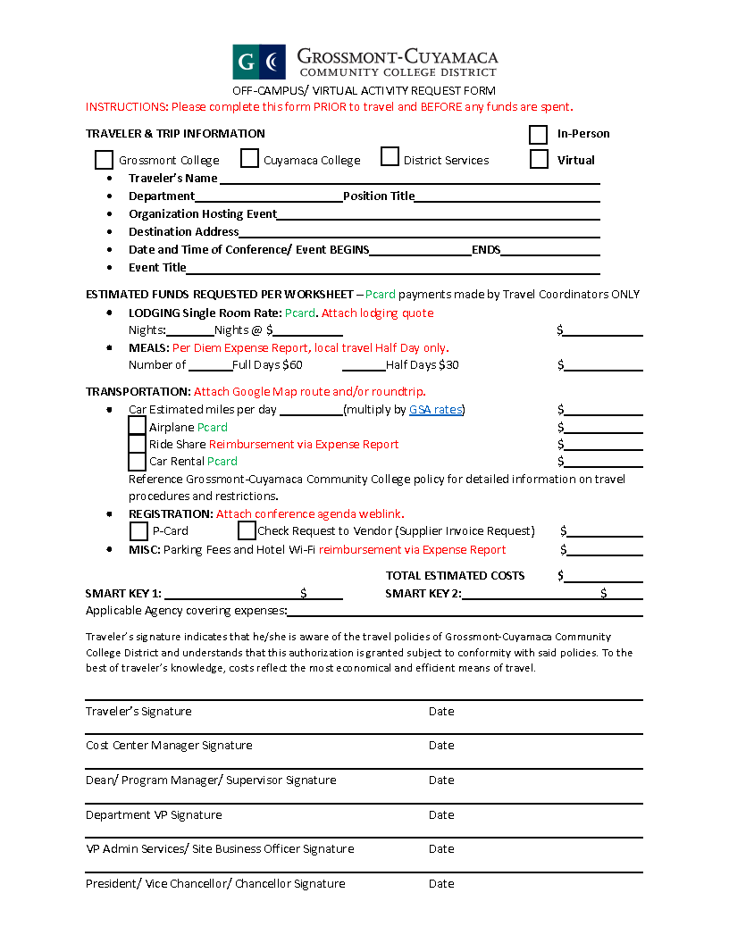

ARTICLE XVII – SAFETY

17.1 Unsafe Working Conditions

Any on-the-job condition(s) considered to be unsafe or potentially unsafe or with regard to classroom noise, ventilation, heating, cooling, water leakage, mold, and other similar problems shall be reported immediately to their Dean/Director and/or the Human Resources Office. If the District determines that the facility and/or equipment poses a serious threat to the health or safety of the unit member, alternative working conditions shall be provided. If problems are not resolved in a reasonable time, faculty shall report the problem to the Guild. The District and the Guild shall meet and confer in an attempt to resolve such problems prior to the filing of any type of formal complaint by the Guild. The unit member may file a claim with Cal/OSHA at any time.

The District shall annually publish Federal Office of Safety and Health Administration (OSHA) standards for temperature for indoor workplaces and Cal/OSHA’s Heat Illness Prevention Standards for outdoor workplaces.

Faculty members shall not be required to work under conditions in which a clear and present danger to their health or safety exists. The District agrees to provide the appropriate and required safety equipment as determined by OSHA or County Department of Environmental Health standards to unit members necessary for the safe performance of their job duties.

The parties agree to collaborate toward developing Districtwide ergonomic standards for faculty.

17.2 Personal Safety

17.2.1 Unit members may use such force as is reasonable under the circumstances to protect themselves from attack, to protect another person or property, quell a disturbance threatening physical injury to others, or to obtain possession of weapons or other dangerous objects on the person or within the control of another person on District property.

17.2.2 Unit members shall report to their immediate supervisor and appropriate law enforcement authorities incidents in which they have been attacked, assaulted, battered, or menaced by any person on District property.

17.2.3 If legal action is brought against a unit member alleging the commission of an assault in connection with their employment or arising out of student discipline, they may request the Governing Board to furnish legal counsel. If the Governing Board denies a request to provide legal counsel and the unit member prevails in the proceeding, the Governing Board shall reimburse the unit member for legal fees and any losses in salary, provided the allegation was not an action brought by the District against the unit member.

17.2.4 In cases where assault results (e.g. worker's compensation) in injury and/or absence from work, the following conditions apply:

17.2.4.1 If absence occurs from such assault, the unit member shall receive full salary during the period of absence in accordance with Education Code § 87042 and 87787.

17.2.4.2 The unit member shall advance on the salary schedule during such period in accordance with the provisions of this Agreement.

17.2.4.3 The unit member may make application to the Board of Trustees for reimbursement for any loss, damage, or destruction of clothing or personal property of the unit member not covered by insurance as a result of assault upon the unit member arising out of and in the course of the unit member’s duties.

17.2.5 All classroom doors shall be equipped with either an electronic lock or dual lock locking mechanism allowing the door to be locked from the inside to keep students and faculty safe in the event of a physical threat of violence. All new construction and renovations shall conform to these standards as new and renovated buildings come on line subsequent to January 1, 2019, per the recommendations from the District Public Safety & Emergency Preparedness Council.

17.2.6 The District will make every effort to provide each unit member who has direct interaction with the public and/or students access to a panic button, or an emergency call button on a District phone, to be used in cases of emergency or threats.

17.3 Discipline of Students

17.3.1 Unit members may make a referral to the behavioral intervention team if a student behaves in a manner in which the unit member considers potentially threatening. The Action Guide concerning referrals may be obtained from the Student Affairs Office.

17.3.2 As per Education Code 76032, a faculty member may remove a student from their class for the day of the removal and the next class meeting (with the assistance of the Sheriff if necessary). The faculty member shall immediately report the removal to the Vice President of Student Services for appropriate follow-up action. Further information regarding student disciplinary procedures may be found in the Student Affairs Office.

17.3.3 During student disciplinary hearings in which unit members may be required to attend, the District shall compensate the unit member at the unit member’s non-classroom rate of pay for any time spent outside of their regularly assigned workweek in such a hearing. A substitute will be provided if said hearing requires the unit member to miss a class meeting.

17.4 Campus Safety

17.4.1 The District will make reasonable efforts through the development of a system and allocation of adequate resources to ensure that the goal for emergency response to any request for help on district property will be less than 10 minutes.

17.4.2 Standardized, consistent, and accessible infrastructure needs to be installed and maintained in working order in every building and every classroom to provide convenient access from the instructor’s teaching area to initiate an emergency response.

17.4.3 Training for all new faculty and staff on how to use the system shall be an included component of training materials provided during the on-boarding process. Any future changes to the system will be accompanied by appropriate training for all existing and new faculty and staff.

17.4.4 There will be a two-tiered system for emergency response:

The first tier is to call “911-Emergency” where law enforcement and/or medical/fire personnel are needed.

The second tier refers to situations relating to student removals that necessitate the need for a security response to assist in the student removal. In these cases the faculty member shall contact the Sheriff department’s non-emergency line.

17.4.5 In addition to the above resources, the District will develop a means to communicate broadly across each campus in addition to cell-phone texts or calls (via a system such as an intercom or PA) in the event that an emergency is occurring that would warrant regional or campus-wide response (such as an earthquake, fire, active shooter, etc.). Such a system will be designed to be heard at all areas of campus, and will be able to be initiated quickly.

17.4.6 Such resources (as stated above) will be made available any time the campus is open.

ARTICLE XVIII – GRIEVANCES

18.1 Purpose

The purpose of the grievance procedure is to resolve grievances at the lowest administrative levels, protecting the rights of all parties.

18.2 Definitions and Limitations

18.2.1 A "grievance" is a formal written allegation by a unit member, AFT on its own behalf, or in the name of, or on behalf of, a specific unit member or members for whom there has been a violation, misinterpretation, misapplication, or mis-implementation of one or more specific provisions of this Agreement, or a violation of this Agreement, written policy, past practice, or regulation pertaining to the scope of the unit member's job.

18.2.2 Other matters for which a method of review is provided by law or another Article of this Agreement, such as dismissal; claims of discrimination or retaliation under any of the following acts: Title VII of the Civil Rights Act of 1964, the Americans with Disabilities Act (including the ADA Amendments Act of 2008), the Age Discrimination in Employment Act, the Equal Pay Act, the Occupational Safety and Health Act, the California Occupational Safety and Health Act, the California Fair Employment and Housing Act, the Uniformed Services Employment and Reemployment Rights Act, the Educational Employment Relations Act, or Workers' Compensation; are excluded from this procedure. AFT, however, may file a grievance over an alleged violation, misinterpretation, or misapplication of AFT Rights, as specified in Article II.

18.2.3 The term "grievant" is defined as AFT representing a specific unit member or members asserting the claim, or a unit member acting on their own behalf. AFT has the right to represent the unit member(s) in all aspects of the grievance procedure.

18.2.4 A "day" for purposes of notifications in this Article is a regular District business day when the District is open and classes are in session.

18.2.5 The "immediate supervisor" is the lowest level managerial or supervisorial position having immediate jurisdiction over the unit member(s) named in the grievance

18.3 Conciliation Procedure

18.3.1 Within thirty (30) days after the occurrence of the alleged act or omission, which was the basis for a potential grievance, or within thirty (30) days after the unit member(s) involved knew, or reasonably should have known, of the act or omission giving rise to a potential grievance, the unit member(s) or AFT on behalf of the unit member(s) shall initiate an informal meeting with unit member’s Dean or the appropriate immediate supervisor in an effort to resolve the potential grievance. When an agreement has been reached that resolves the potential grievance at this level, it shall be reduced to writing.

18.4 Level I- Grievance Procedure

When conciliation efforts fail to resolve the issue, AFT or the grievant, within ten (10) days of the informal meeting may present the grievance in writing to the appropriate Vice President. The statement shall detail the specific act or conditions, the grounds upon which the grievance is based, and the specific remedy sought. The Vice President shall communicate in writing his/her decision to AFT, and the College President, within ten (10) days after receiving the grievance. During this period, either party may request a joint conference.

18.5 Level II - Grievance Procedure

If the grievance is not resolved at Level I, AFT or the grievant may appeal the decision in writing to the College President (or designee) or Vice-Chancellor of Human Resources, as appropriate, within ten (10) days after receipt of a final decision by the Level I administrator.at the conclusion of the Level I process. The statement of appeal shall include a copy of the original grievance, the decision rendered at the conclusion of the Level I process, and why the disposition of the grievance at the prior level was unsatisfactory. The President or designee shall communicate a decision in writing to the grievant and AFT if AFT is representing the grievant, and the Chancellor within ten (10) days after receiving the appeal. Either party may request a joint conference during this period in an attempt to resolve the grievance.

18.6 Level III - Grievance Procedure

18.6.1 If the grievance is not resolved at Level II, AFT or the grievant may appeal the decision in writing to the Chancellor or designee within ten (10) days after the delivery of the decision by the President or designee. The statement shall include a copy of the original grievance, the decisions rendered at Levels I and II, and why the disposition of the grievance at prior levels was unsatisfactory. The Chancellor or designee shall communicate a decision in writing within ten (10) days after receiving the appeal. Either party may request a personal conference during this period. The decision of the Chancellor or designee shall be final unless a written appeal is filed with the Chancellor by the unit member, or AFT acting on its own behalf, within ten (10) days of the receipt of the Chancellor or designee's decision.

18.6.2 Upon mutual written agreement of the parties, within ten (10) days after receipt of the Level II decision, the parties may elect to proceed to mediation in an attempt to resolve the grievance. If the parties elect mediation, a mediator as mutually agreed to by the parties, or from the California Mediation and Conciliation Service, may be contacted to facilitate the resolution of the grievance. If the issue is still not resolved following mediation, AFT may then proceed to arbitration. Costs for the services of the mediator shall be borne equally by AFT and the District. If the grievant is not being represented by AFT, the District shall pay the full cost of the mediation.

18.7 Level IV - Grievance Procedure

18.7.1 AFT shall notify the District in writing of its decision to seek arbitration within ten (10) days after the receipt of the decision of the Level III procedure, or within ten (10) days following the conclusion of mediation.

18.7.2 Questions as to the arbitrability of an issue shall be decided by the arbitrator prior to a determination of substantive issues. Submission to arbitration shall be made to an arbitrator as mutually agreed to by the parties, or the California Mediation and Conciliation Service which will provide a list of five (5) names, in the absence of an approved panel of arbitrators. AFT and the District shall alternately strike a name; the remaining person, upon mutual agreement, shall be the arbitrator. The arbitrator shall proceed under the Voluntary Labor Arbitration Rules or the Expedited Labor Arbitration Rules of the American Arbitration Association.

The parties agree to establish a panel of five (5) arbitrators from which they will consecutively select to hear each case that reaches arbitration.

18.7.3 The arbitrator shall be empowered to hold hearings, set procedural rules, and require such evidence or testimony as they may judge necessary. Their decision shall be in writing (unless mutually agreed to by the parties) detailing all findings of fact, reasoning, and conclusions on the issues submitted. The arbitrator shall not require any action prohibited by law or that violates the terms of this Agreement. The decision of the arbitrator shall be final and binding on AFT and the District.

18.8 Grievance Process Policies

18.8.1 A grievant shall have the right to have a representative present at all levels of the grievance process.

18.8.2 Records pertaining to a grievance shall be kept in a grievance file separate from the individual grievant's official District personnel file.

18.8.3 If the presence of an AFT representative is necessary at a meeting between the grievant and the District during the work day to resolve a grievance, the representative and/or grievant shall be released from duties without loss of pay. A reasonable amount of reassigned time shall be granted to AFT to process grievances.

18.8.4 AFT shall have the right to state its views at all levels of the grievance procedure. When the grievant represents themself, the District shall not agree to resolution of the grievance prior to AFT receiving a copy of the proposed resolution and having a minimum of ten (10) days to file a written response.

18.8.5 Costs for the services of the arbitrator and related hearing costs shall be borne equally by AFT and the District.

18.8.6 The parties shall make available all nonconfidential documents and data in their possession pertaining to the grievance.

18.8.7 If the District representative does not respond to the grievance within the designated time, the grievant or AFT may appeal to the next level.

18.8.8 Mutual agreement of the parties may extend or shorten the time limits specified at each level of the procedure.

18.8.9 The grievance forms, if any, shall be jointly developed by the District and AFT.

18.8.10 No punitive action shall be taken by the District, AFT, the grievant, or any representative of the parties for participating in the grievance process.

ARTICLE XIX – DISCIPLINE AND DUE PROCESS FOR TENURE/TENURED-TRACK FACULTY

19.1 Definitions and Rights

19.1.1 This Article shall only apply to tenure/tenure-track unit members, or full time unit members serving in a categorically-funded position who are disciplined or terminated for cause before the expiration of the categorical funds.

19.1.2 Within the parameters as set forth in the following Sections of this Article XIX, the District maintains the right to discipline or discharge unit members for cause.

19.1.3 When problems arise in the performance of assigned duties and responsibilities, the District will make reasonable attempts to assist the unit member in correcting those problems through the application of progressive discipline. In issuing discipline, the District will take into consideration the totality of circumstances including but not limited to:
- Whether progressive discipline has been issued in the past and whether the offense is one in which progressive discipline should be considered;
- Whether there has been a fair investigation of the allegations of misconduct;
- Whether the level of discipline is proportionate to the alleged cause for discipline in consideration of extenuating and mitigating factors and the unit member’s past history of misconduct or poor performance.
Nothing herein shall limit the District’s ability to respond to serious offenses by taking action not usually prescribed as an initial step in a progressive discipline process. No part of the video or audio recording or livestream of a distance education or HyFlex assignment may be used as evidence in or to initiate any type of disciplinary proceeding against the faculty member, nor shall it be accessed and/or utilized to view or review any part of the assignment for any reason, including a response to a complaint.

19.1.4 Informal discipline refers to oral counseling sessions, oral and written warnings, and other lower level admonitions that are kept in the immediate supervisor’s office and not placed in the unit member’s personnel file.

Formal discipline includes: written reprimands, suspensions without pay, or dismissals for cause, the documentation of which is placed in the unit member’s official personnel file in District Human Resources.

For purposes of this Article, denial of tenure, non-renewal of a contract for a tenure-track employee, a Notice of Unprofessional Conduct and/or a Notice of Unsatisfactory Performance, and compulsory suspensions pursuant to Education Code § 87736 shall not be considered to be discipline for the purposes of this Article, and shall not be subject to the provisions of this Article.

All documentation of misconduct resulting in formal discipline must be placed in the unit member’s official personnel file within thirty (30) days of the imposition of the discipline. A unit member’s level of formal discipline may be based upon any prior disciplinary action only if those prior formal disciplinary materials are in the unit member’s official personnel file in the District Human Resources Office and are less than three years old.

Disciplinary investigation shall occur in a timely manner following the occurrence or knowledge by the District of said incident.

Where the District intends to interview an accused unit member in the course of an investigation into allegations made against the accused unit member:

    - The accused unit member shall be advised of the allegations made against them which are the subject of the investigation upon scheduling the investigatory meeting;
    - A copy of any written complaint shall be provided or shown to the unit member before or during the interview where appropriate;
    - The District shall inform the accused unit member of their right to union representation upon scheduling the investigatory meeting.
The District shall take all reasonable efforts to ensure confidentiality during the course of the investigation in order to protect the integrity of the investigation and prevent against retaliation.

19.1.5 No unit member shall be formally disciplined except for one or more of the causes as delineated in Education Code § 87732.

19.2 Due Process

Unit members shall be free from disciplinary action without proper regard for due process as defined in this Article and as required by law. The burden of proof shall at all times remain with the District, except in the case of the assertion of an affirmative defense by the unit member.

19.2.1 All unit members shall be provided a pre-disciplinary hearing conducted by an appropriate management employee outside of the unit member' s direct line of supervision, prior to implementation of any disciplinary action more severe than a five (5) day suspension. The management employee conducting the hearing cannot have been involved in the investigation, review, consultation, or recommendation of discipline in the subject of the hearing or be otherwise incapable of providing an impartial hearing.

19.2.2 For disciplinary actions of suspension or other loss in compensation or property rights equal to or less than in severity to a five (5) day suspension, the pre-disciplinary hearing process delineated in Sections 19.2.4 and 19.2.5 below may be held after the imposition of the discipline. All of the other provisions of Sections 19.2.4 through 19.2.7 shall still apply in these cases.

19.2.3 With the exception of those cases where Section 19.2.2 above applies, all unit members who are either orally or in writing directed not to return to work pending an investigation, or pending the imposition or the possible imposition of discipline, shall be considered to be in paid administrative leave status.

19.2.4 Notice of Pre-Disciplinary Hearing

In all discipline cases requiring a pre-disciplinary hearing, notice of such discipline shall be made in writing and served upon the unit member in person or by registered or certified mail. The notice shall include the following:

- A statement of the proposed disciplinary action;
- A statement of the charges upon which the proposed disciplinary action is based;
- A statement of the facts upon which the proposed disciplinary action is based including the rule, regulation, practice, violation, or policy involved (if applicable);
- A statement of the unit member's right to respond orally or in writing or both;
- A statement of the unit member’s right to have representation at the pre-disciplinary hearing.
- All documents or materials upon which the recommendation to impose discipline has been made or a statement of the member’s right to review the specified documents.

19.2.5 Pre-Disciplinary Hearing Timelines

19.2.5.1 The unit member must respond to the pre-disciplinary notice no later than ten (10) working days after delivery of the written pre-disciplinary notice. The pre-disciplinary hearing shall occur no sooner than twenty (20) working days after delivery of the written pre-disciplinary notice.

19.2.5.2 After the pre-disciplinary hearing has been concluded and all pertinent facts have been reviewed, the appropriate manager shall notify the unit member and their representative in writing of the recommendation to be made to the President or Vice-Chancellor of Human Resources no later than ten (10) working days after the conclusion of the hearing. If the President or Vice-Chancellor of Human Resources sustains the recommendation, the recommendation shall be forwarded to the Chancellor for action with a copy provided to the unit member within ten (10) working days of receipt of the recommendation from the hearing officer.

19.2.5.3 If the Chancellor sustains the recommendation, the Chancellor shall notify the unit member and their representative in writing of the recommendation to be made to the Board of Trustees regarding discipline, if any, within ten (10) working days of the recommendation made by the President or Vice-Chancellor of Human Resources.

19.2.5.4 Any of the pre-disciplinary hearing timelines may be modified by mutual agreement of the parties.

19.2.5.5 If the Chancellor recommends that a suspension or termination be imposed, the recommendation shall be submitted to the Board of Trustees for consideration and decision pursuant to Education Code § 87671 and 87672.

19.2.6 Final Notice of Discipline

Following the decision made by the Board of Trustees pursuant to Education Code § 87672, a final notice of disciplinary action shall be sent to the unit member by registered or certified mail or personally served upon the unit member. This final notice of disciplinary action shall contain the following:
- A statement of the exact discipline to be imposed and the effective date(s);
- A statement of the charges upon which the disciplinary action is based;
- A statement of the facts upon which the final decision to impose discipline was based; A statement of the unit member’s right to appeal the disciplinary action within thirty (30) working days from the date of service of the final notice of disciplinary action;
- A copy of all materials upon which the District has based its decision to impose discipline or a statement of the member’s right to review the specified documents.
- A separate card or paper, the signing and filing of which shall constitute a demand for hearing and a denial of the charges.

In cases where the District’s disciplinary action is to dismiss a unit member for immoral conduct, conviction of a felony or of any crime involving moral turpitude, with incompetency due to mental disability, or with willful refusal to perform regular assignments without reasonable cause, and pursuant to Education Code § 87735 and 87736, the District may, if it deems such action necessary, immediately suspend the employee from their duties and that 30 days after service of the notice, they will be dismissed, unless they demand a hearing. If the employee does not demand a hearing within the 30-day period, their dismissal shall be effective upon the expiration of 30 days after service of the notice. The preceding notice requirements of section 19.2.6 still apply in these cases.

19.2.7 Appeal of Discipline

Unit members who are dismissed or suspended may appeal the disciplinary decision pursuant to Education Code § 87673 et. seq.

As per Education Code § 87677 and 87683, in cases of appeal of discipline where the grievant is not being represented by AFT, the employee will bear all costs associated with their own representation and the District shall pay the full cost of the arbiter and all hearing related costs.

19.3 Video Cameras

19.3.1 Recognizing the need to maintain a safe and secure environment, the District and AFT agree that the purpose for the installation of video cameras on District property is to promote and ensure the safety and security of students, staff, and District property and is not intended for employee discipline. The District and AFT agree that cameras are not intended to replace or circumvent the supervisory or managerial responsibilities associated with employee supervision, evaluation, and discipline.

19.3.2 Video cameras may only be installed in public spaces that would be considered public forums in which the public has access to and will not be installed within internal work spaces.

19.3.3 The camera feeds and records can only be accessed by the necessary safety personnel in the course of their regular work duties except as required by court order or part of an internal disciplinary investigation concerning allegations of immoral conduct, sexual misconduct, violation of BP 3410/3430, or as part of an internal investigation regarding alleged criminal activity.

19.3.4 The parties agree that the intended purpose and use of the cameras are for safety and not be used to replace or circumvent supervisory or managerial responsibilities. If as a result of a review of the video recording, unrelated to any type of disciplinary issue, a camera incidentally records an employee committing a crime or violating a District policy that would generally give rise to disciplinary action, the District may use that video recording as evidence in disciplinary proceedings.

19.3.5 In no cases may any video recording be used to initiate or substantiate performance issues.

19.3.6 The District will provide the AFT Guild, upon request, with a report on camera access including the date and time the camera or recording was accessed and by whom the camera or recording was accessed.

ARTICLE XX – SAVINGS CLAUSE and SUPPORT OF AGREEMENT

20.1. If any provision of this Agreement or its application to a unit member is held to be contrary to law, such provisions or applications shall not be deemed valid and subsisting, except permitted by law, but all other provisions or applications shall continue in full force and effect. Upon request of either party, the parties shall meet for the purpose of renegotiating the affected provision(s).

20.2 AFT and the District recognize the duty and obligation of its respective representatives to comply with the provisions of this Agreement and to extend every effort for the implementation of all its provisions.

ARTICLE XXI – NOT-FOR-CREDIT AND CCAP INSTRUCTORS

All Articles of this Agreement shall apply to not-for-credit faculty and CCAP regular or contract high school employees who teach a GCCCD course outside of their high school 1.0 FTEF contract load with the exceptions of:

- Article IV – all
- Article VII – all sections except 7.17
- Article IX – sections 9.4 and 9.9 shall apply. The remainder of Article IX will not apply.
- Article XI – all
- Article XIV – all
- Article XV – all sections except 15.4
- Appendix B – all

Articles which will not apply to regular or contract high school employees who teach a GCCCD course as part of their high school 1.0 FTEF load:

- Article IV – all
- Article VII – all sections except 7.17
- Article IX –a stipend of $300 per 0.20 FTEF will be provided. The remainder of Article IX will not apply.
- Article XI – all
- Article XIII – all
- Article XIV – all
- Article XV – all sections except 15.4
- Appendix A – all
- Appendix B – all

ARTICLE XXII – DURATION AND CONDITIONS

21.1 Any individual agreement between the District and any individual faculty member within the representational unit of this Agreement which would modify the faculty member’s wages, hours or other terms and conditions of employment in such a manner to be inconsistent with this Agreement heretofore executed shall be subject to and made subject to and consistent with the terms of this or subsequent agreements to be executed by both parties. If an individual agreement contains any language inconsistent with this Agreement, this Agreement, during its duration, shall be controlling unless otherwise agreed to in writing between the District and AFT.

21.2 This Agreement shall supersede any rules, regulations, or practices of the District which are or may be in the future contrary to or inconsistent with its terms. The provisions of the Agreement shall be considered part of the established policies and procedures of the District.

21.3 For the duration of this Agreement, the AFT and the District shall not be obligated to meet and negotiate with respect to any subject or matter with the exception of re-openers on the following Articles, once the District receives an Advance, P1, P2, or R1 Apportionment Report that notes its Total Computational Revenue to be $147,145,125 or greater:

- Compensation for Performing an Excessive Number of Evaluations
- Reduction from 17 to 15 for 1.0 FTEF of Laboratory Load
- Compensation for Excessive Teaching Loads
- Department Chair Compensation and Reassigned Time
- Class Size
- Number of TA Hours
- Distance Education Recertification
- General Salary Increase
- Modifications to Salary Schedules
- Athletics and Speech and Debate Coaching Stipends
- Effective Date of Salary Class Advancement
- Salary Advancement Credit for Professional Development for Part-Time Faculty
- Compensation for Canceled Classes for Part-Time Faculty
- Compensation for all Faculty when Serving on Committees Outside of the Academic Year
- Equal Professional Development Salary Advancement Opportunities for Part-Time Faculty
- Salary Advancement Credit for Equity-Minded Teaching & Learning Institute and Faculty Equity & Innovation Institute Program
- Appendix I – Load Determination Formulas
The Parties agree that sufficient funding may not be available to fund any or all of the above negotiable items.

And those other Articles within this Agreement which specifically call for meeting and negotiating. Upon mutual written agreement, the parties may reopen additional articles for negotiations.

21.5 This Agreement shall constitute the full and complete commitment between both parties and shall supersede and cancel all previous agreements, both written and oral. This Agreement may be altered, changed, added to, deleted from or modified only through the voluntary, mutual consent of the parties in a written and signed amendment to this Agreement.

21.6 The duration of this Agreement shall be October 1, 2025, through June 30, 2028 .

APPENDICIES
APPENDIX A – SALARY SCHEDULES 2
APPENDIX B – FRINGE BENEFITS (Reference Article IX) 6
APPENDIX C – EVALUATION FORMS 7
APPENDIX D – REASSIGNED TIME AND STIPENDS FOR DEPARTMENT CHAIRS AND PROGRAM COORDINATORS 19
APPENDIX E – DISCRETIONARY REASSIGNED TIME 23
APPENDIX F – APPLICATIONS FOR SALARY ADVANCEMENT 26
APPENDIX G – UNIT MEMBER JOB DESCRIPTIONS 29
APPENDIX H – ADJUNCT/OVERLOAD FACULTY LOAD DETERMINATION 59
APPENDIX I – EXCEPTIONS TO FTEF LOAD DETERMINATION FORMULA 61
APPENDIX J – ADJUNCT OFFICE HOUR FORM 62
APPENDIX K – COUNSELING MEMORANDUM OF UNDERSTANDING 64
APPENDIX L – LEAVES TABLE 64

APPENDIX A – SALARY SCHEDULES

Adjunct, Overload & Substitute Salary Schedule:
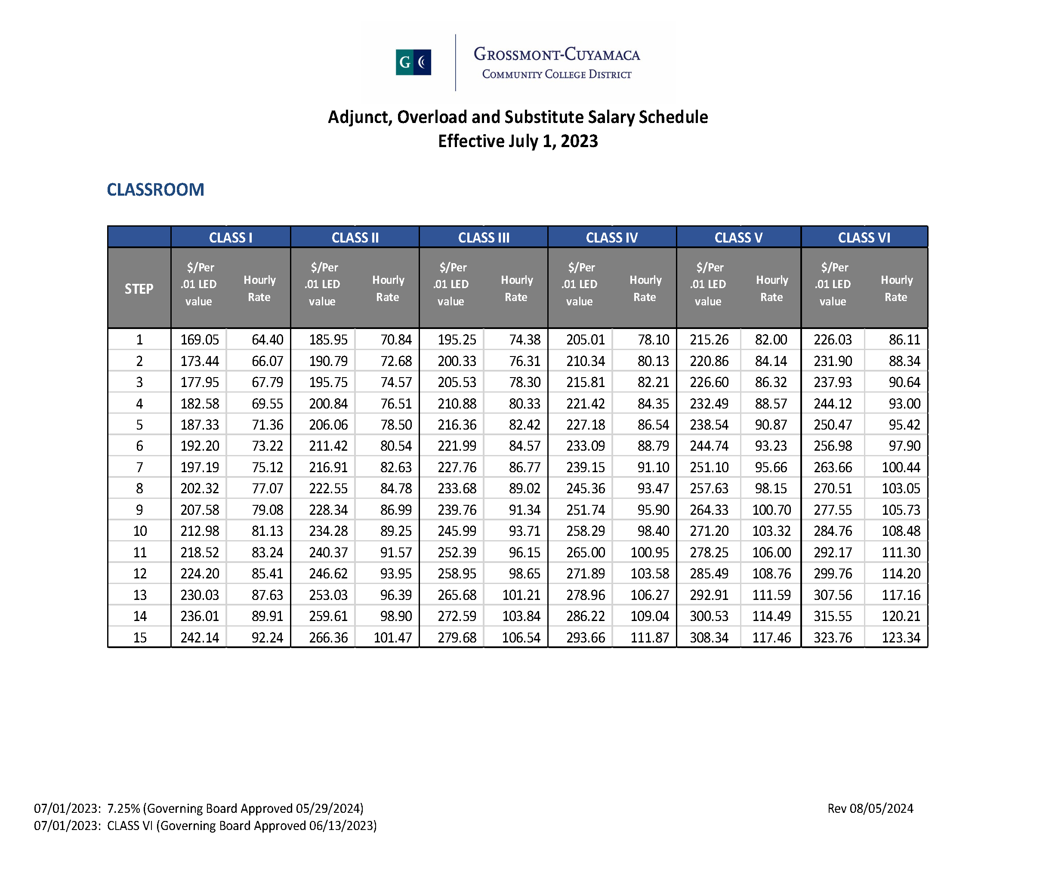
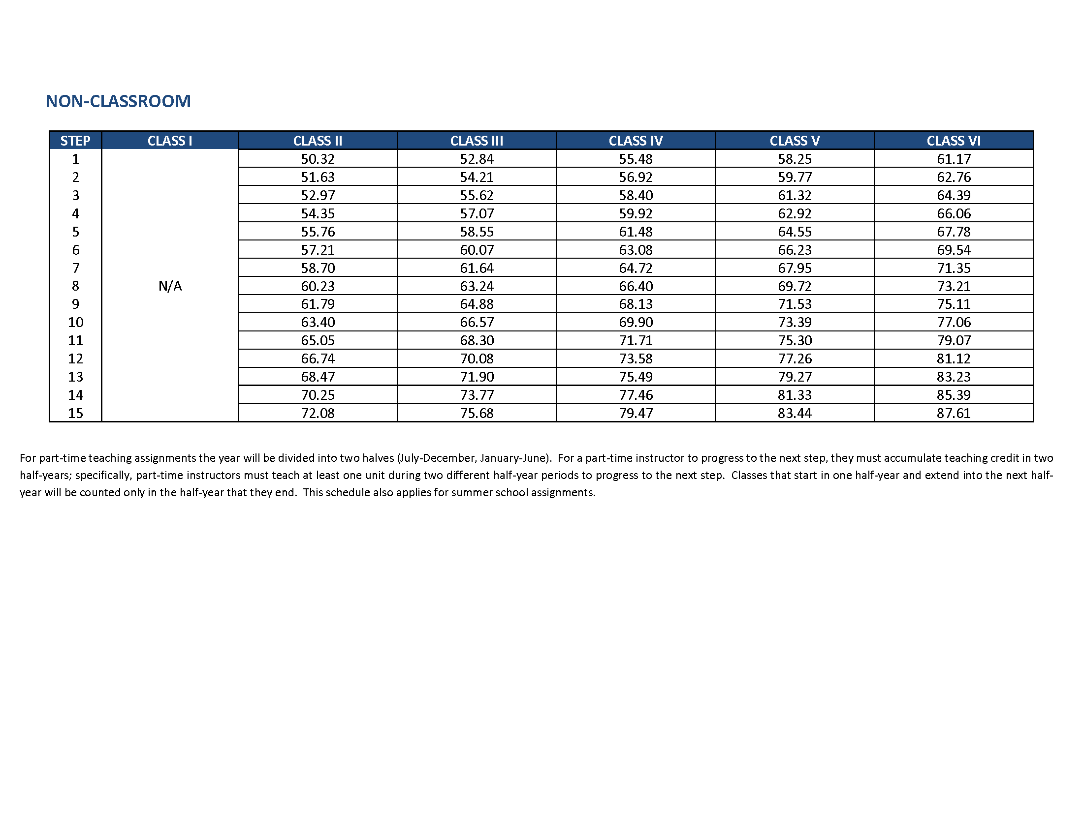

11-Month Salary Schedule:
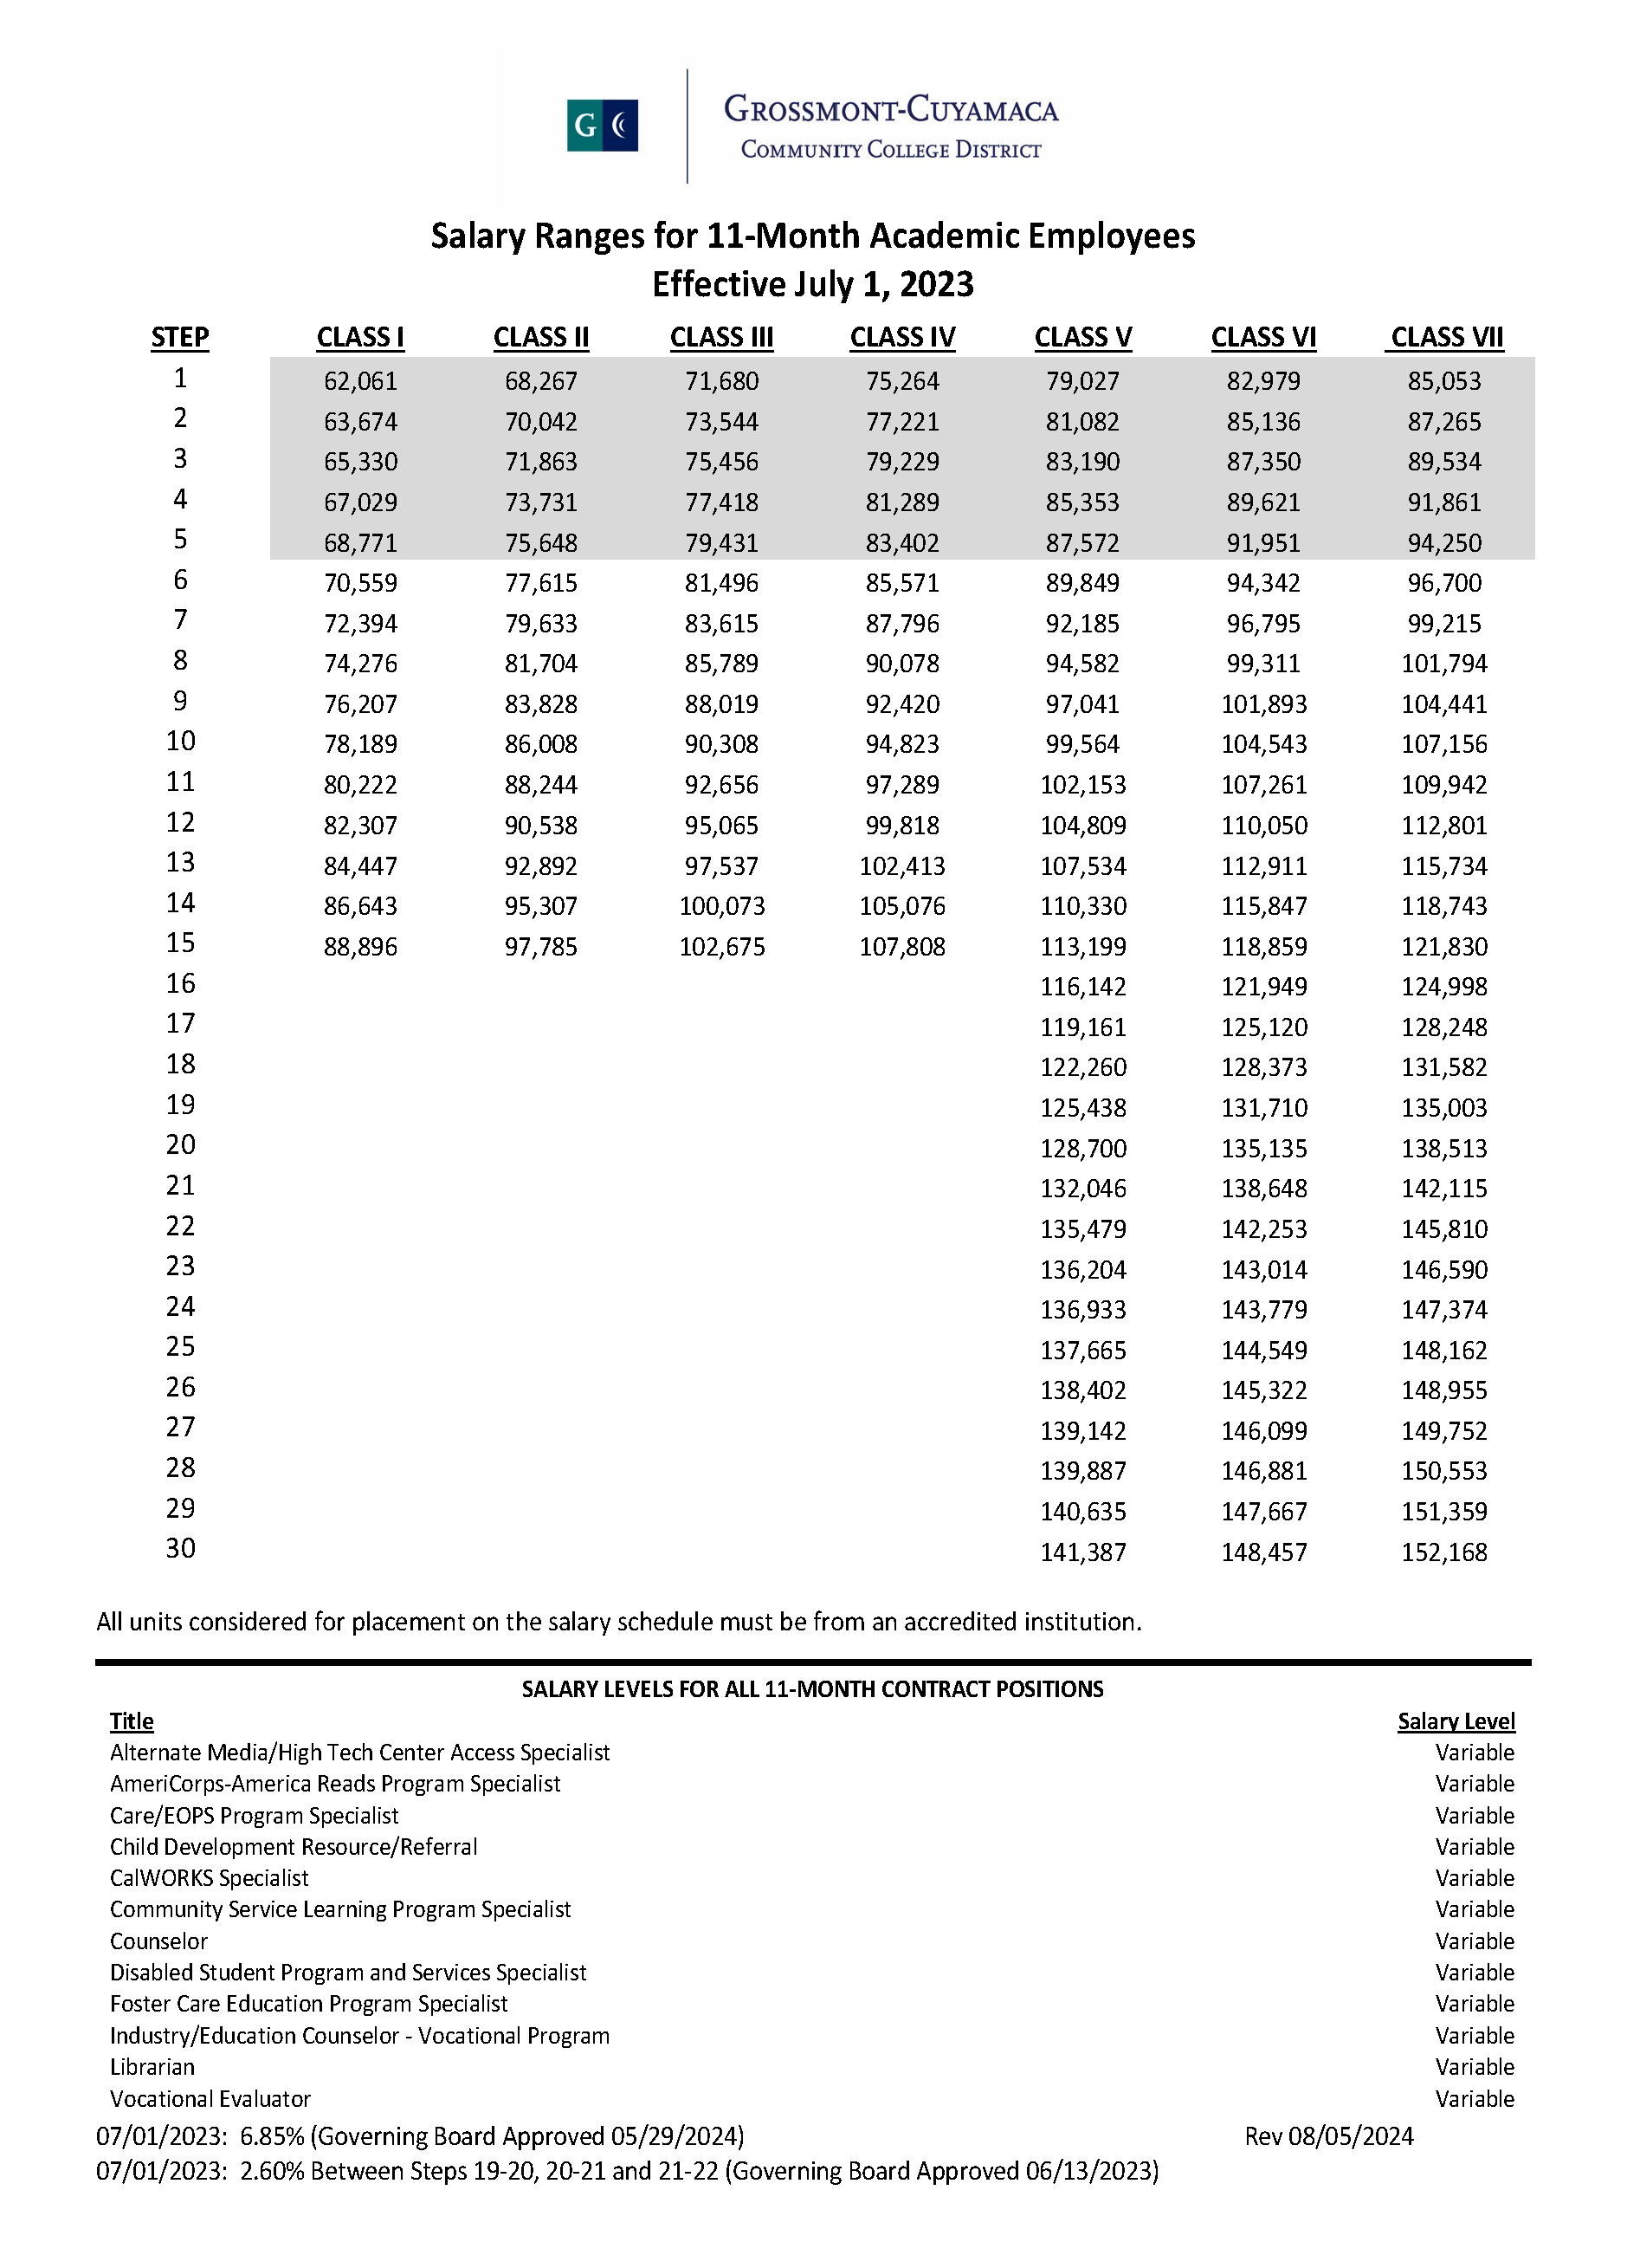

10-Month Salary Schedule: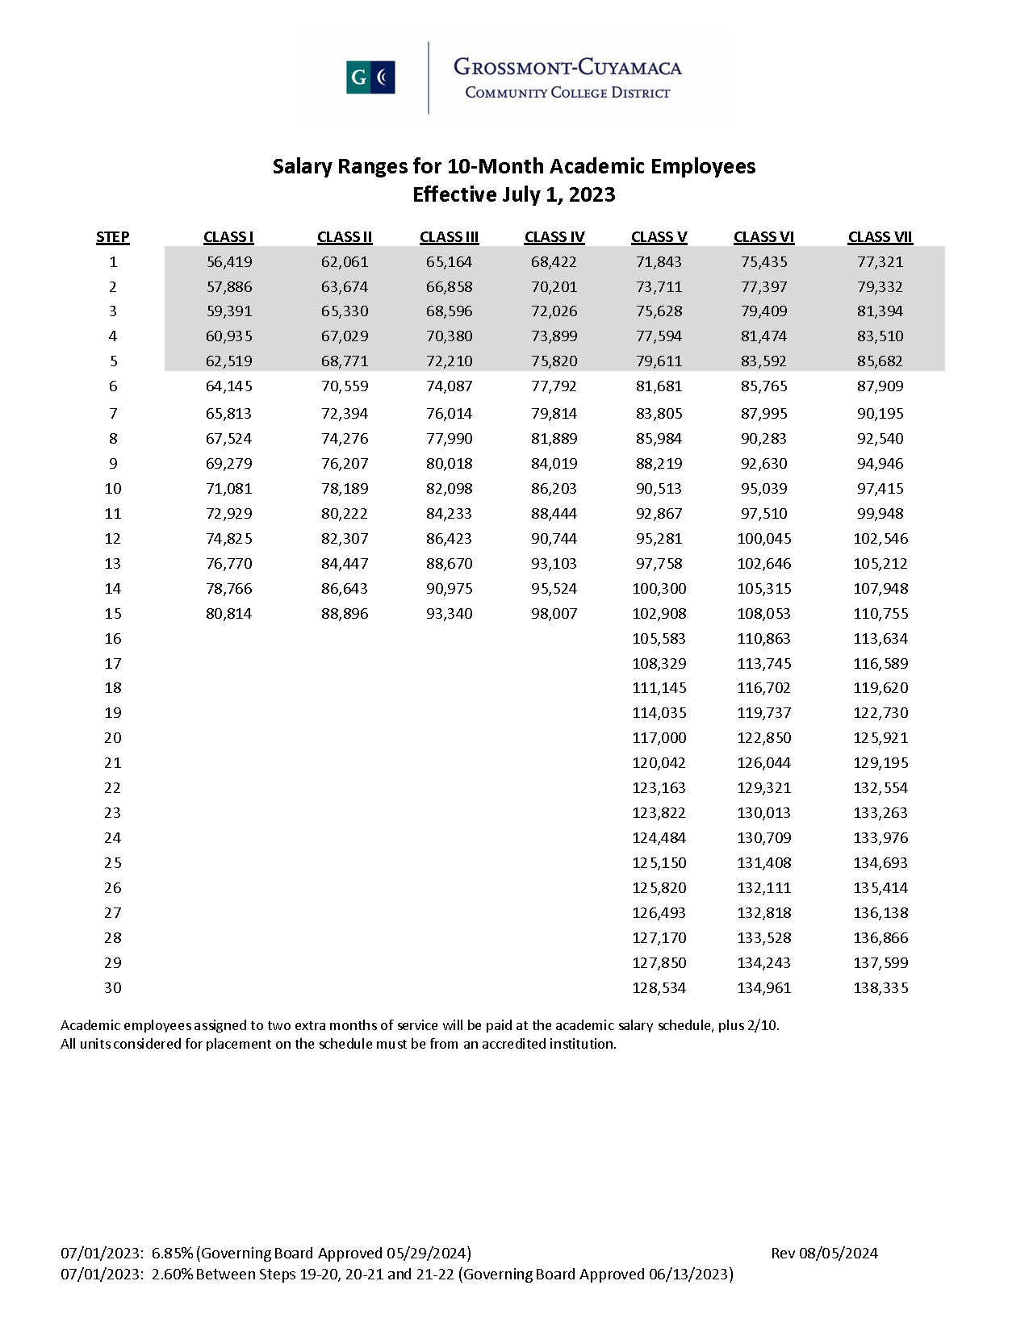

Assistant Coach Stipend Schedule:

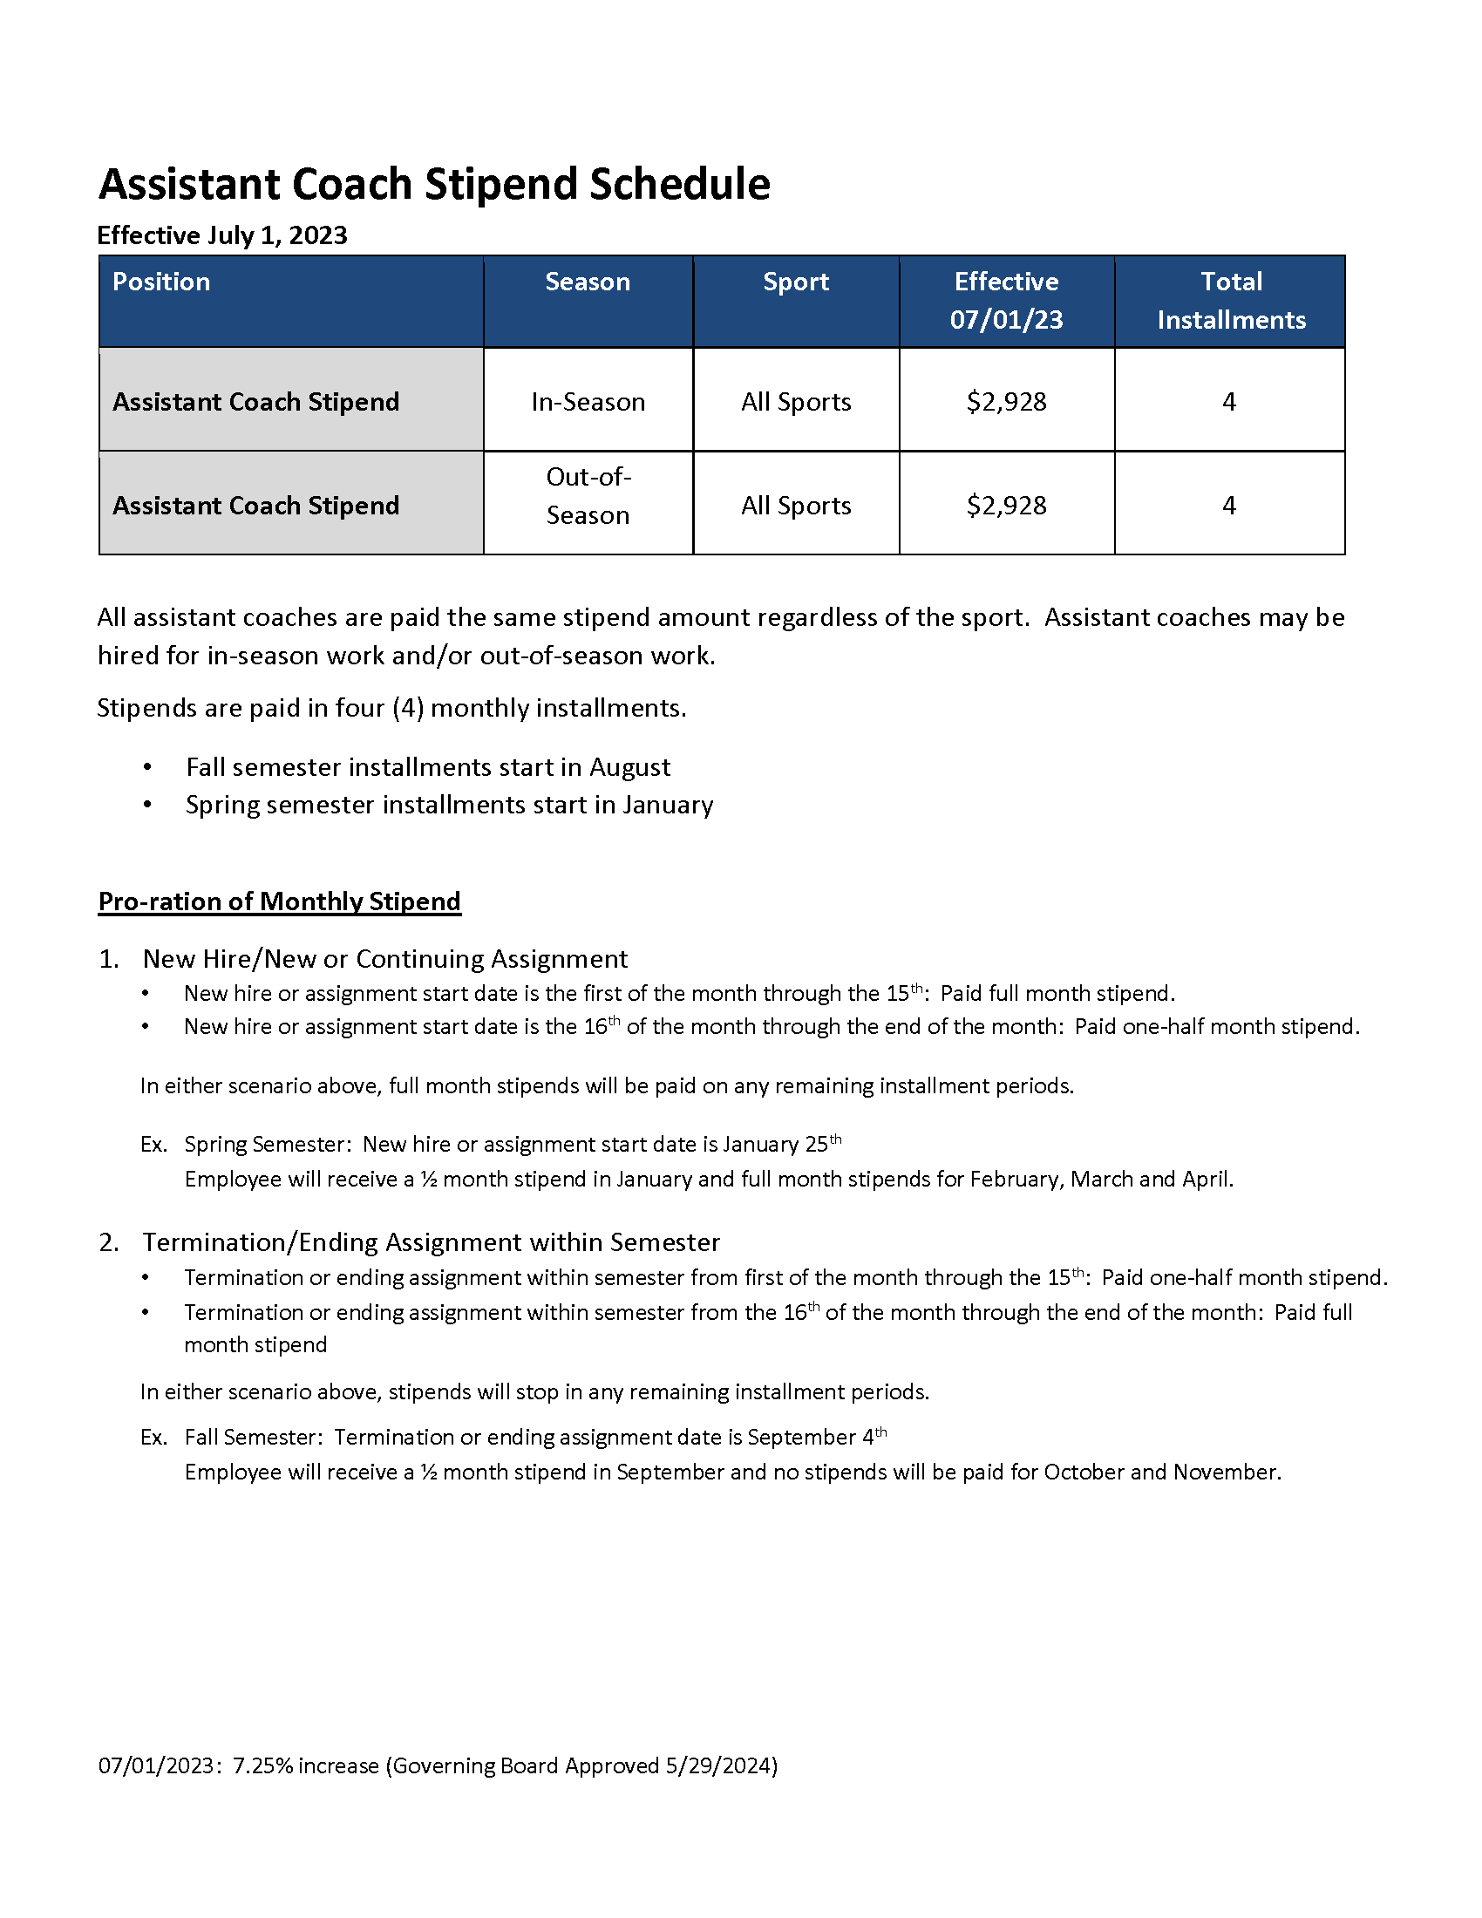

APPENDIX B – FRINGE BENEFITS (Reference Article IX)

The District and AFT agree to continue VEBA participation which was first effective January 1, 2013.

The parties have agreed to the detailed benefits information for Full-Time and Part-Time Faculty which can be found on the District Benefits Department Website.

No duplication of coverage Employees and retirees may not be covered under more than one District-sponsored health plan. An individual may not be simultaneously enrolled as an employee (or retiree), and as a dependent of another employee or retiree. Additionally, no individual may be covered as a dependent under more than one employee’s or retiree’s plan. Employees who are dependents of another District employee, or a dependent who later becomes eligible for coverage as an employee themselves, must elect to either:
- Continue coverage as a dependent; or
- Elect coverage as an employee.
For example, if an individual is covered as a dependent under the Kaiser plan and subsequently becomes eligible for coverage as an employee, they must either remain a dependent under Kaiser or enroll independently as an employee under a separate plan.
Active employees who can demonstrate coverage in a VEBA approved plan as a dependent through their spouse or domestic partner can elect to opt-out of the District plan and will receive a stipend equal to 50% of the single employee premium for the Kaiser plan.

Part-Time employee Alternative Retirement Plan – For those part-time academic employees who are not members of CalSTRS or CalPERS, the employee will be mandatorily enrolled in the County Department of Education FBC ARS-3121 Plan. The contribution rate is 3.75% with the District matching at the same percentage. The unit member’s contribution is tax deferred. Vesting is immediate upon the first day at work. A summary plan description of the plan is available in the Benefits office.

Retiree Coverage:

- Retirees and dependents will be covered by the same medical plans approved for active employees.
“Opting Out” of District Benefits coverage:

- Active employees and their dependents are not permitted to “opt-out” of District provided health coverage (medical, dental and vision) in order to receive an opt-out payment, as described below.
- Retirees under the age of 65 (payments to be made in January and July):
  - Retirees who retired on or before December 31, 2020, and who either reside outside of the United Stated or elect to opt out of District-provided health coverage (medical, dental and vision) shall receive a monthly payment equal to seventy-seven percent (77%) of the monthly premium for the least costly health plan available to active employees, based on either:
    - Single-party coverage; or
    - Retiree and spouse coverage,
whichever is applicable, in lieu of receiving direct health coverage.
  - Retirees who retired on or after January 1, 2021, and who either reside outside of the United States or elect to opt out of District provided health coverage (medical, dental, vision) shall receive a monthly payment equal to fifty percent (50%) of the monthly premium for the VEBA Kaiser plan, based on single-party coverage, in lieu of receiving direct health coverage.

APPENDIX C – EVALUATION FORMS

Coaching Instructor Evaluation Form:
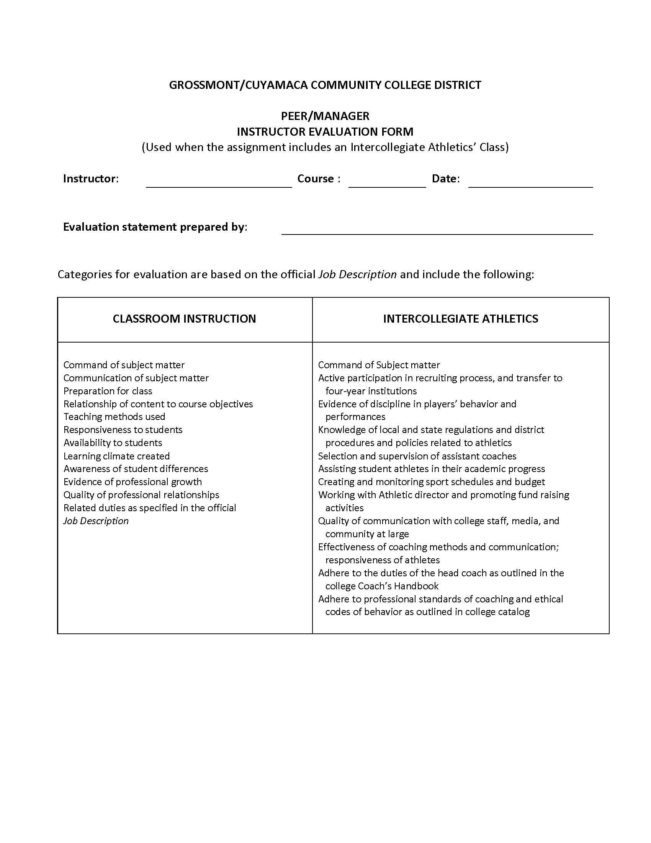
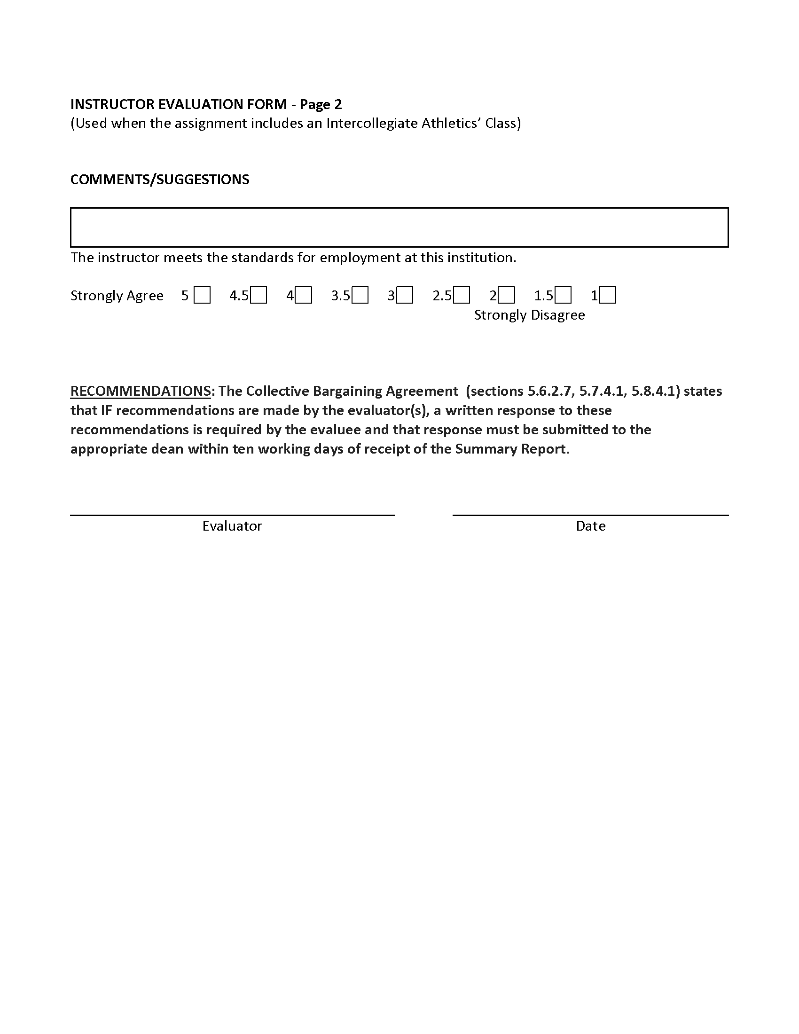

Counselor Form:
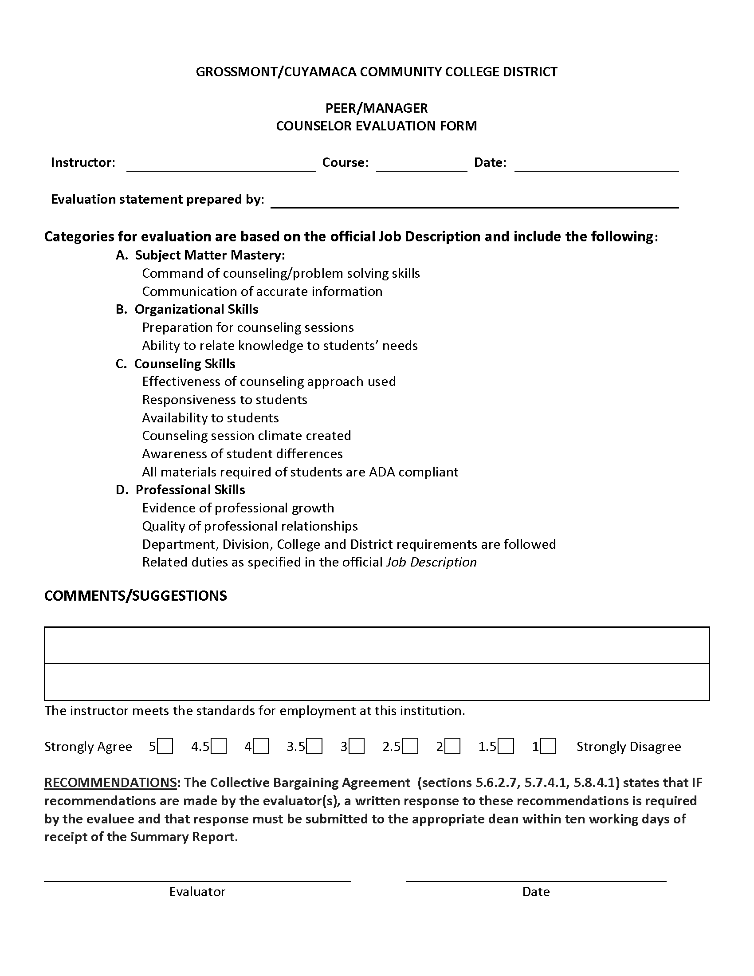

DSP&S Specialist/Counselor Form:
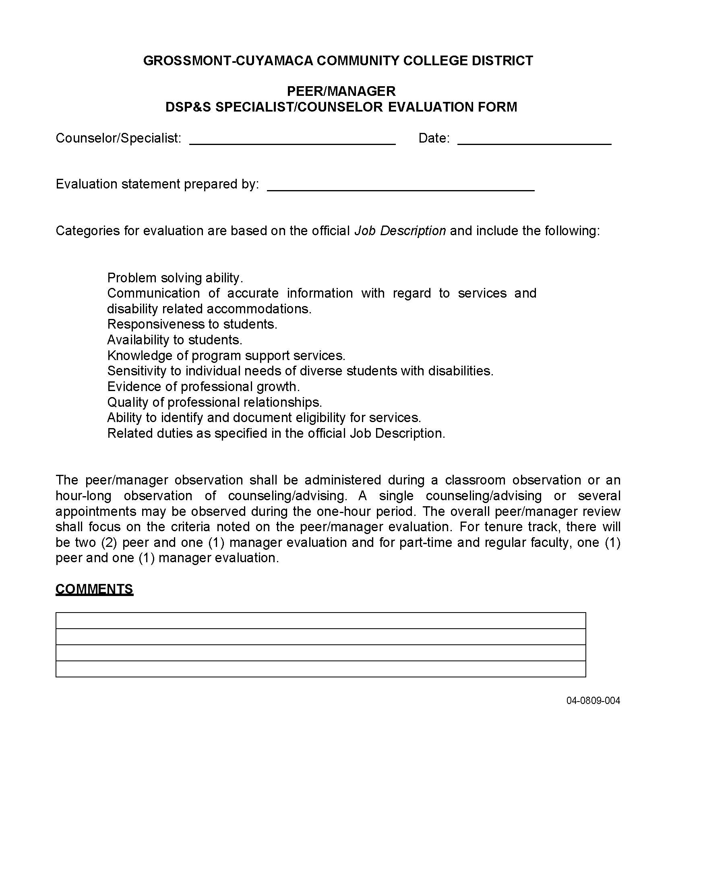

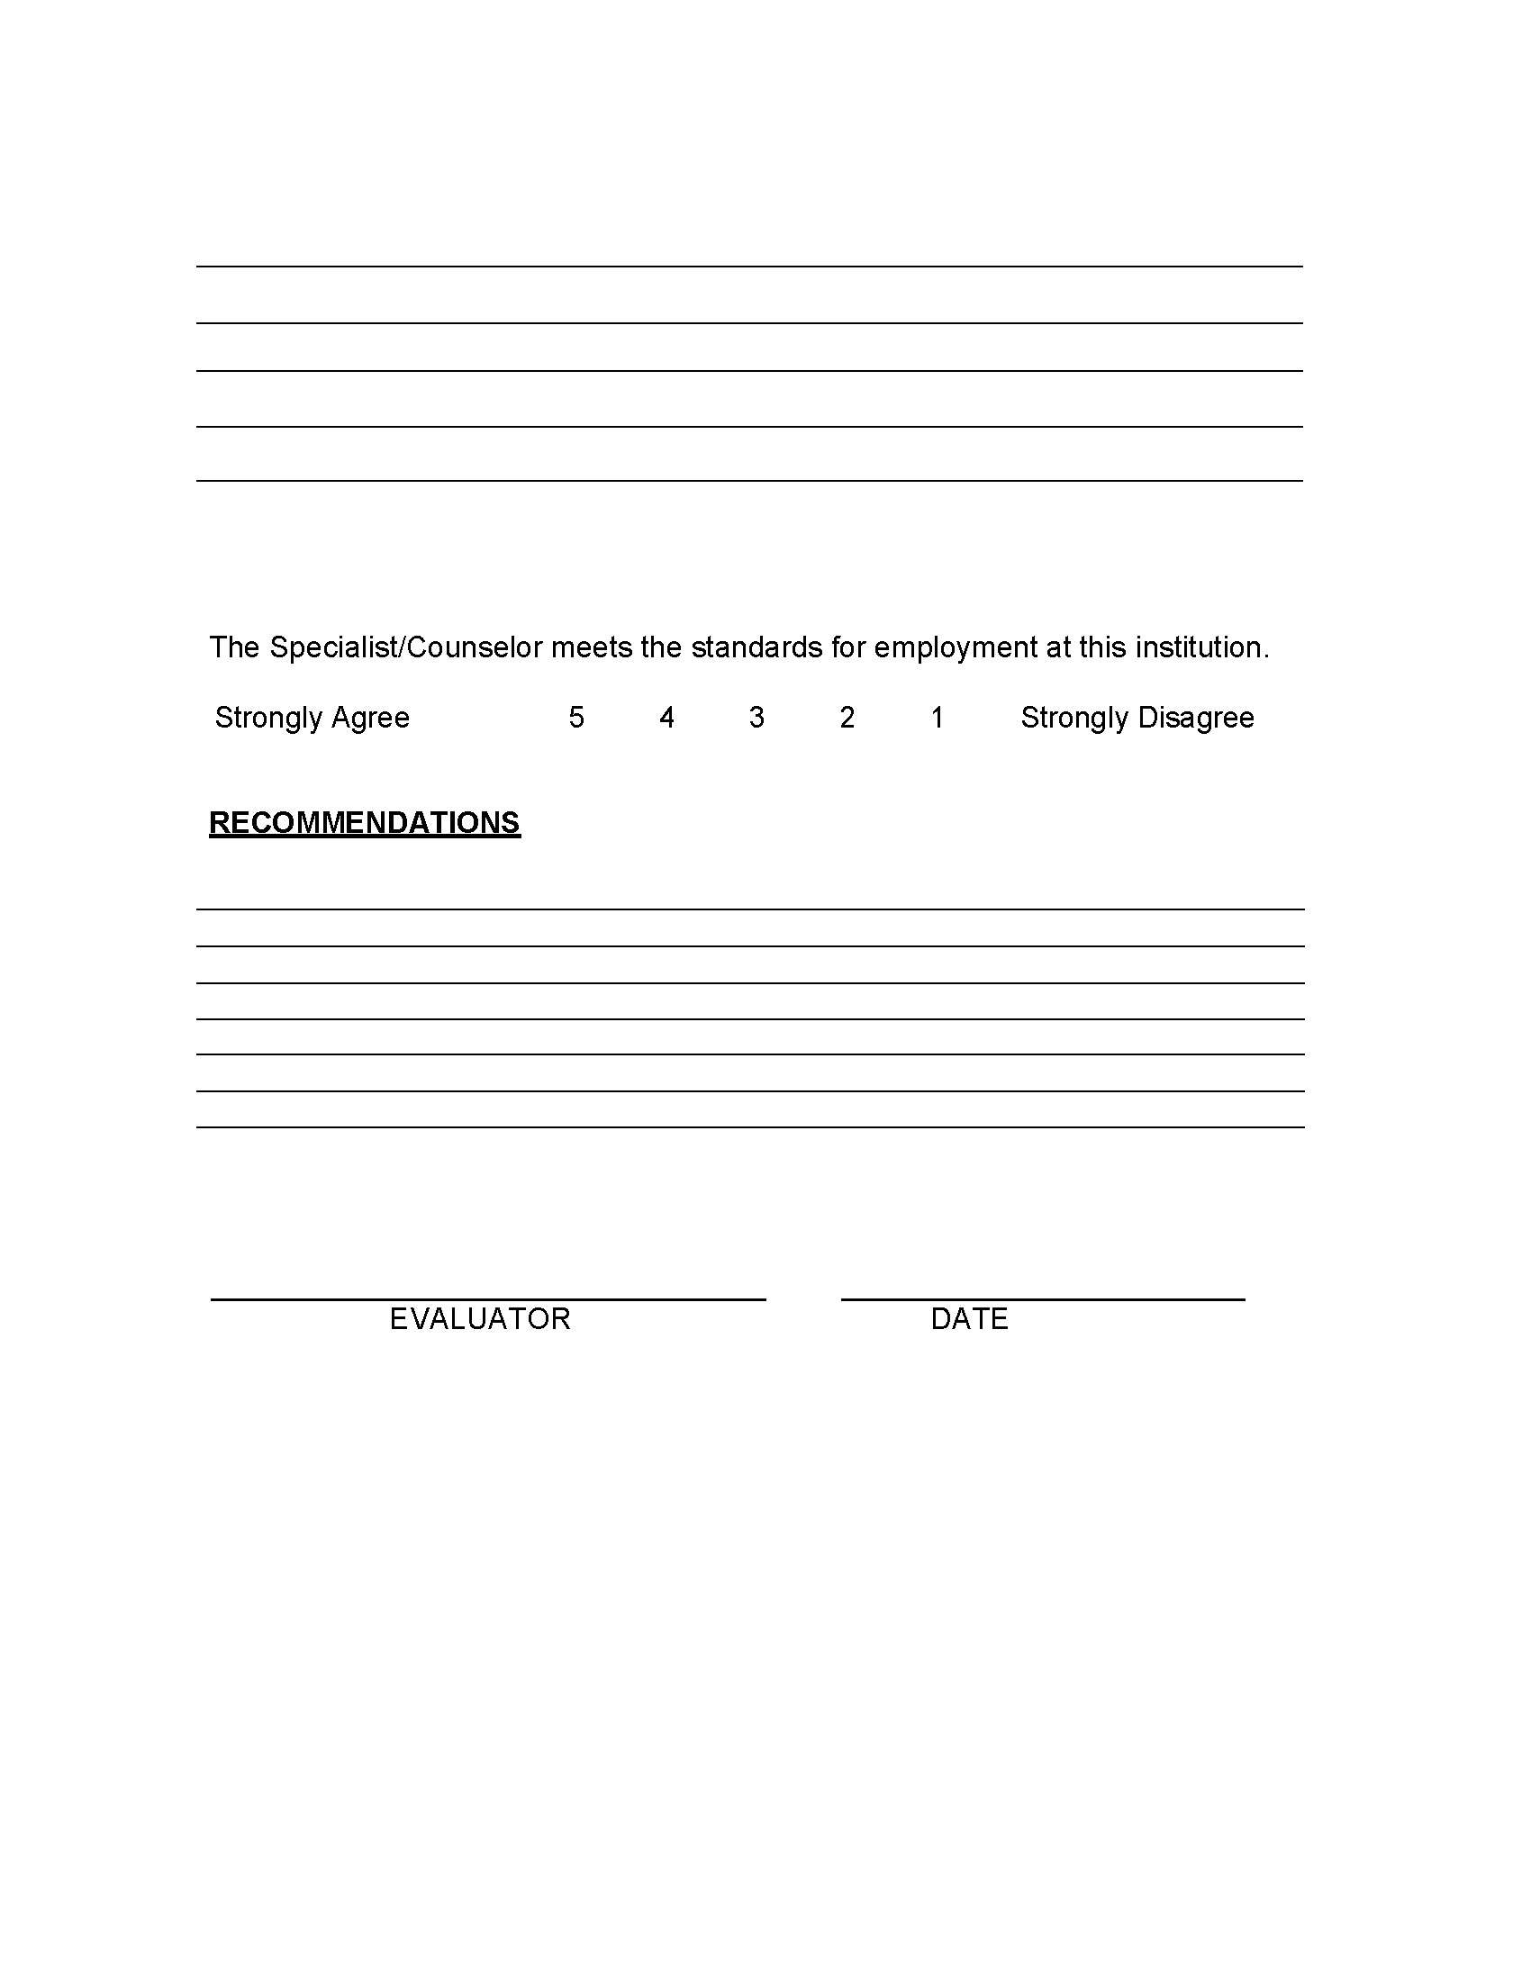

Instructional Evaluation Form:
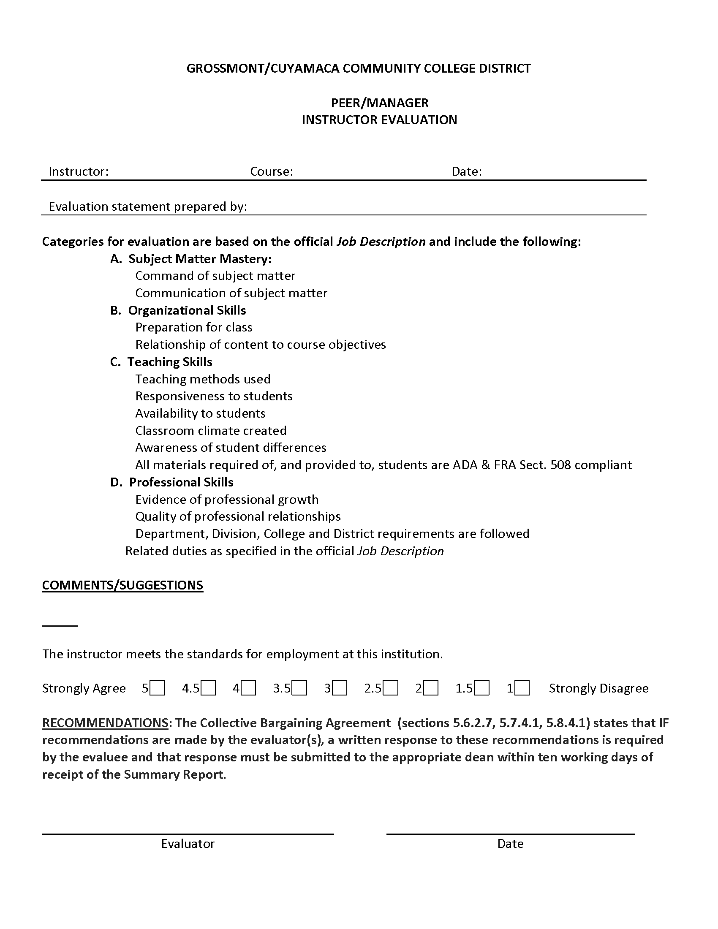

Librarian Form:
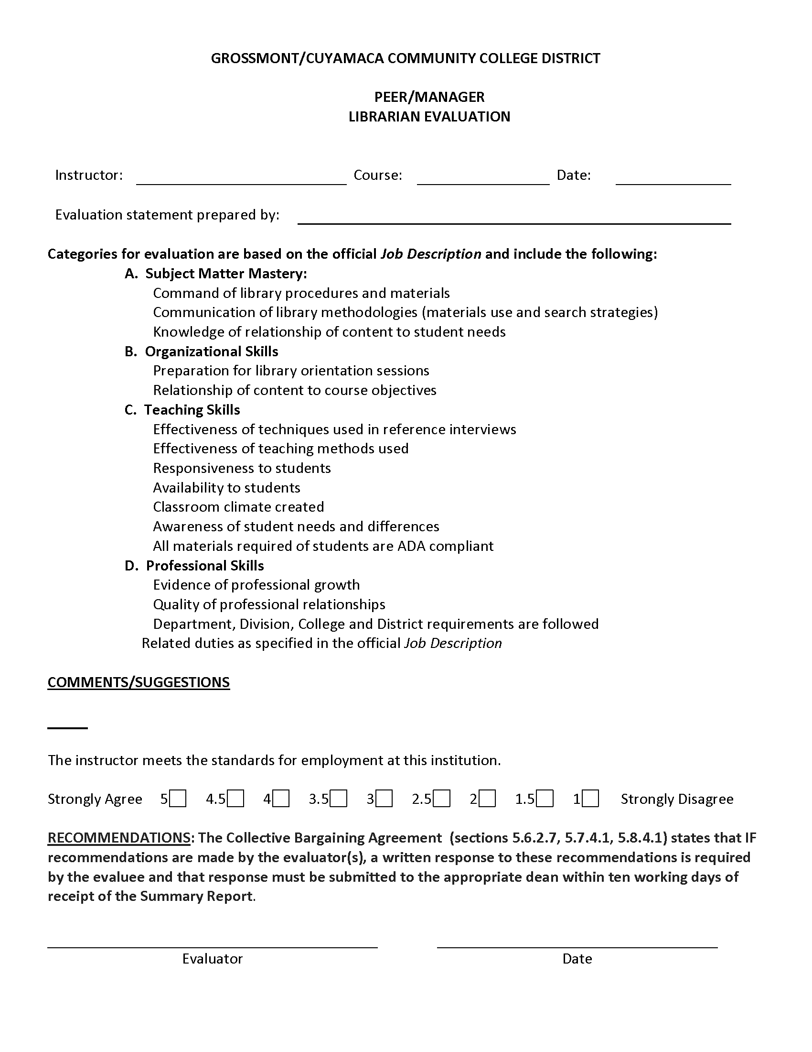

Online Instructor Form:
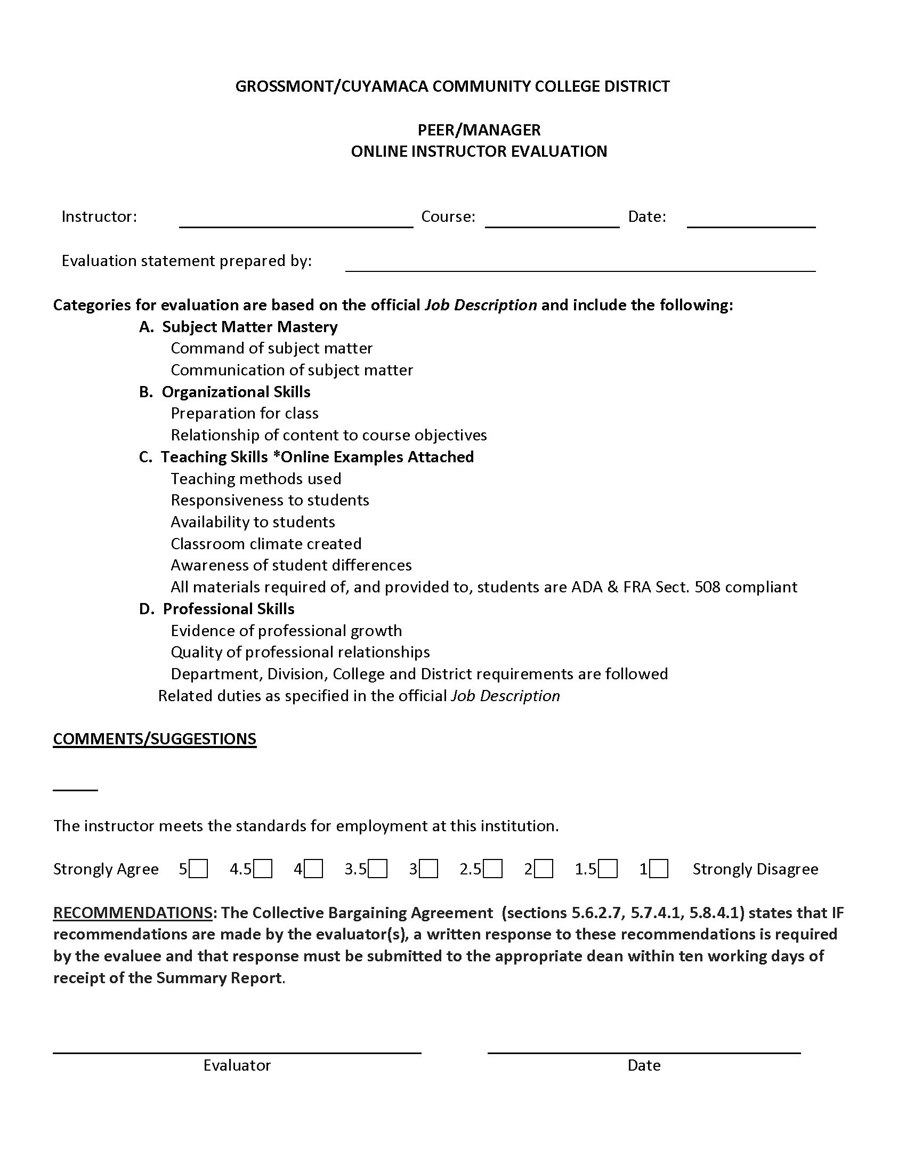
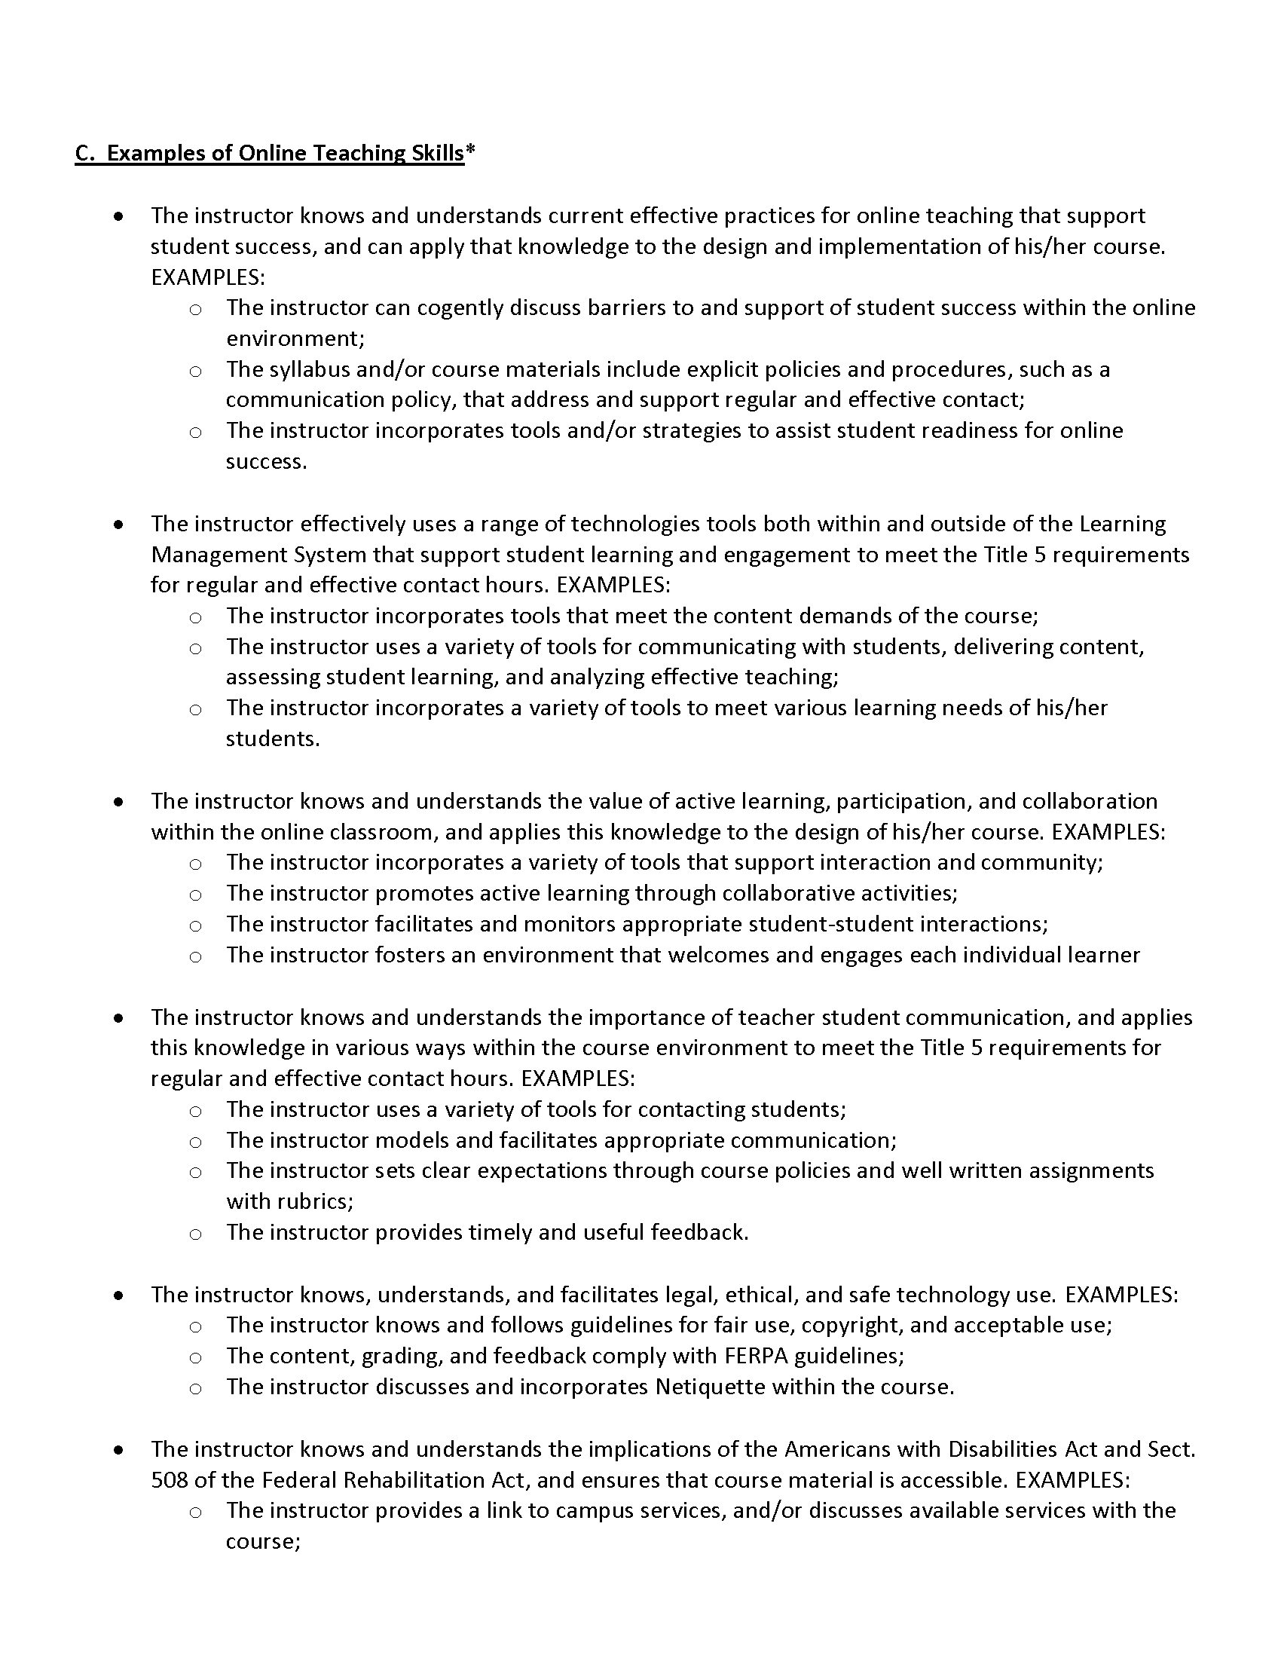
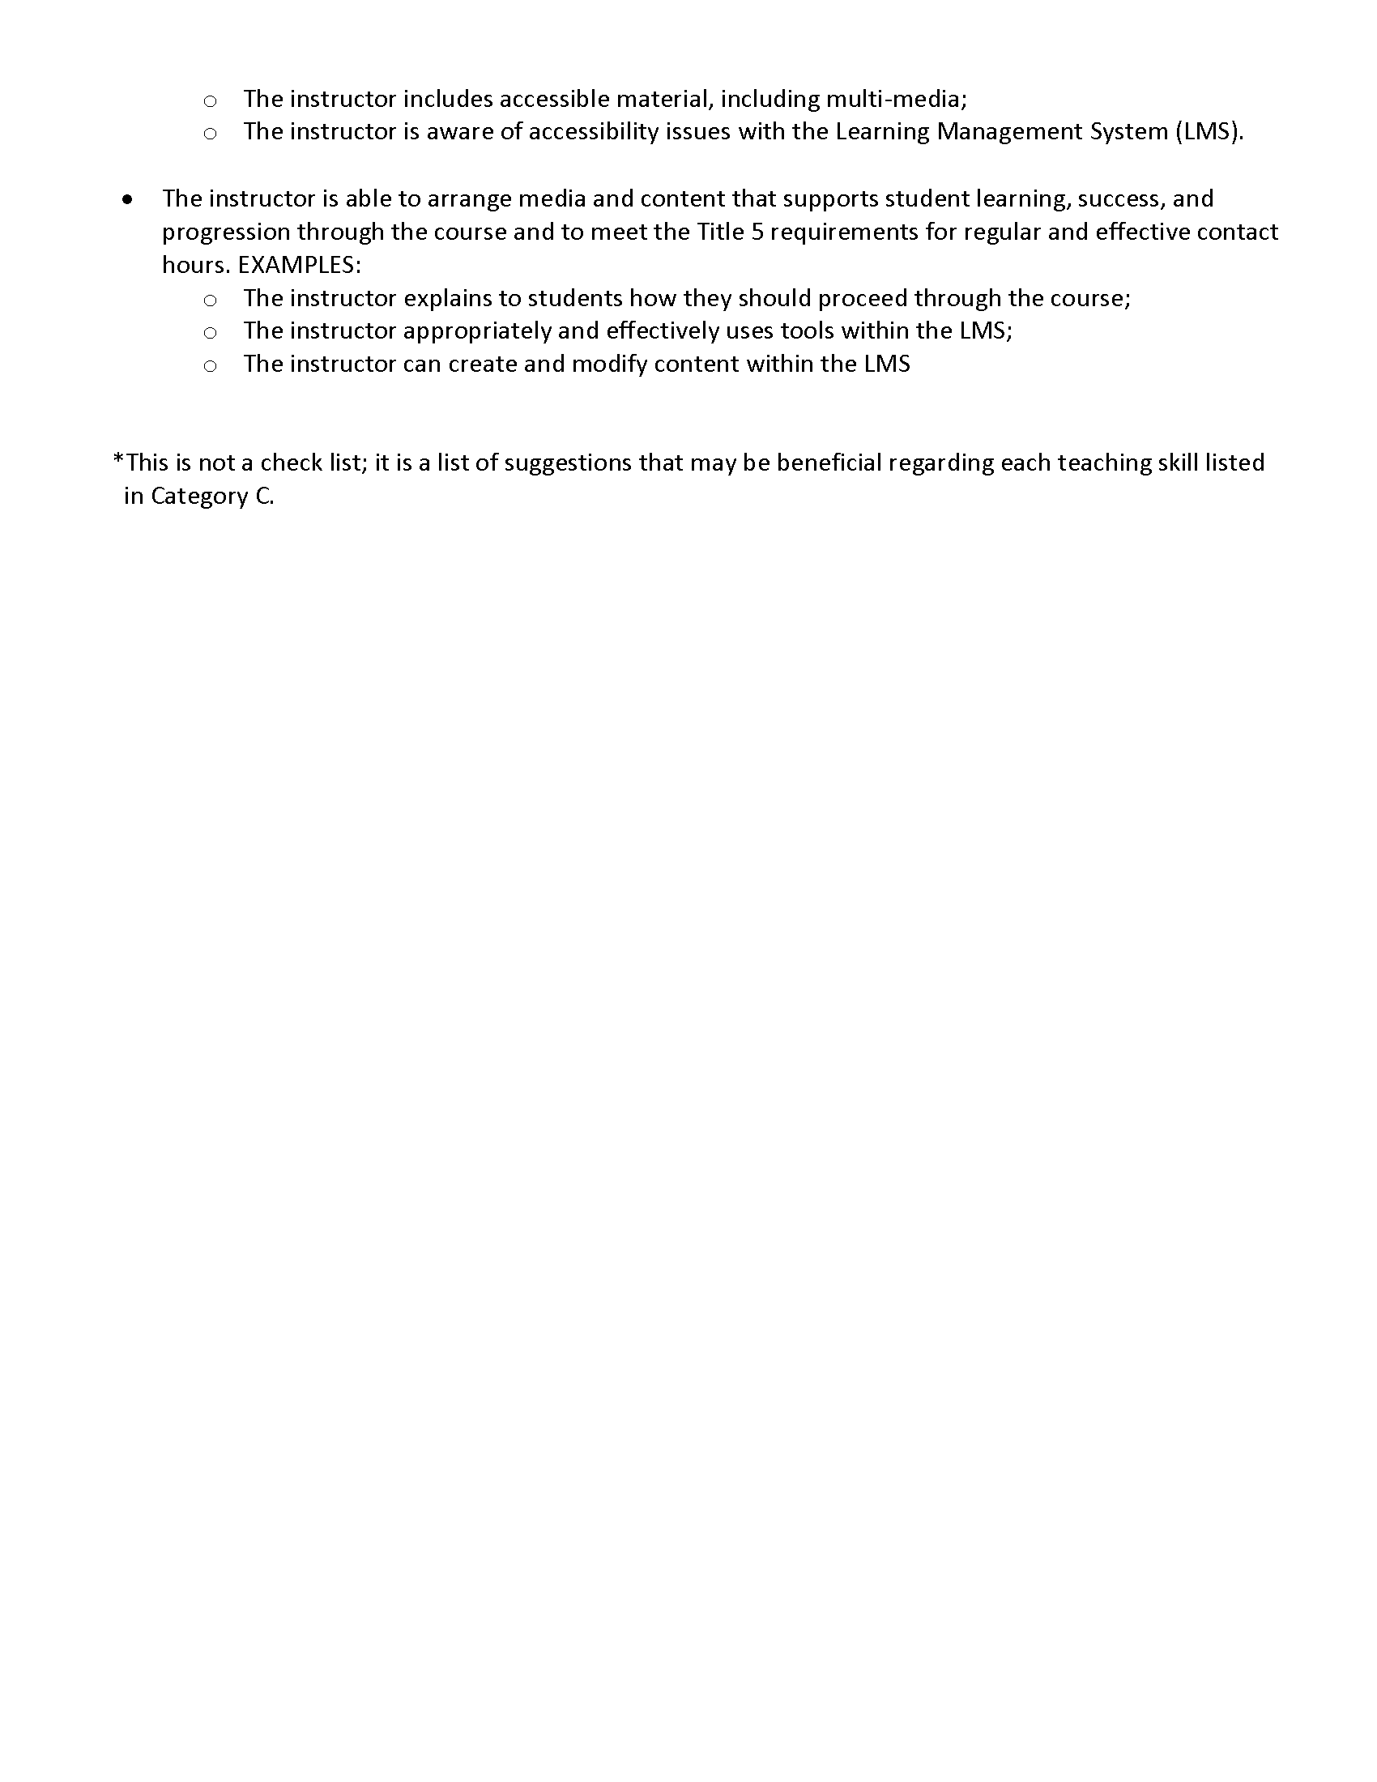

APPENDIX D – REASSIGNED TIME AND STIPENDS FOR DEPARTMENT CHAIRS AND PROGRAM COORDINATORS

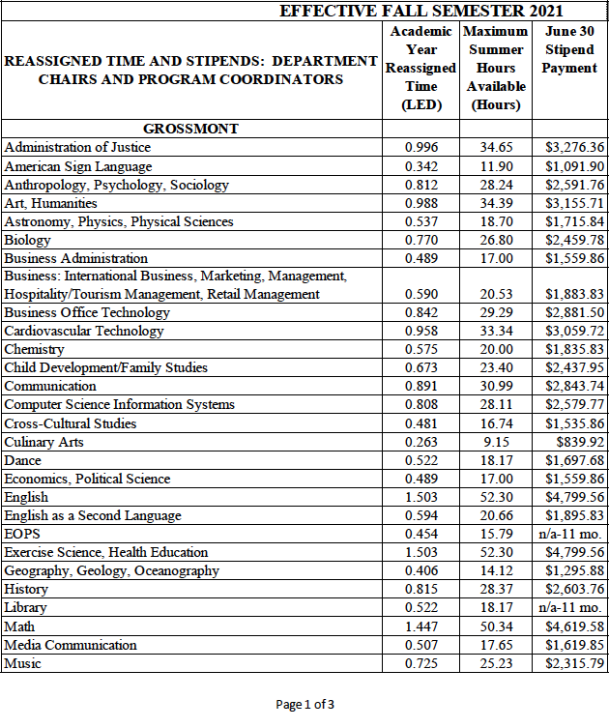
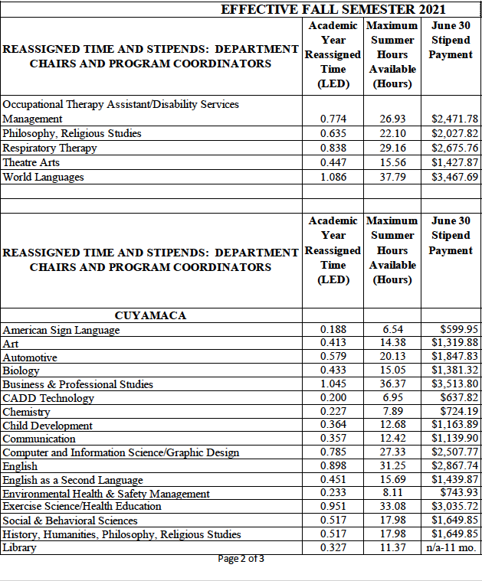
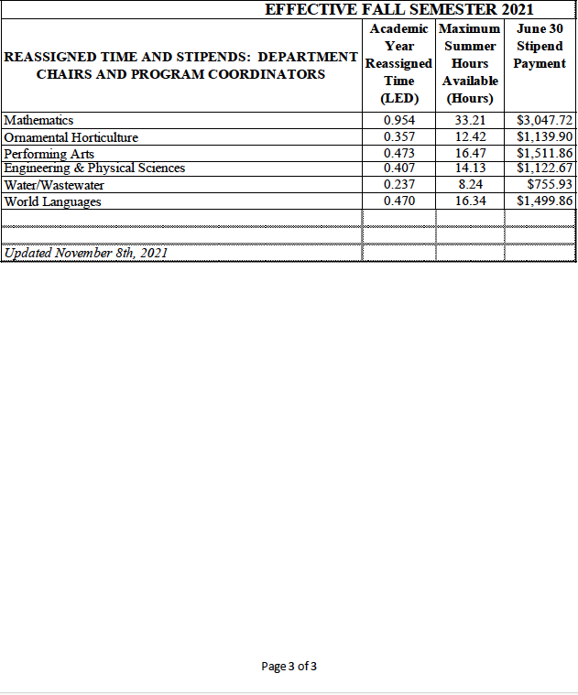

SUMMER/INTERSESSION CHAIR/COORDINATOR COMPENSATION FORM

For chair/coordinator work outside of the contract year.

Complete this form and submit to your Dean for approval three weeks prior to the start date of your proposed activity.

DEPARTMENT:

CHAIR/COORDINATOR NAME:

The maximum number of hours available per fiscal year as compensation for summer/intersession chair and coordinator work is based on the preceding chart under the column entitled “Maximum Summer/Intersession Hours Available.” Compensation is at the chair/coordinator’s non-classroom hourly rate of pay.

Description of proposed summer/intersession activity:________________________________
_______________________________________________________________________________________________________________________________________________________________________________________________________________________________________________________________________________________________________________________________________________________________________________________________________________________________________________________________________________________________________________________________________________________________________________________________________________________________________________________________________________________________________________________________________________________________________________________________________________________________________________________________________________________________________________________________________________________________________________________________________________

Dean Signature: Date:

Vice President Approval: Date:

President Approval: Date:

APPENDIX E – DISCRETIONARY REASSIGNED TIME

APPLICATION FOR REASSIGNED TIME – DISCRETIONARY ASSIGNMENTS

I. Guidelines

1. Use the form below. Attach additional sheets if necessary.

2. The application should be routed as follows:

a. Initiated by Department Chair/Program Coordinator/Faculty Applicant

b. Appropriate Next Level Administrator

c. Consultation between the Chair, Coordinator, Faculty Applicant and the appropriate Administrator

d. Appropriate Vice President

e. President

f. District Reassigned Time Review Committee (DRTRC) for final approval.

3. AFT and the District expect that consultation between the faculty member who will be accepting the assignment and the appropriate administrators will have occurred before the application is presented to DRTRC for review.

4. Total of load and FTEF value of all reassigned time cannot exceed 1.0 FTEF.

5. Discretionary assignments should be appropriate to the position description in the Appendix of the AFT/GCCCD Agreement.

6. As a reference please note that a 0.20 FTEF assignment equals 105 hours of work for the semester (based on 30 hours per week x 17.5 weeks = 1.0 FTEF).

7. Reassigned time is necessary when the scope of the assignment is such that it cannot be completed during the time set aside for other professional activities during unscheduled hours and requires that the faculty member be released from their regular teaching, counseling or librarian load to complete the assignment.

II. Approval Signatures:

Department Chair/Coordinator Date

Appropriate Administrator Date

Appropriate Vice President Date

President Date

APPENDIX F – APPLICATIONS FOR SALARY ADVANCEMENT

Group A - Depth & Breadth
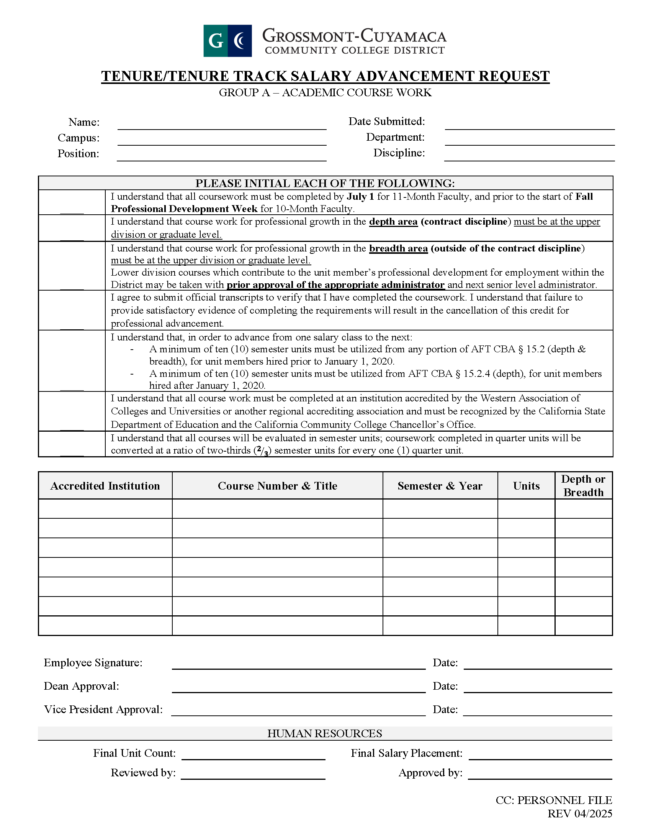

Group B – Professional Growth Activities
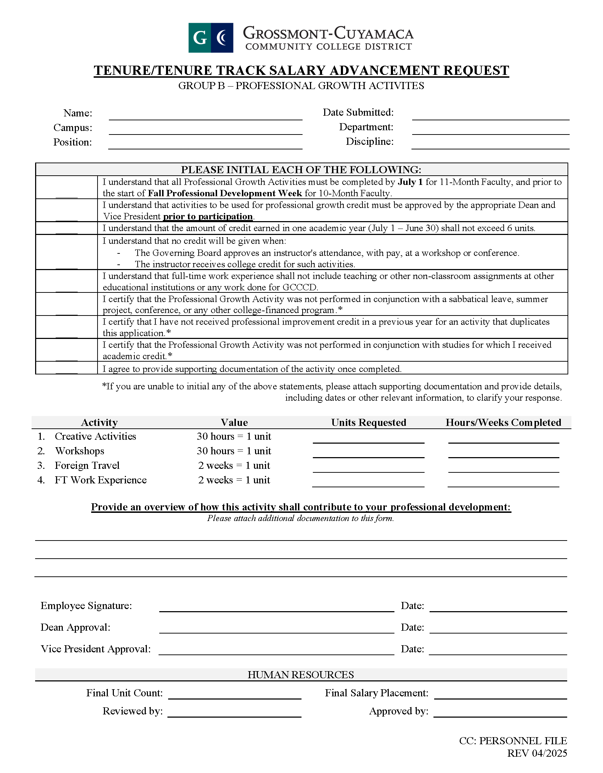

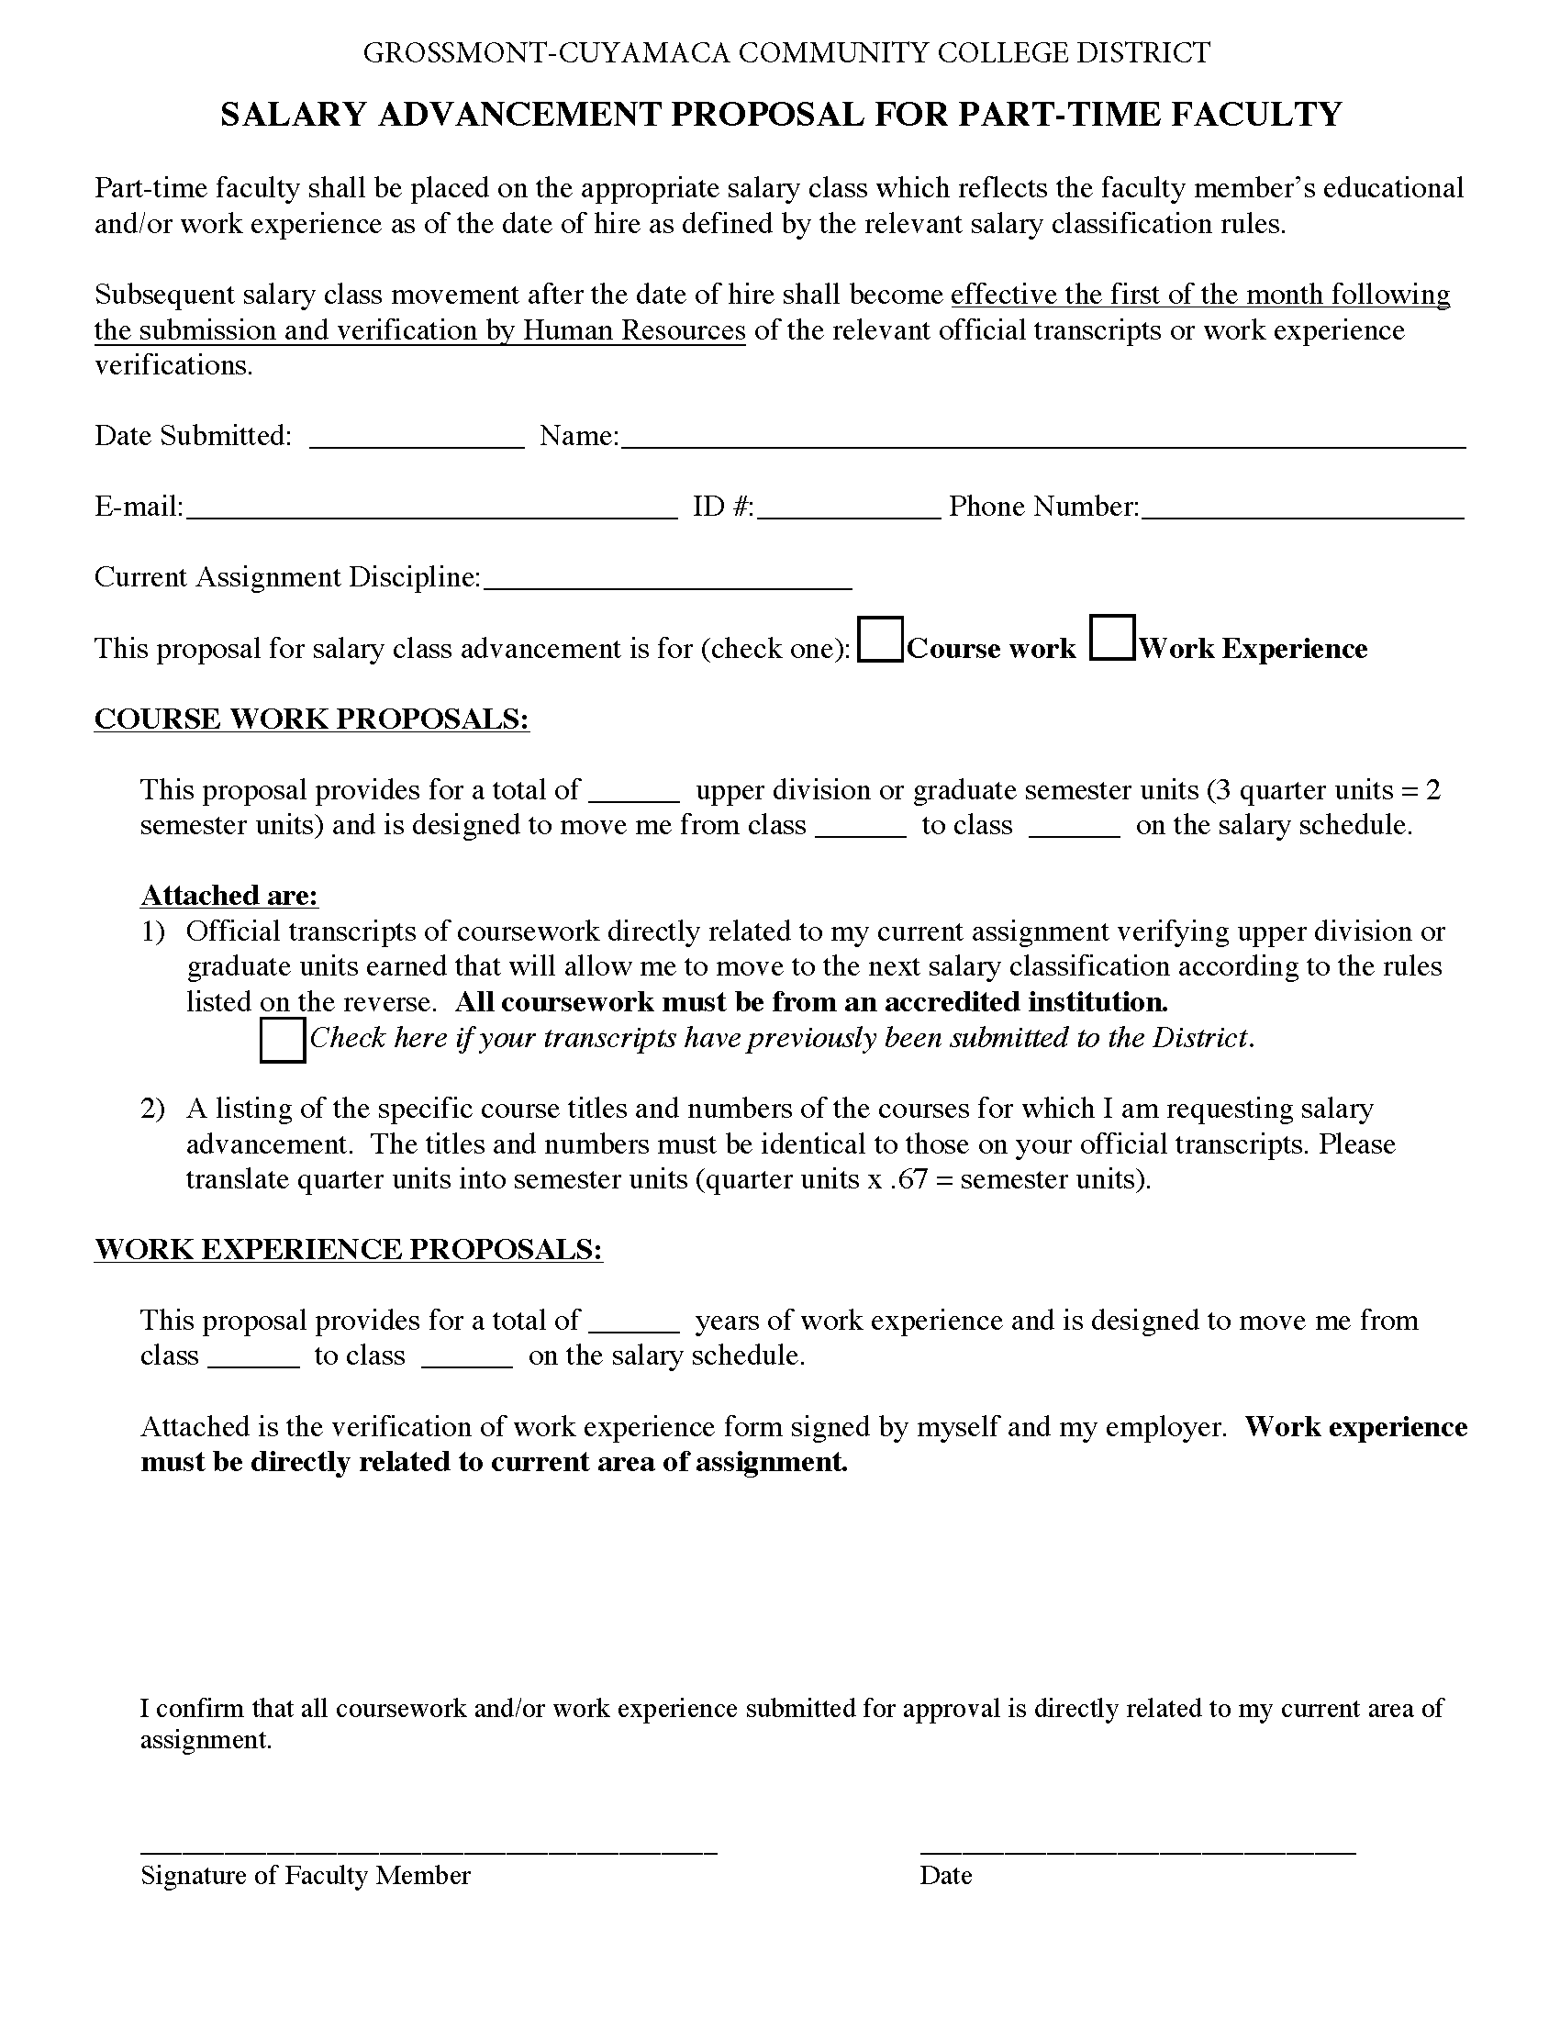
Adjunct Faculty: Salary Advancement Forms


APPENDIX G – UNIT MEMBER JOB DESCRIPTIONS

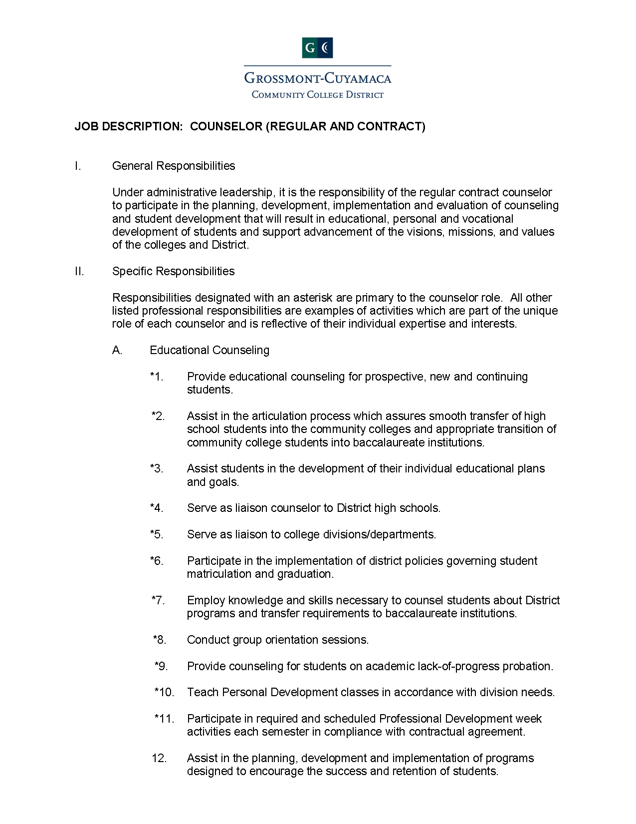
Counselor Job Description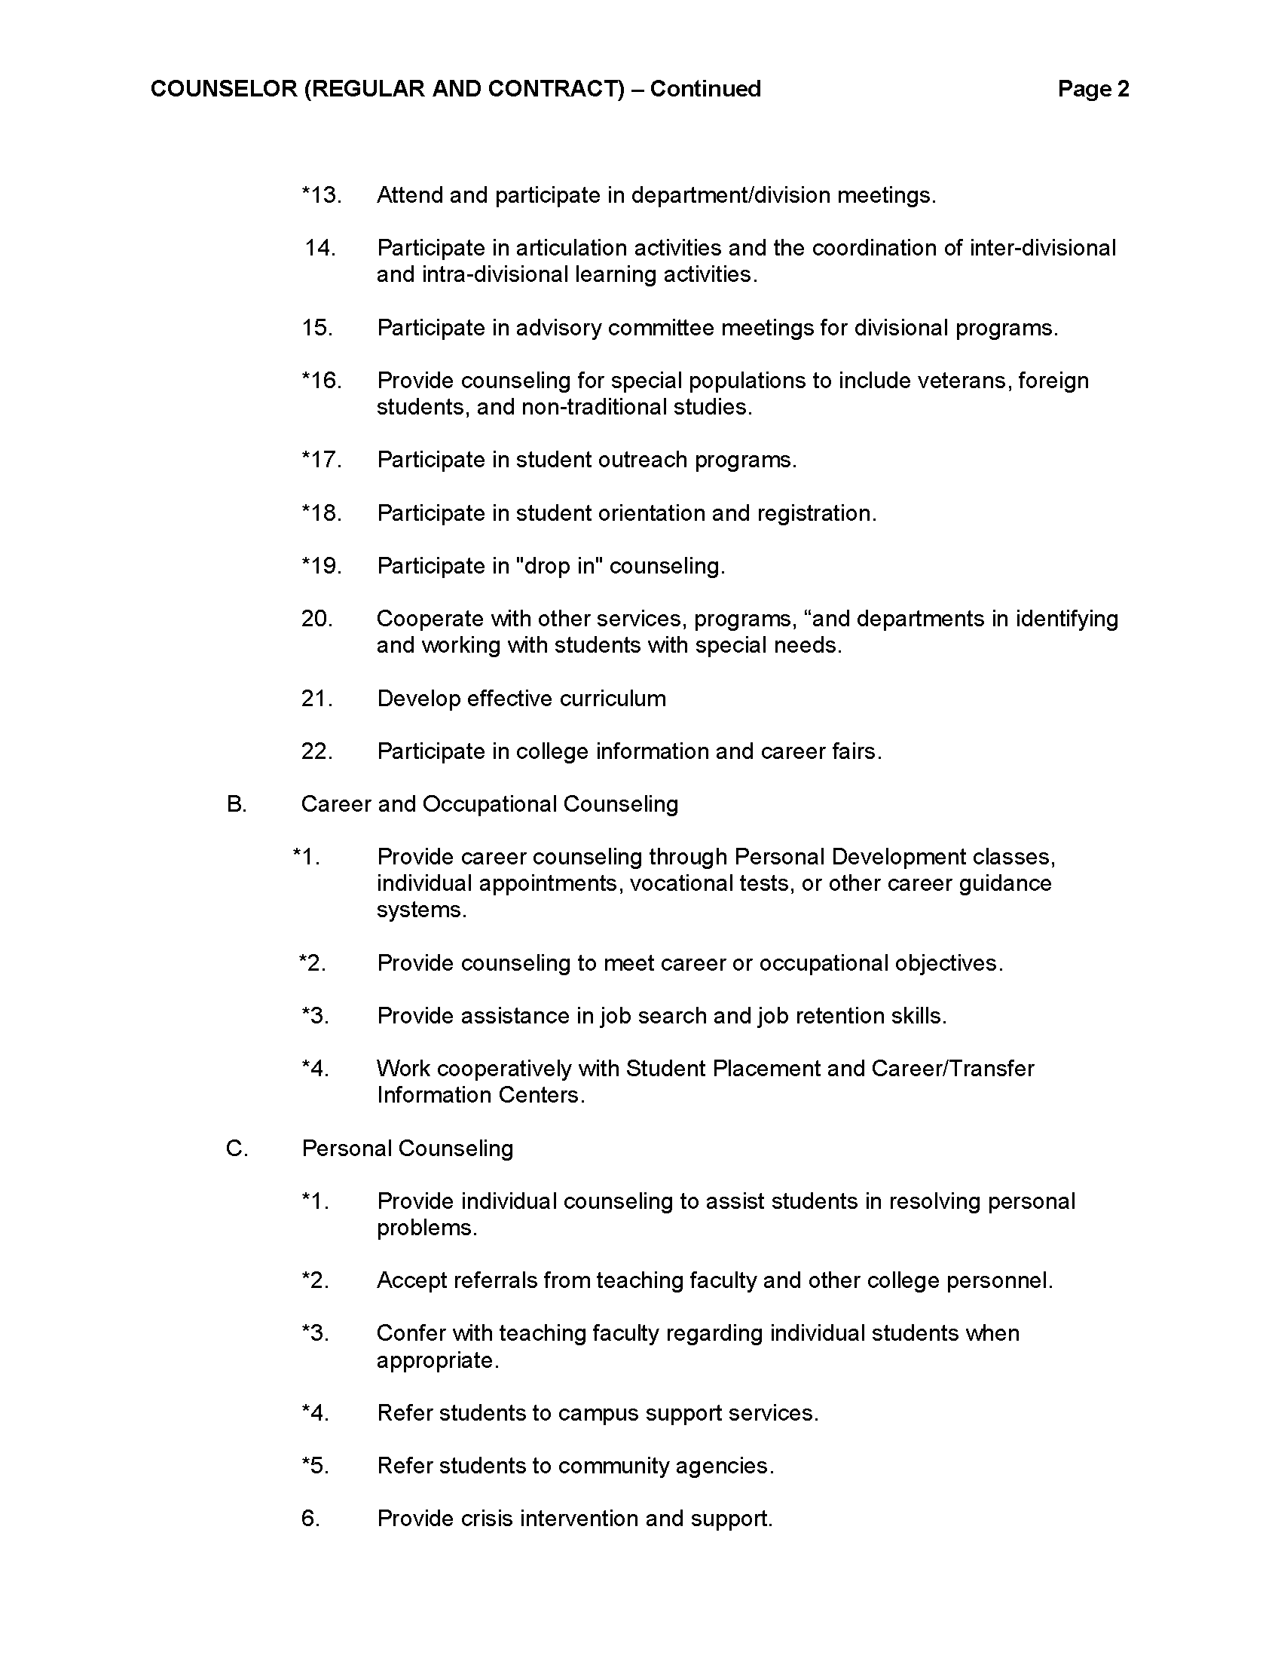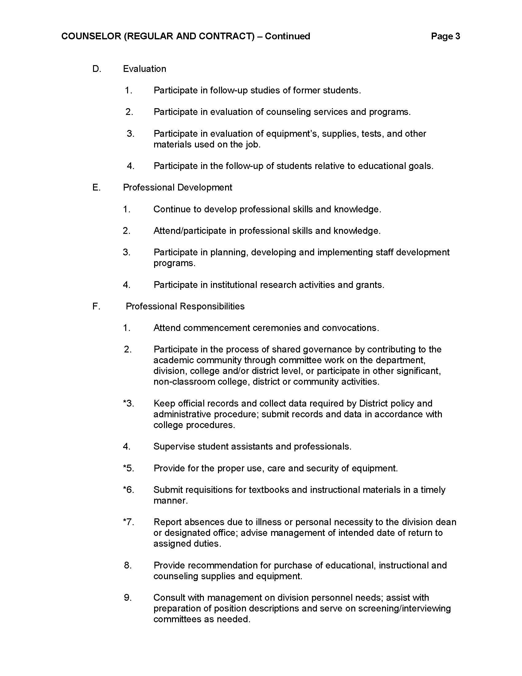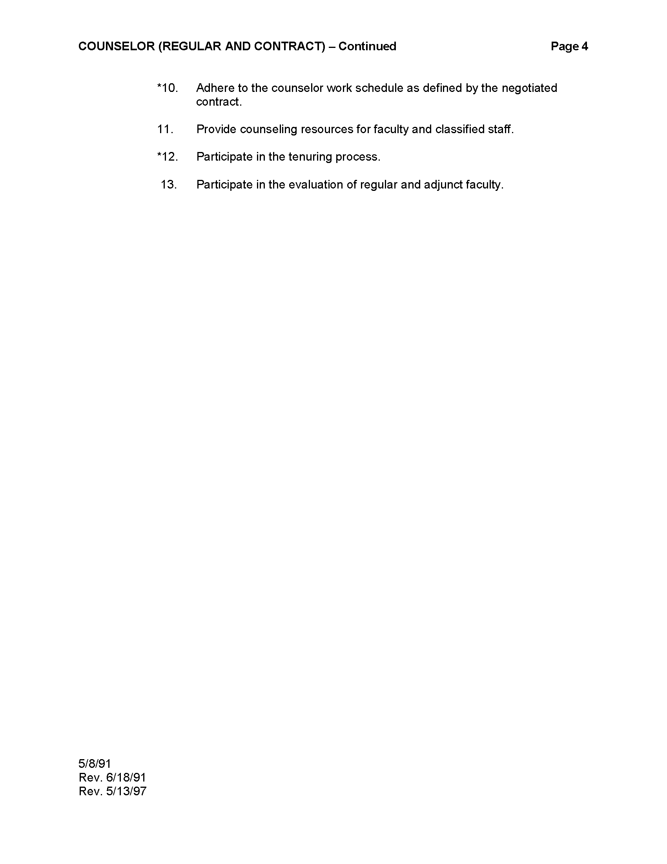

Instructor Full-Time Job Description
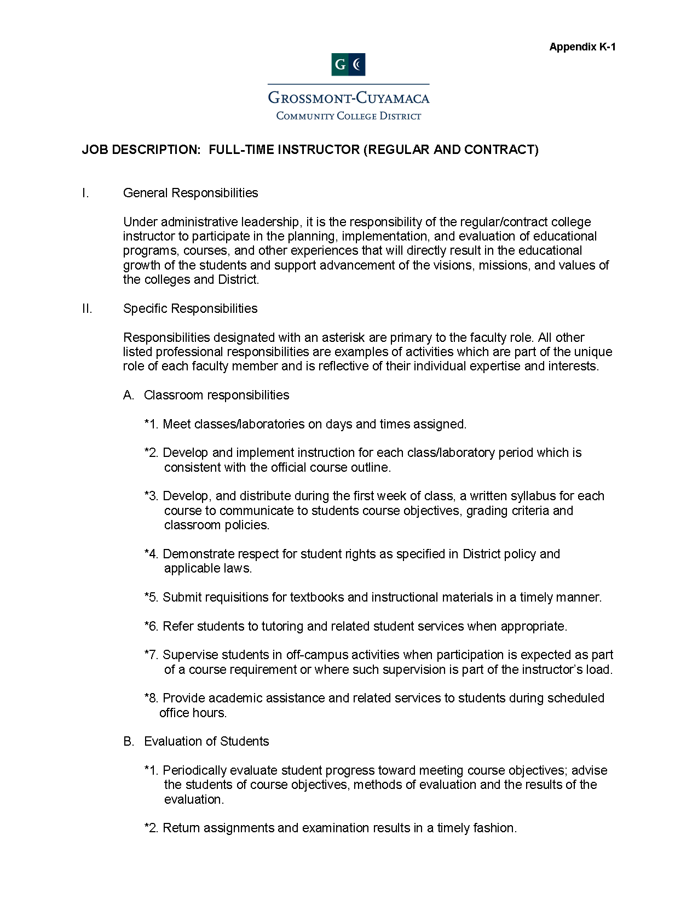
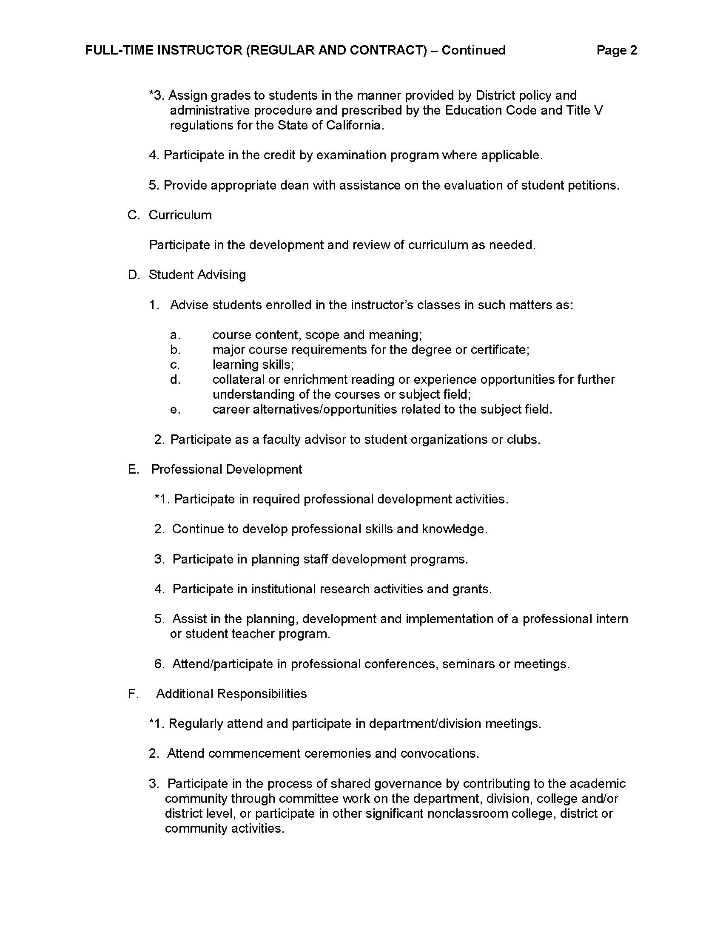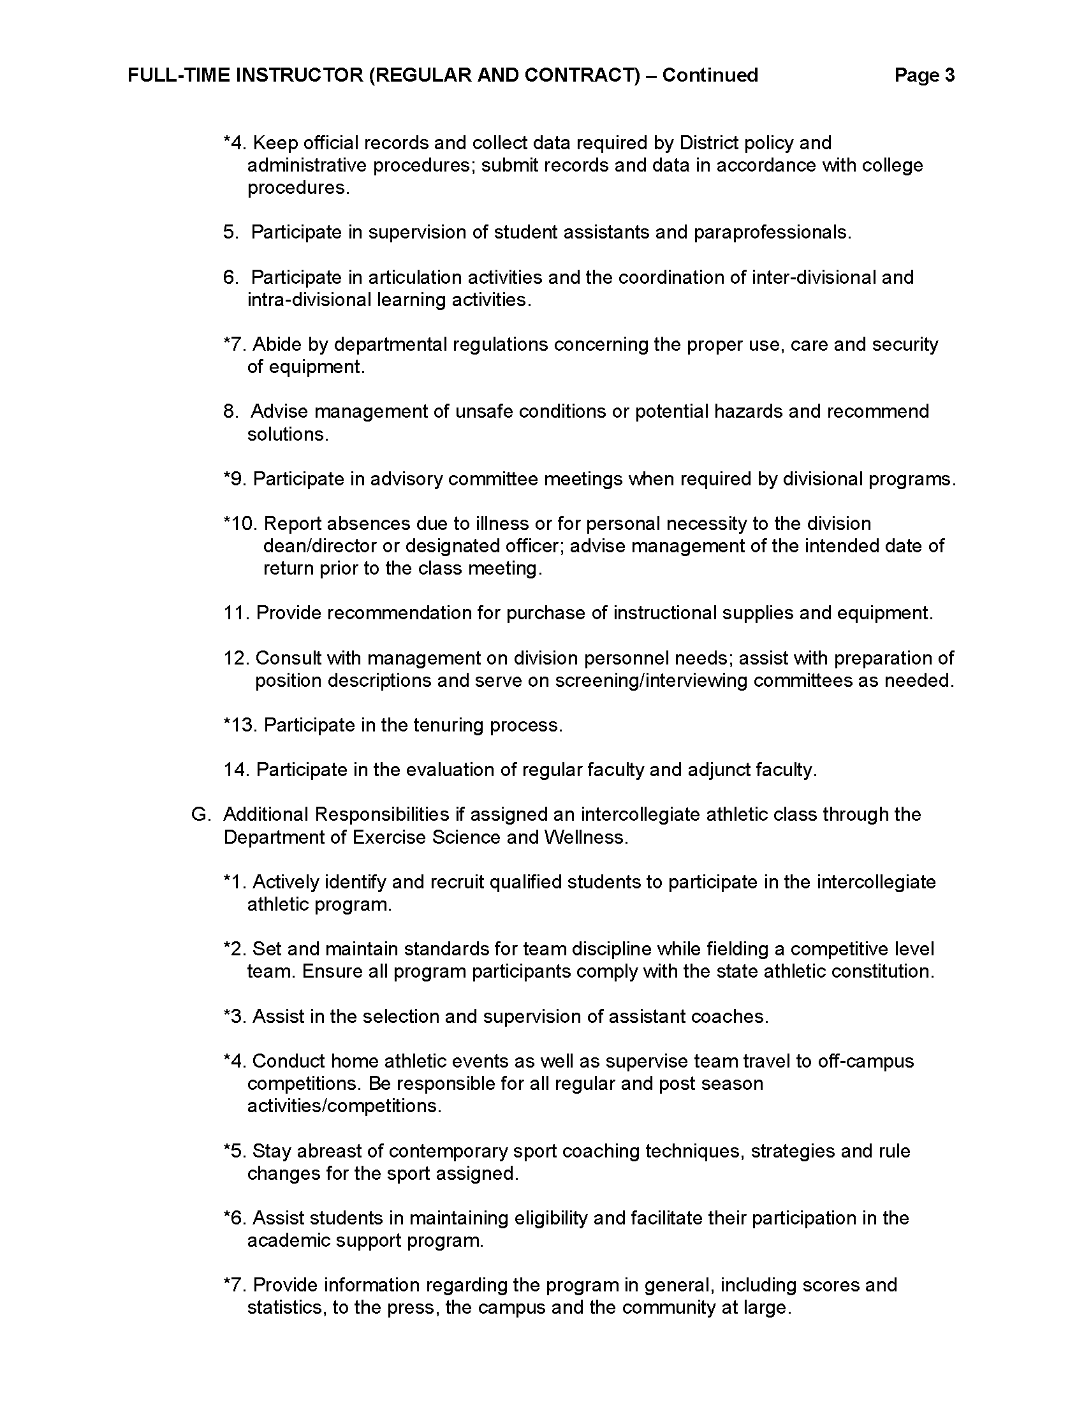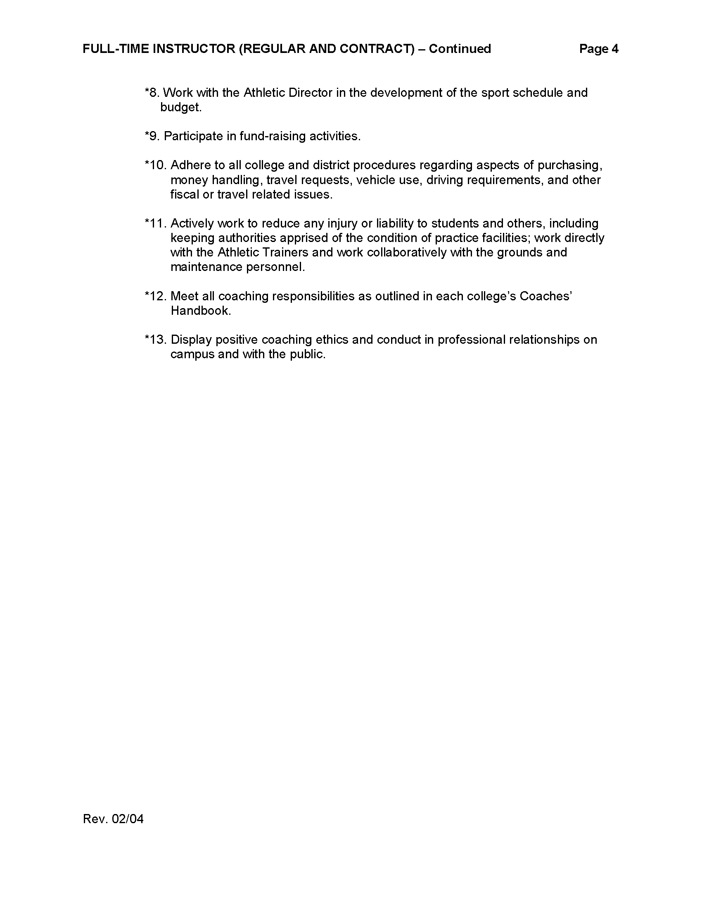

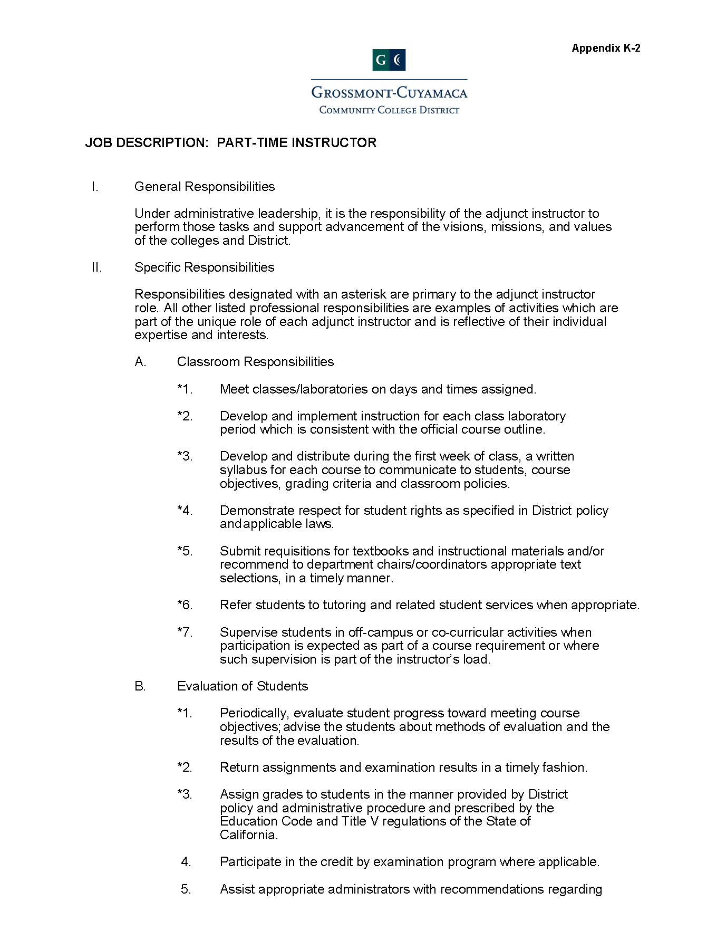
Instructor Part-Time Job Description
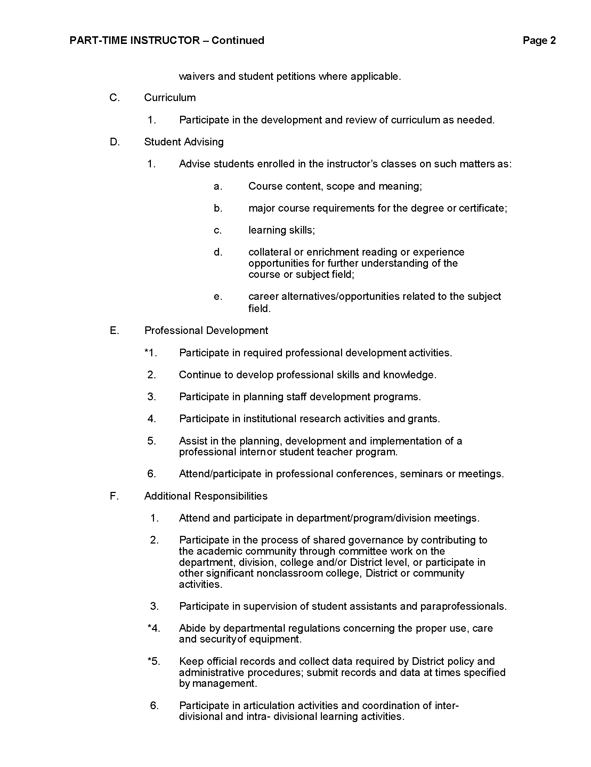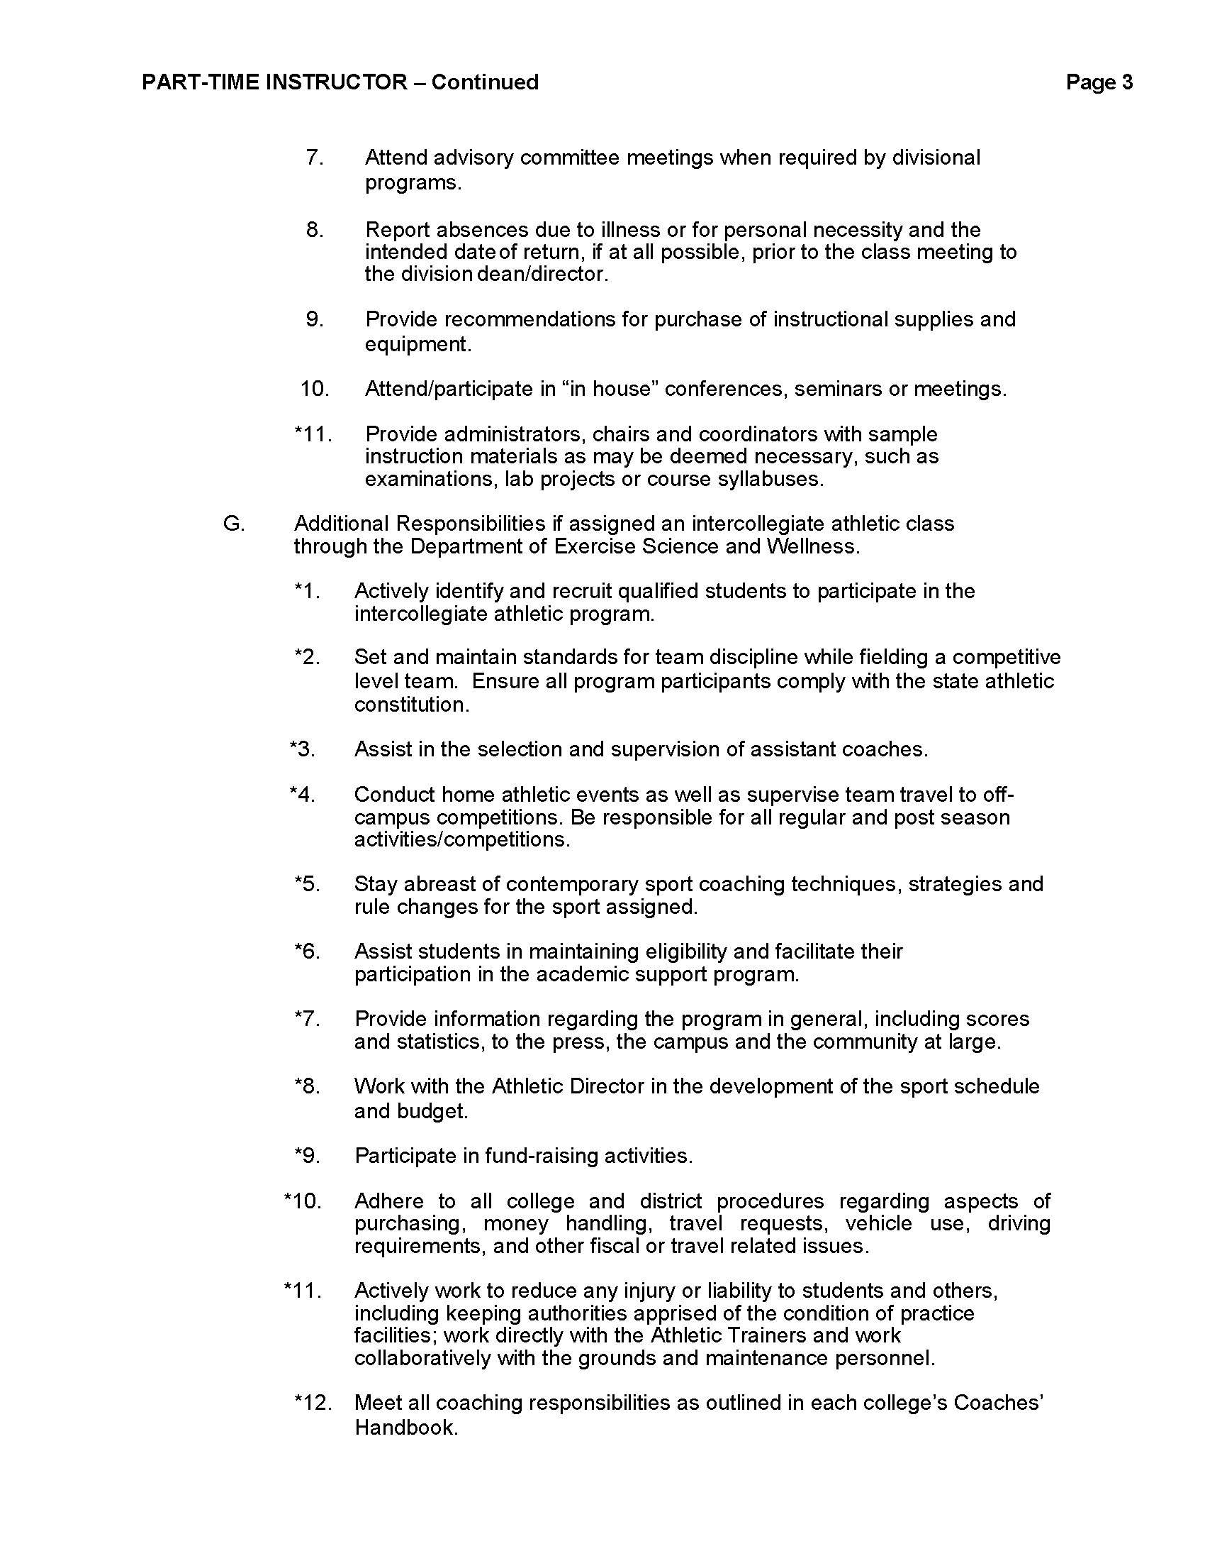

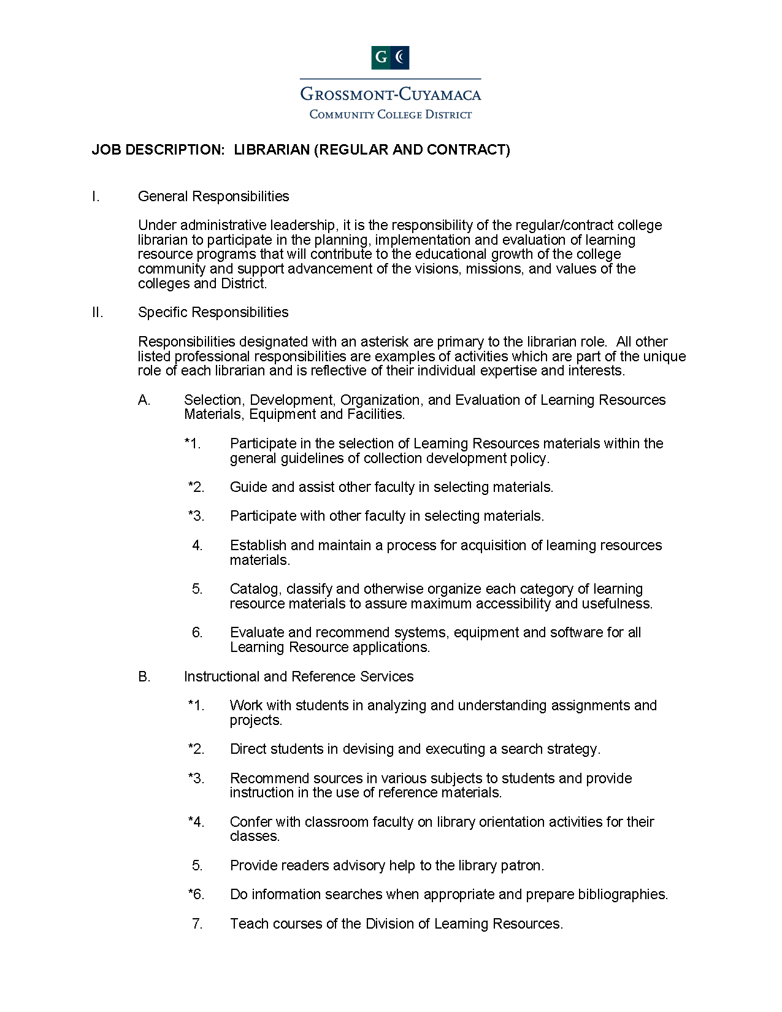
Librarian Job Description
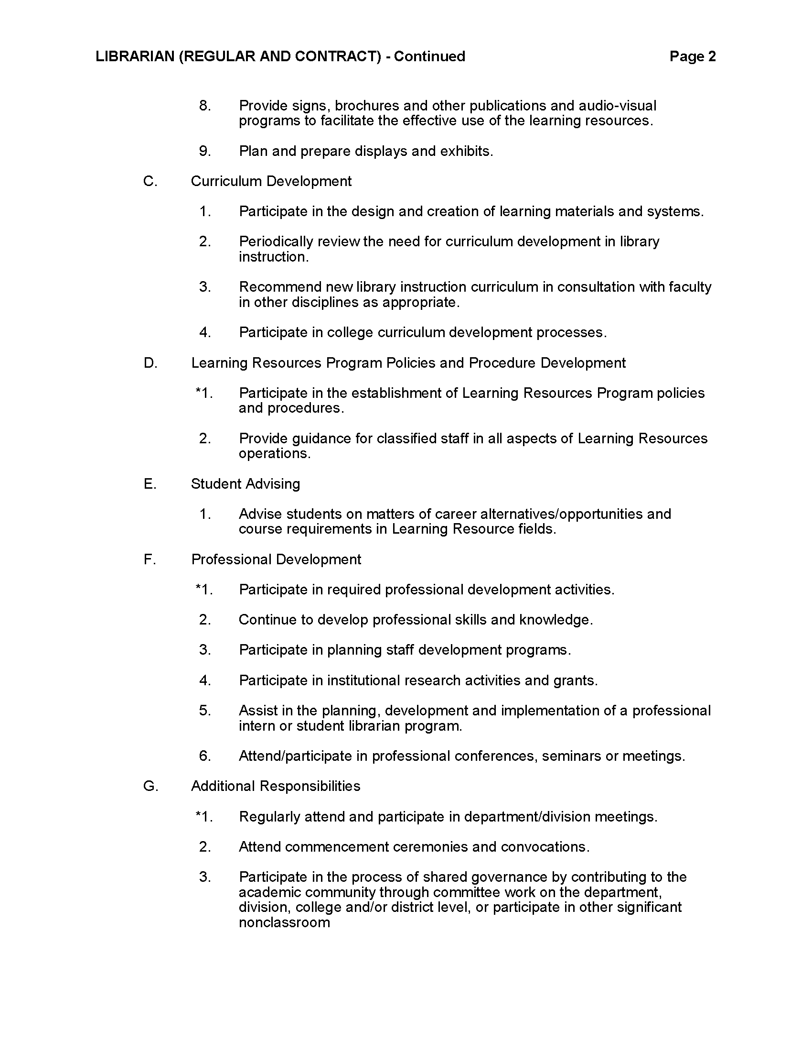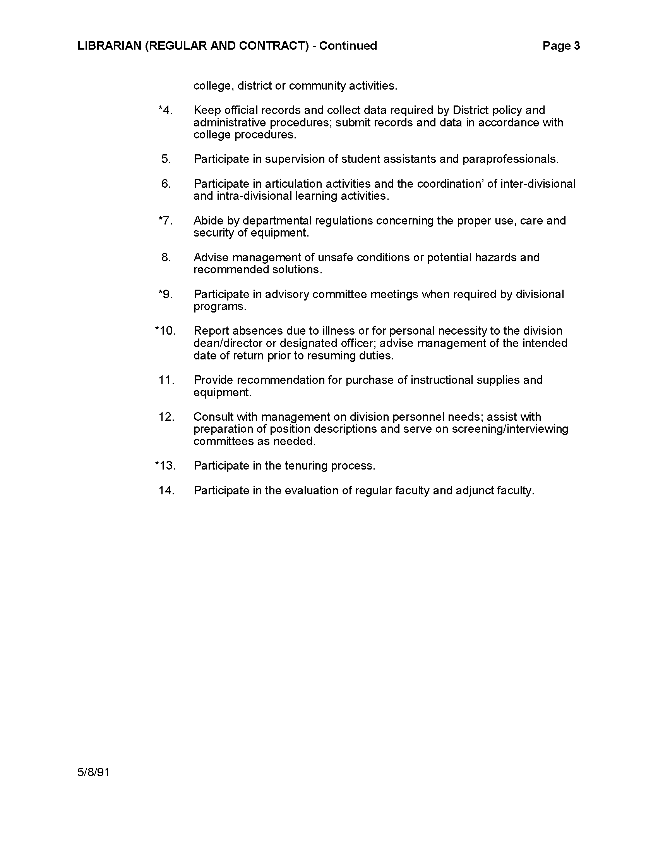

Career Counselor

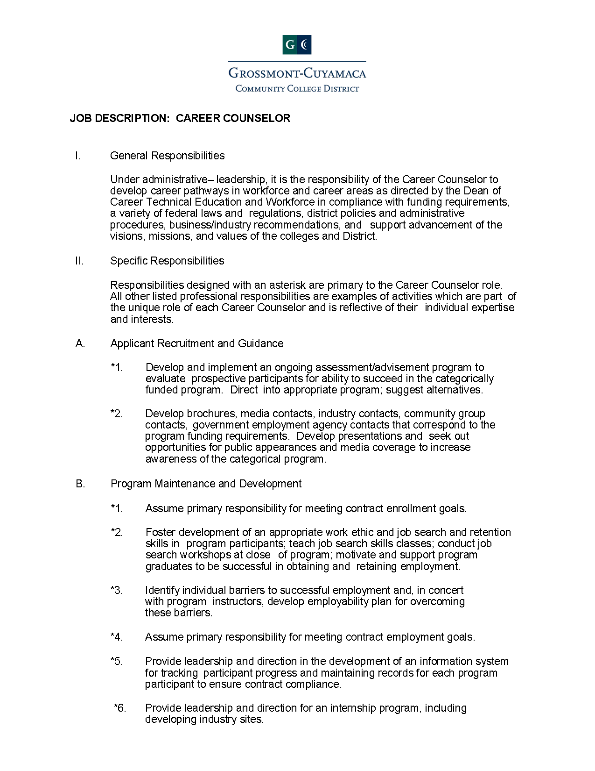
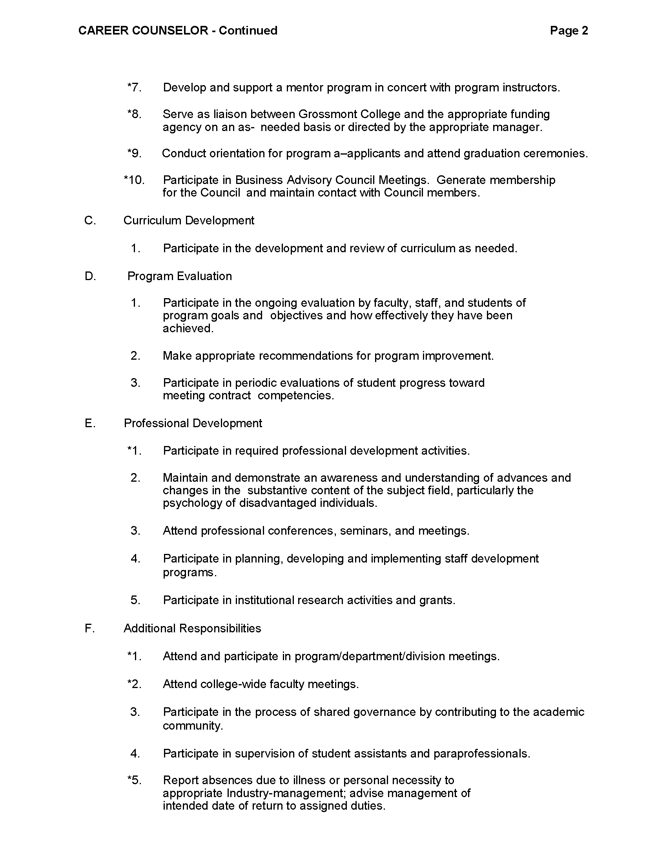

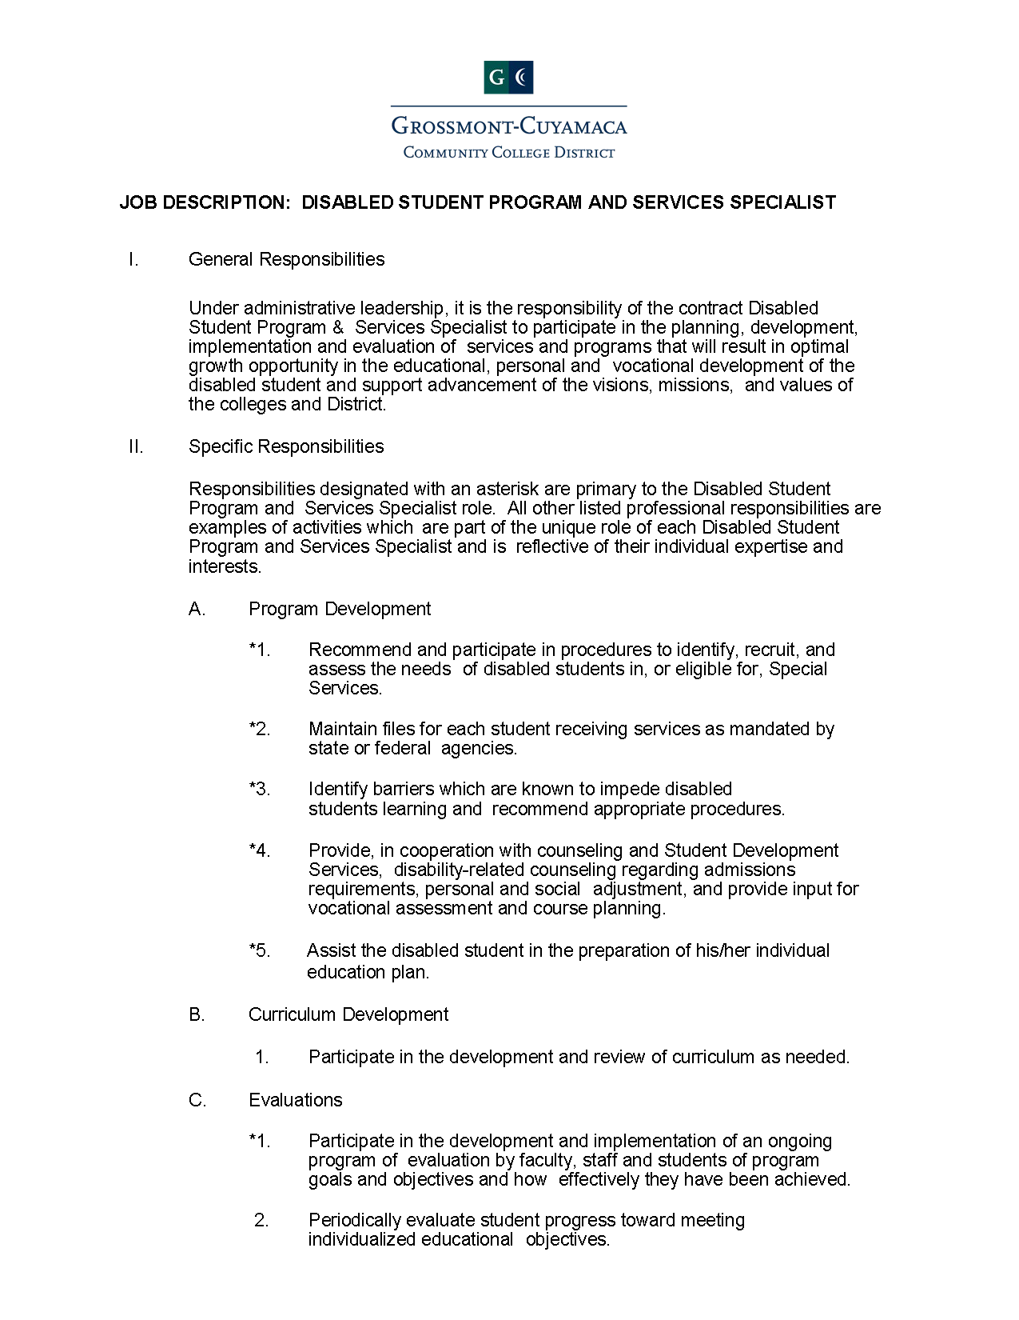
Disabled Student Program and Services Specialist
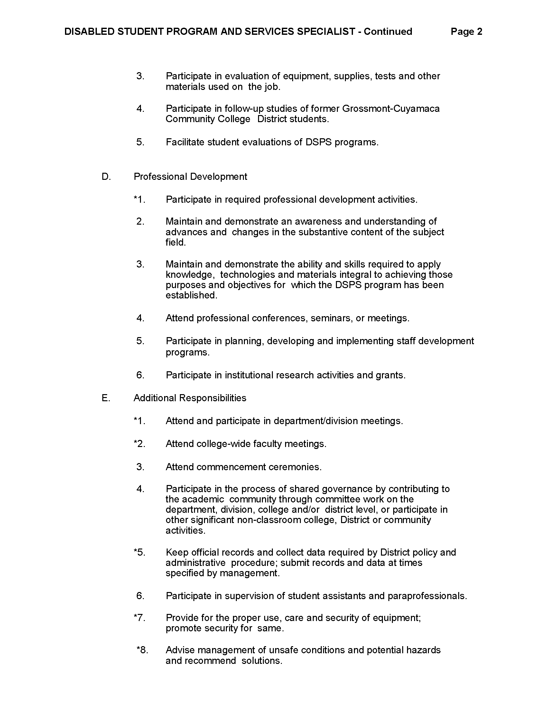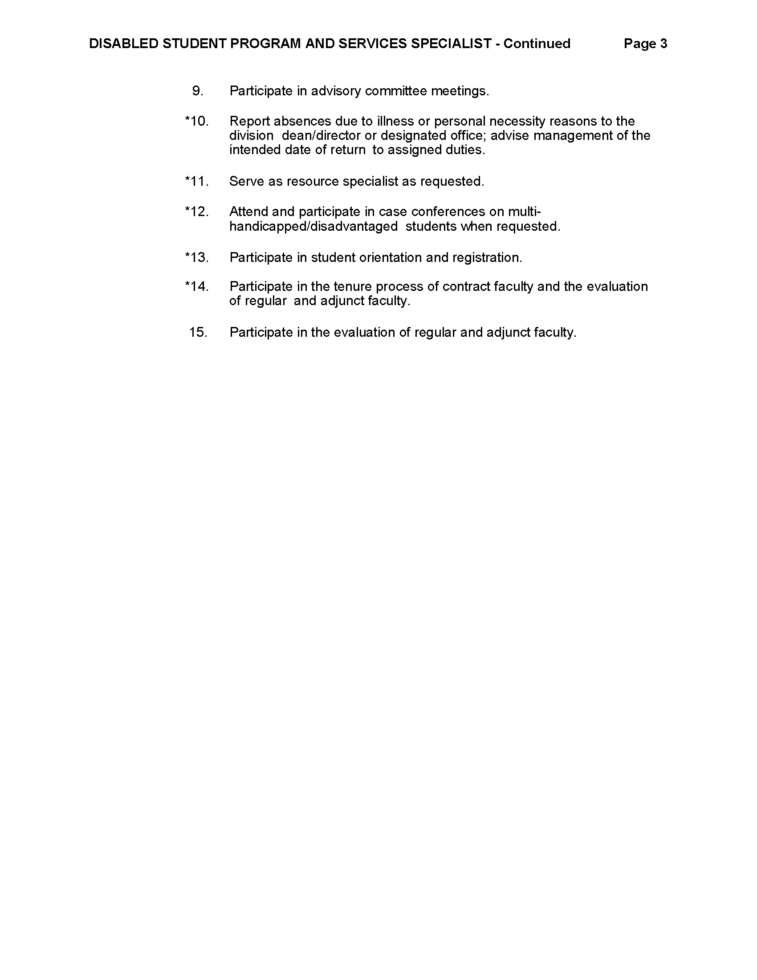

Department Chair
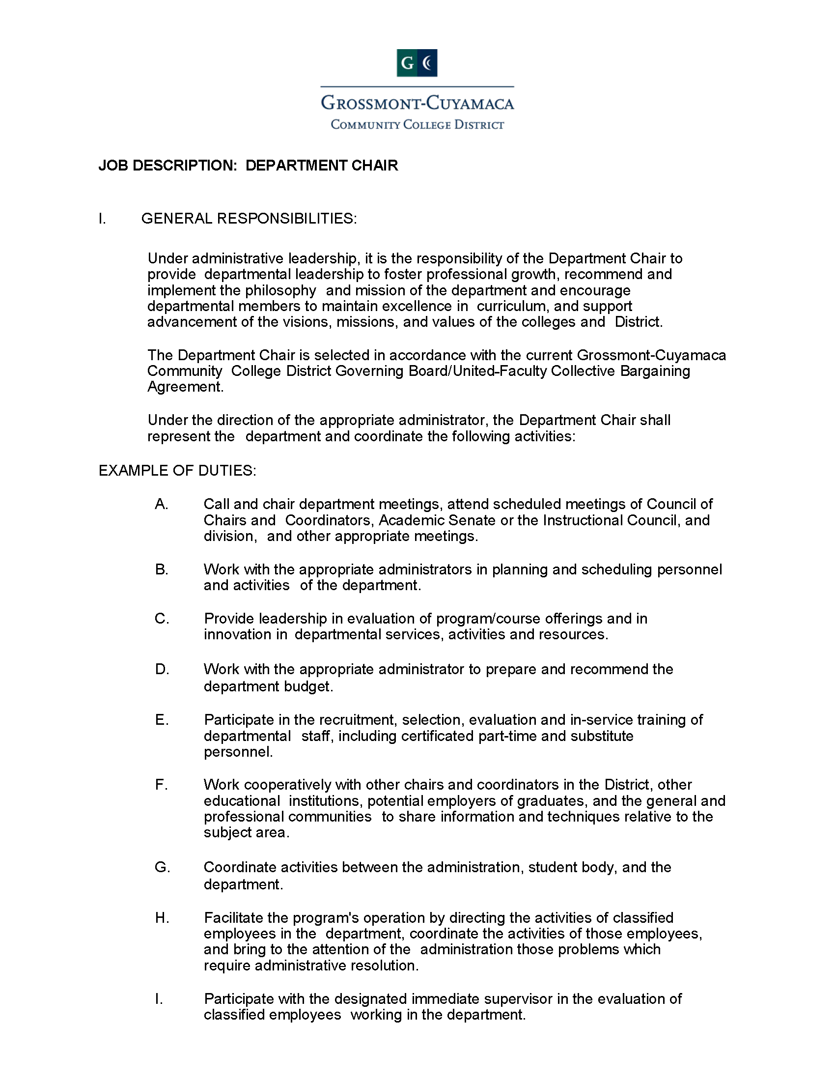
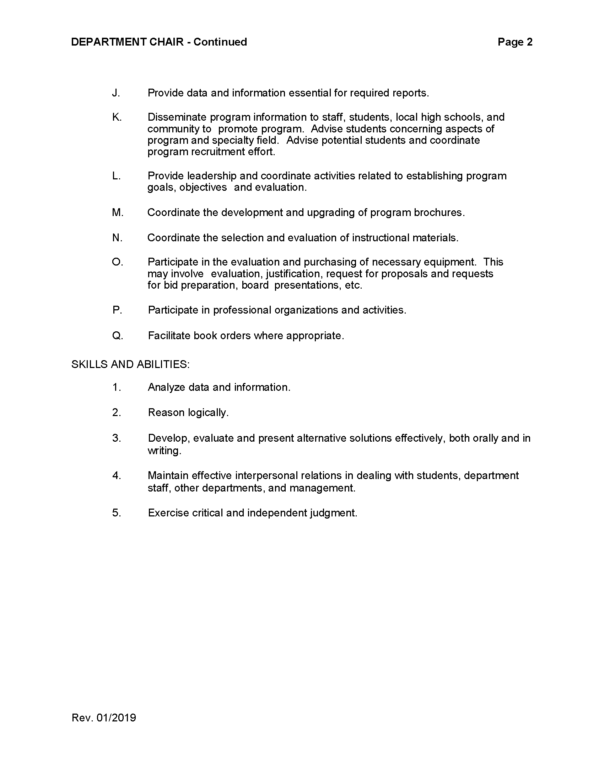

Instructional Program Coordinator
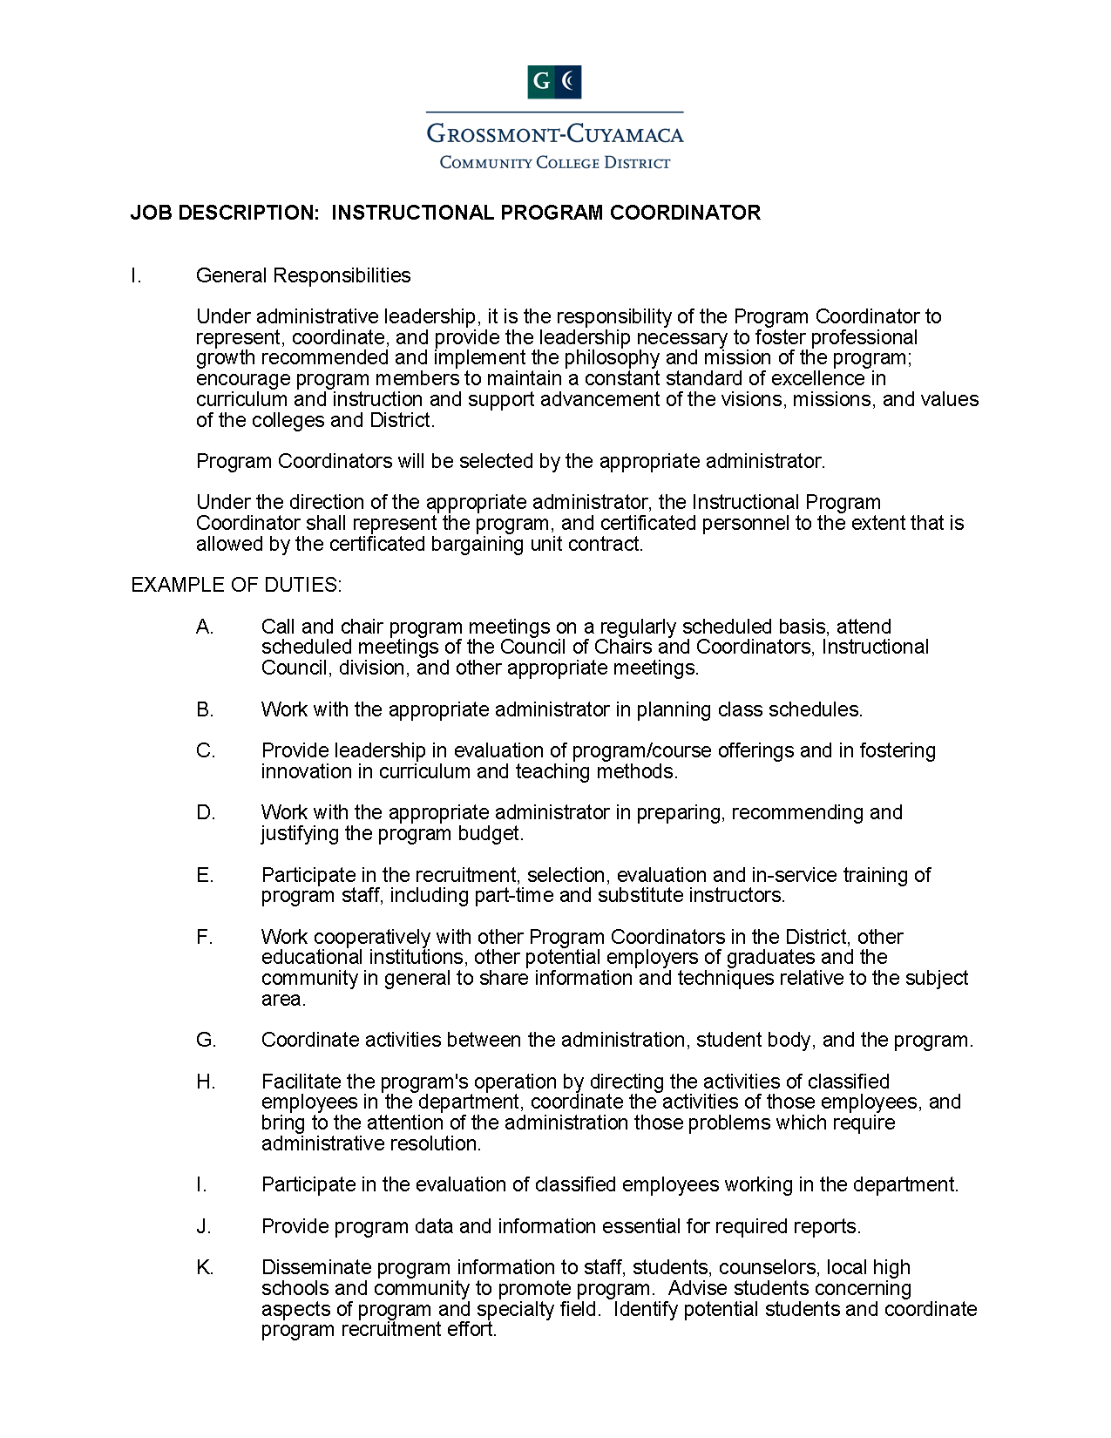
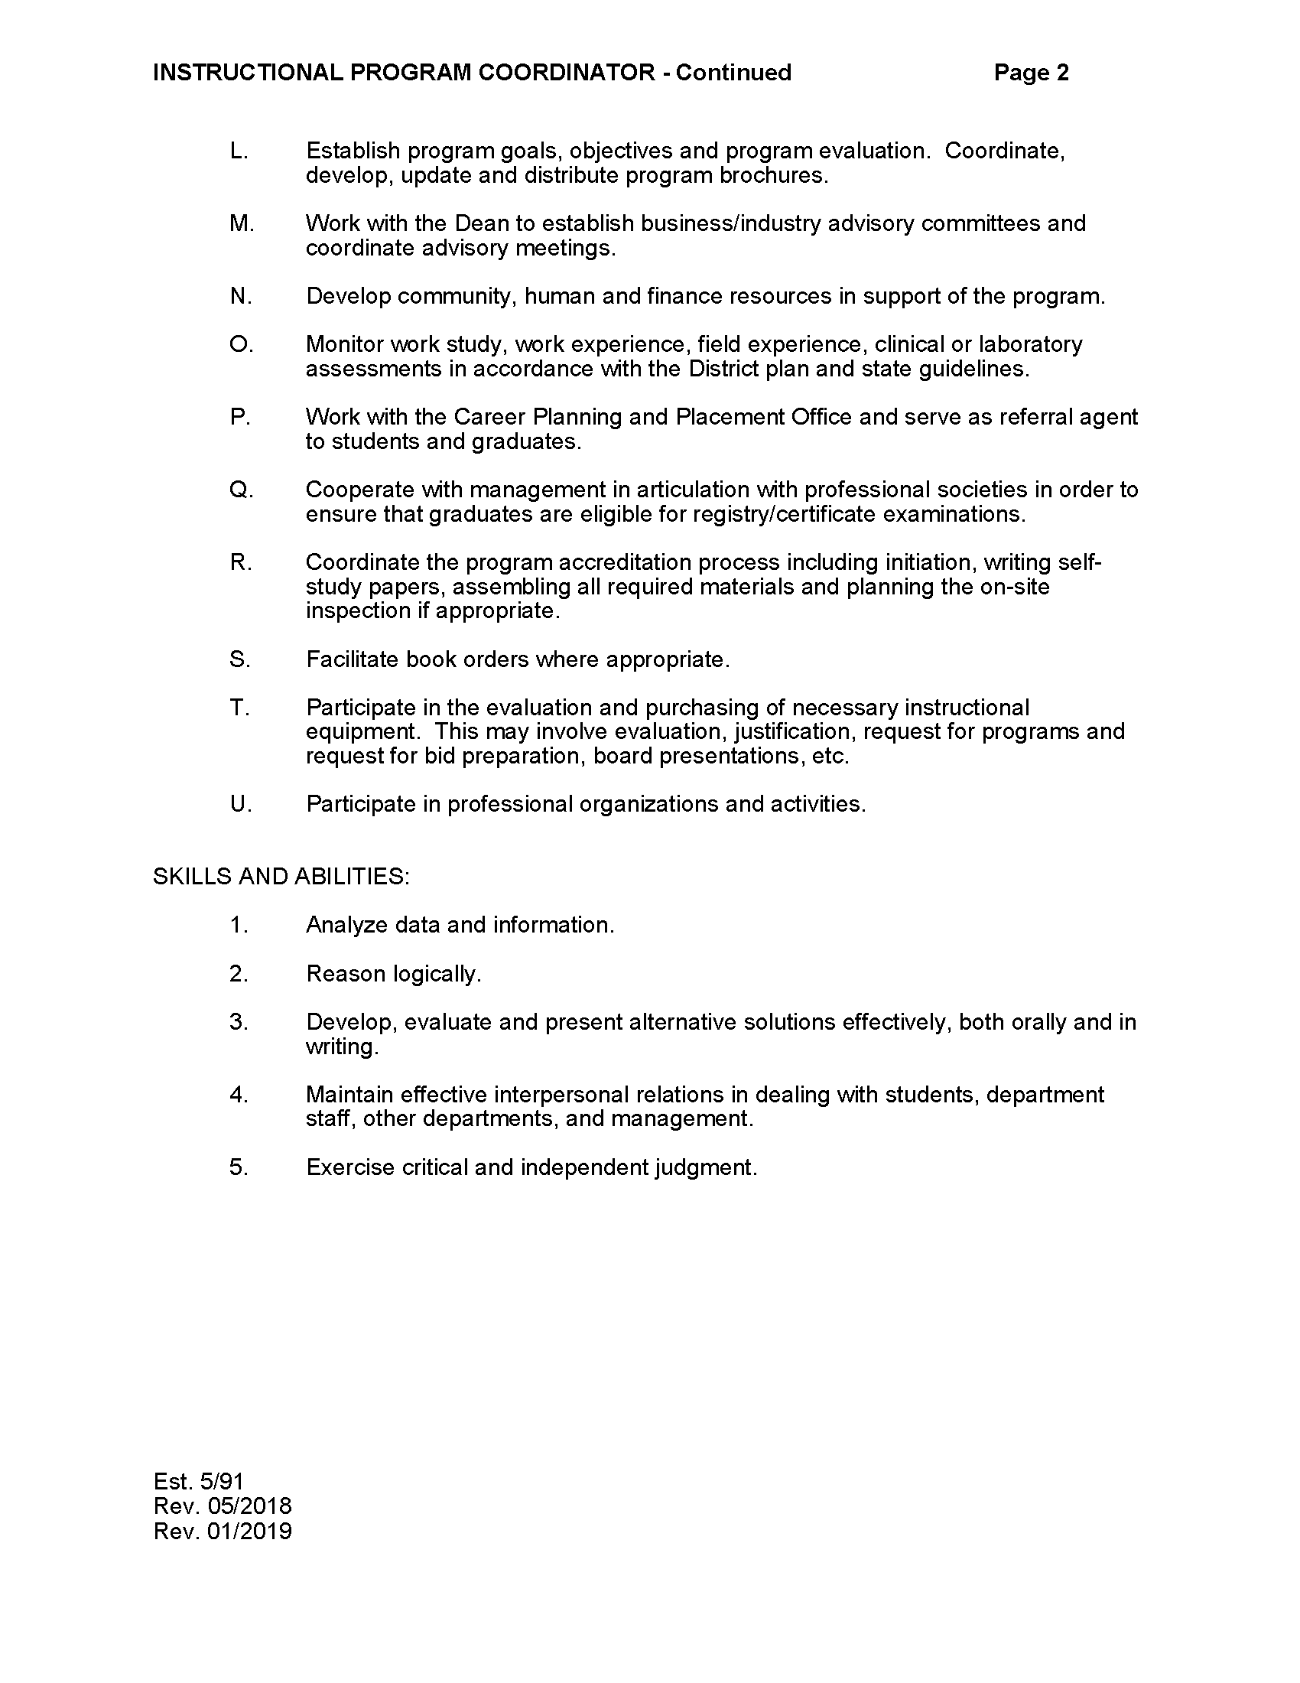

CARE/New Horizons Program Specialist
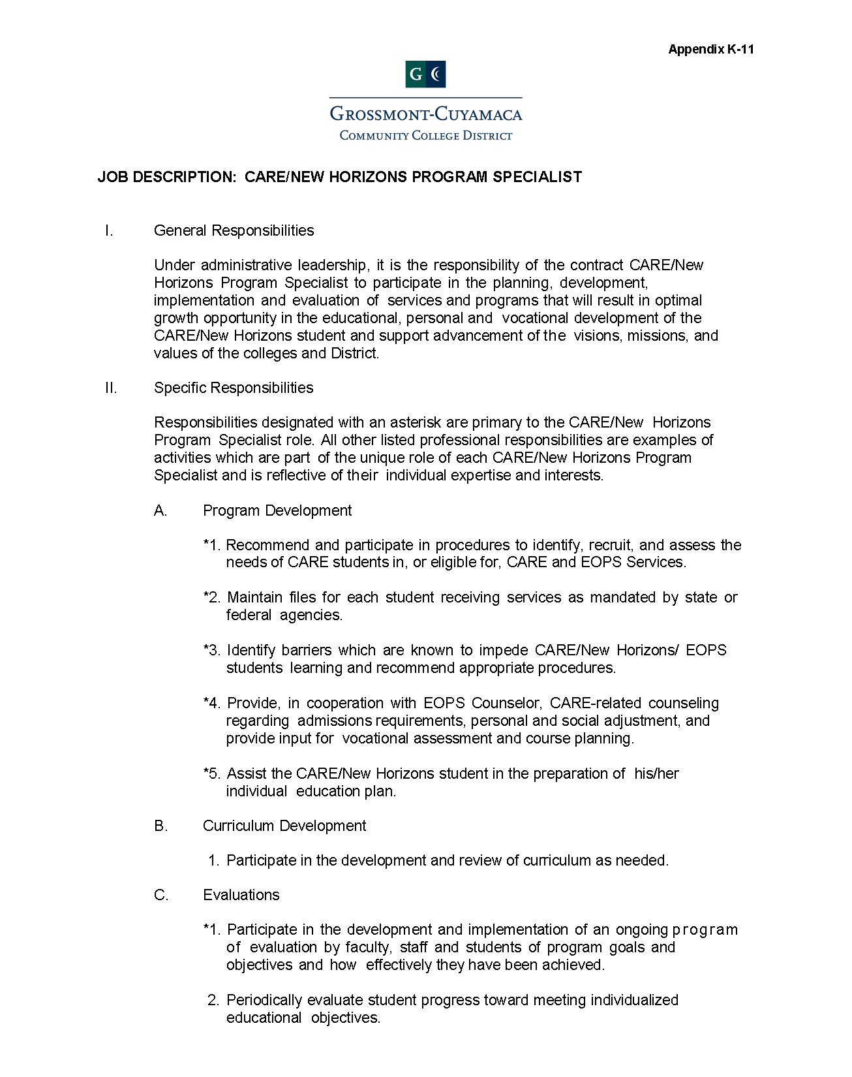
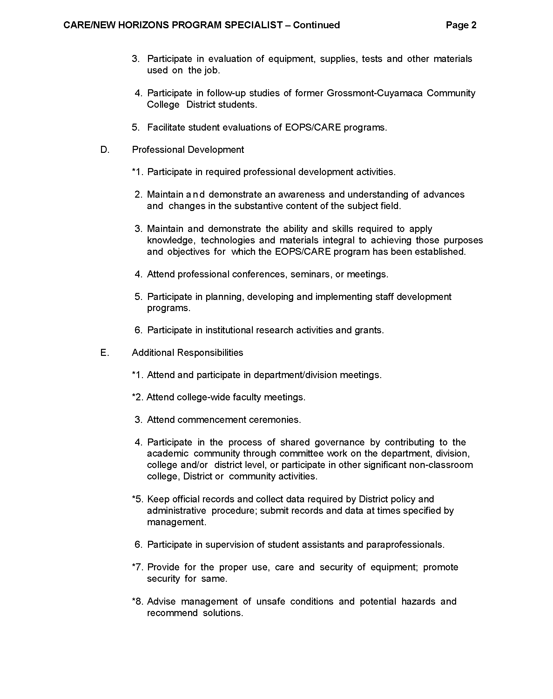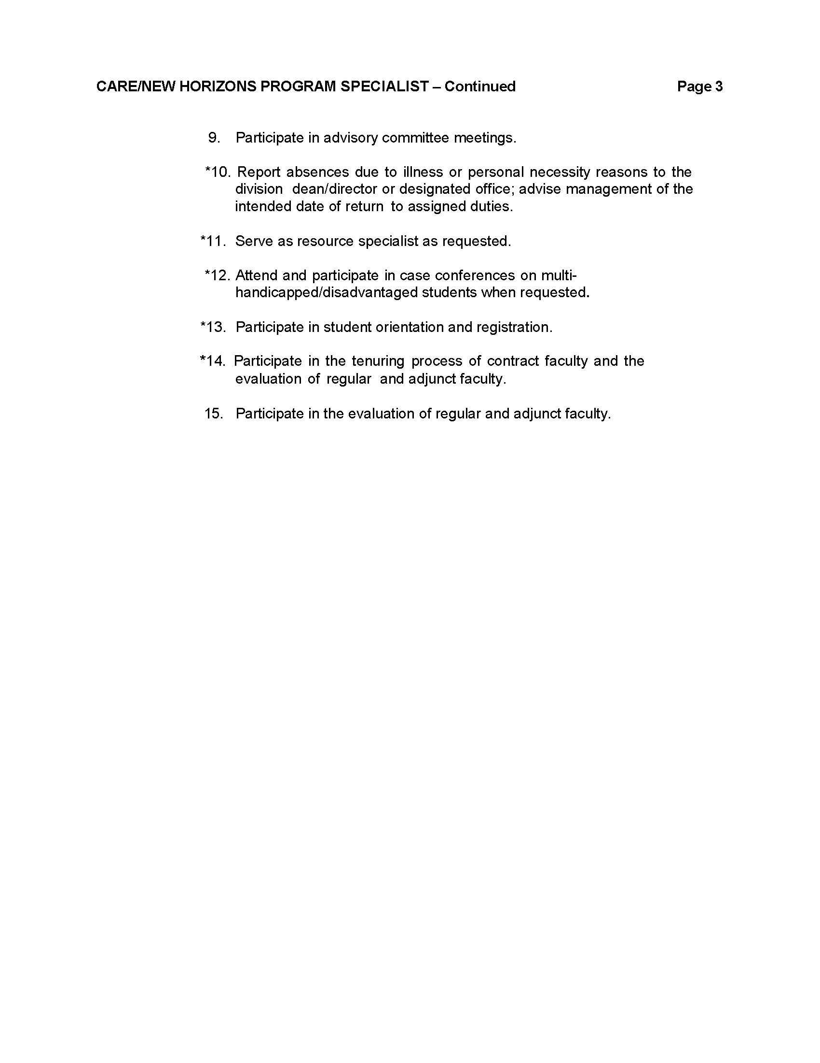

Alternate Media/High Tech Center Access Specialist
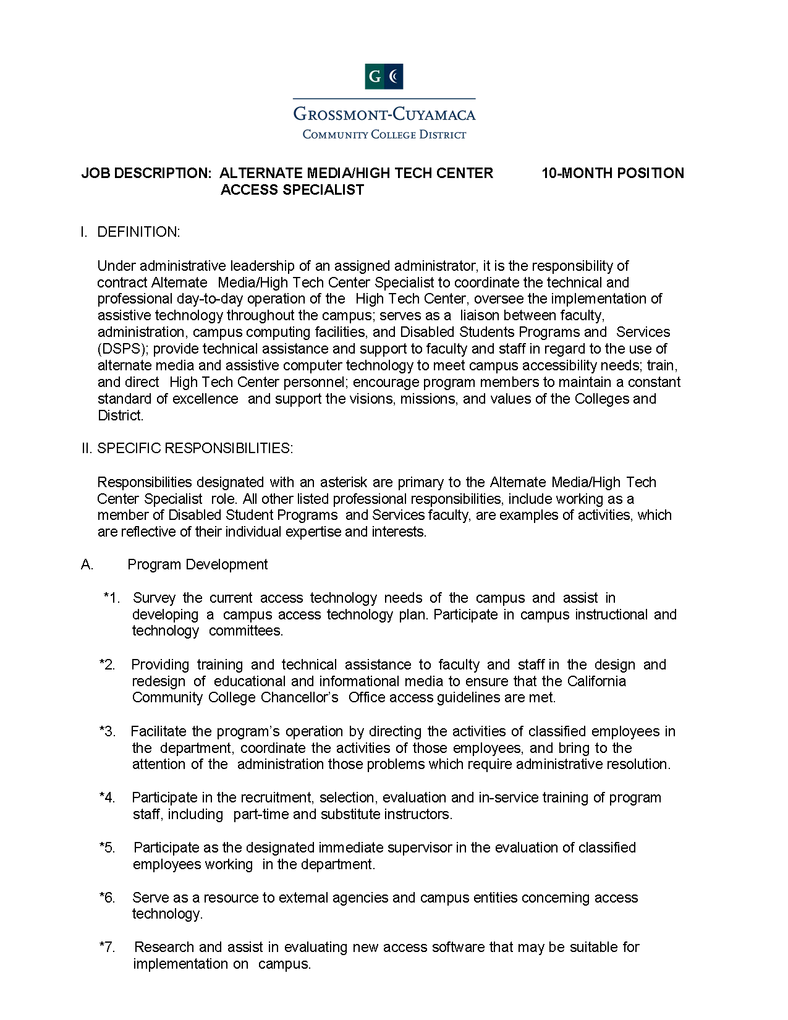
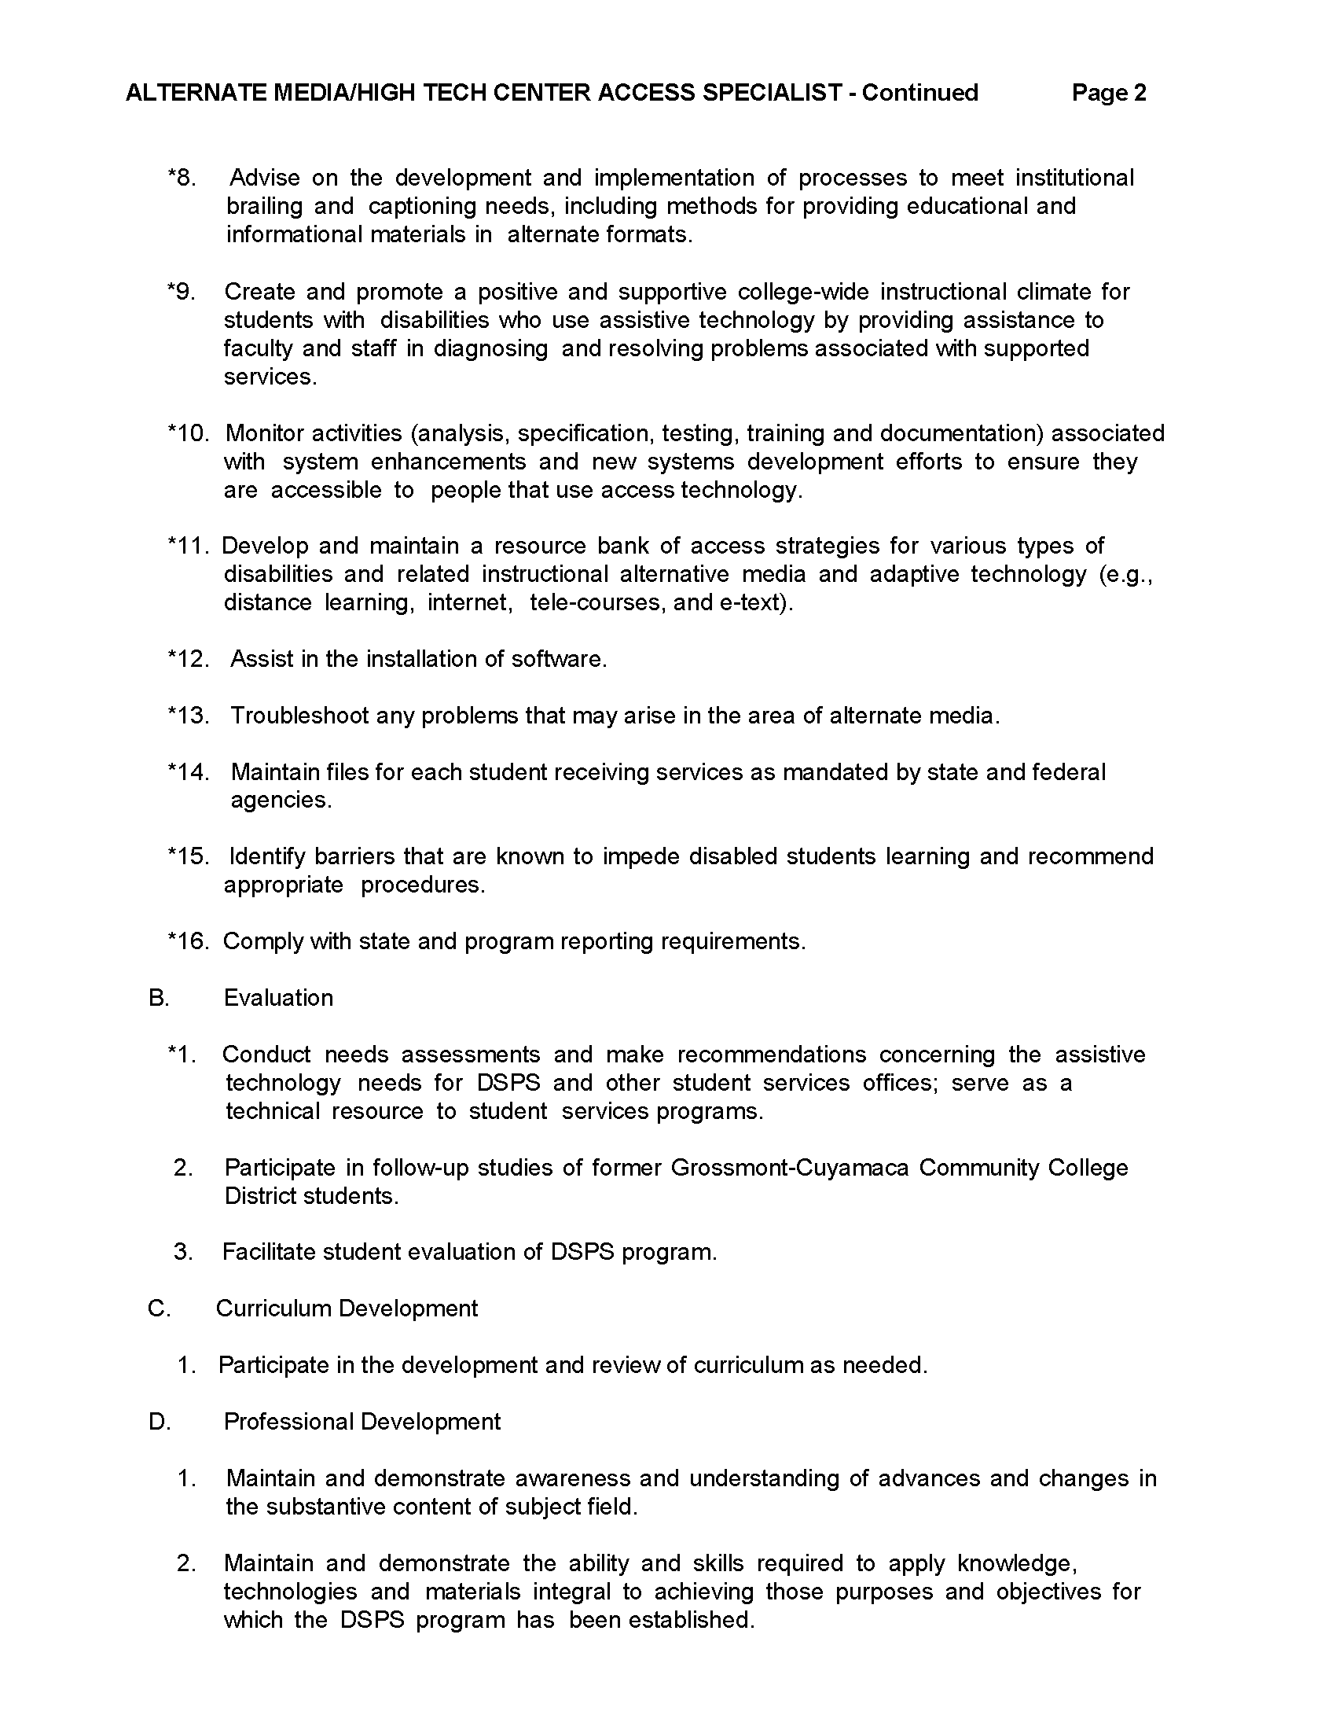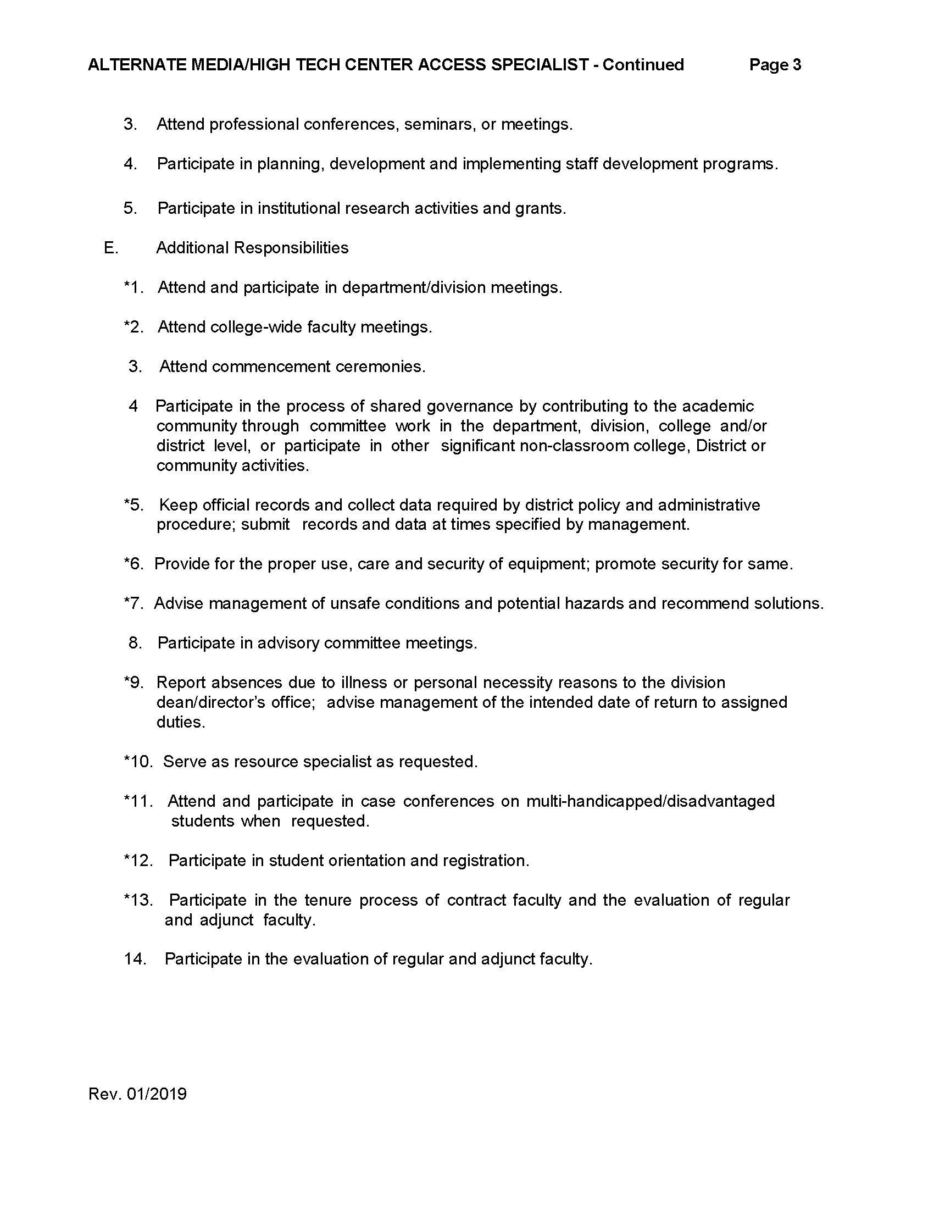

APPENDIX H – ADJUNCT/OVERLOAD FACULTY LOAD DETERMINATION

The parties agree to the following:

Generally speaking, if an adjunct faculty member is performing a service that non-classroom tenured/tenure-track faculty perform during their on-campus assigned time, then the adjunct faculty member’s service needs to count toward their load calculation (FTEF). In addition, any and all adjunct faculty teaching assignments always count toward load (unless it’s a fee-based, not-for-credit assignment).

Examples of adjunct faculty assignments that count toward load:
- Any form of Instruction or Instructional or Laboratory Supervision
- Any work a tenured/tenure-track Librarian would perform as part of their on-campus assigned duties.
- Any work a tenured/tenure-track Counselor would perform as part of their on-campus assigned duties.
- Any other type of special program coordination that a tenured/tenure-track could conceivably be assigned to perform as part of their regular assignment.

Examples of adjunct faculty assignments that do not count toward load:
CA Education Code § 87482.5 states the following:
(c) (1) Service in professional ancillary activities by persons employed under this section, including, but not necessarily limited to, governance, staff development, grant writing, and advising student organizations, shall not be used for purposes of calculating eligibility for contract or regular status unless otherwise provided for in a collective bargaining agreement applicable to a person employed under this section.

Some examples of these types of Ancillary Activities include:
- Governance: This includes participation in the formal governance process and structure of the college, including assignment to a standing governance committee, a special governance assignment, or other college governance activities.

- Staff Development: This includes participation in college training and professional development activities such as pre-approved department training, and professional development activities supporting broad-based strategic themes, research and development of new college curricula, and other professional development activities. For purposes of Ancillary Activities, Staff Development does not include those activities required to be performed by faculty as part of their FLEX obligation.

- Grant Writing: This includes participation in pre-grant workshops, grant meetings and presentations, grant research and development, grant writing, and other approved grant activities.

- Advising Student Organizations: This includes activities of development and advisement of Associated Student Government in organization, management, and leadership.

In addition, the parties have agreed that adjunct office hours or tutoring, whether paid or volunteer, will not count toward load.

Other Miscellaneous activities that do not count toward load:
  - Evaluations
  - Library surveys
  - Assessment testing and scoring
  - Industry/community outreach
  - Organizing a conference or event
  - Development and implementation (not teaching) of new materials
  - Teaching fee-based classes (continuing education not-for-credit) only

APPENDIX I – EXCEPTIONS TO FTEF LOAD DETERMINATION FORMULA (REFERENCE ARTICLE 7.8.2)

 |  |  | FTEF
 | Course | Title | Lec | Lab | Comp | Total
BOT | 101A | Keyboarding/Document Processing I | 5.33 | 11.00 | 0.00 | 16.33
 | 101B | Keyboarding/Document Processing II | 5.33 | 11.00 | 0.00 | 16.33
 | 102A | Intermediate Keyboarding/Document Processing I | 5.33 | 11.00 | 0.00 | 16.33
 | 102B | Intermediate Keyboarding/Document Processing II | 5.33 | 11.00 | 0.00 | 16.33
BUS | 128 | Business Communication | 20.00 | 0.00 | 5.00 | 25.00
ENGL | 098 | English Fundamentals | 33.33 | 5.00 | 5.00 | 43.33
 | 120 | College Composition and Reading | 20.00 | 5.00 | 5.00 | 30.00
 | 124 | Advanced Composition: Critical Reasoning and Writing | 20.00 | 5.00 | 5.00 | 30.00
 | 126 | Creative Writing | 20.00 | 0.00 | 5.00 | 25.00
 | 130 | Short Fiction Writing I | 20.00 | 0.00 | 5.00 | 25.00
 | 131 | Short Fiction Writing II | 20.00 | 0.00 | 5.00 | 25.00
 | 132 | Short Fiction Writing III | 20.00 | 0.00 | 5.00 | 25.00
 | 133 | Short Fiction Writing IV | 20.00 | 0.00 | 5.00 | 25.00
 | 134 | Creative Nonfiction Writing I | 20.00 | 0.00 | 5.00 | 25.00
 | 135 | Creative Nonfiction Writing II | 20.00 | 0.00 | 5.00 | 25.00
 | 136 | Creative Nonfiction Writing III | 20.00 | 0.00 | 5.00 | 25.00
 | 137 | Creative Nonfiction Writing IV | 20.00 | 0.00 | 5.00 | 25.00
 | 160 | Drama Writing I | 20.00 | 0.00 | 5.00 | 25.00
 | 161 | Drama Writing II | 20.00 | 0.00 | 5.00 | 25.00
 | 162 | Drama Writing III | 20.00 | 0.00 | 5.00 | 25.00
 | 163 | Drama Writing IV | 20.00 | 0.00 | 5.00 | 25.00
 | 175 | Novel Writing I | 20.00 | 0.00 | 5.00 | 25.00
 | 176 | Novel Writing II | 20.00 | 0.00 | 5.00 | 25.00
 | 177 | Novel Writing III | 20.00 | 0.00 | 5.00 | 25.00
ESL | 1A | Accelerated Reading and Writing for English as a Second Language | 40.00 | 0.00 | 5.00 | 45.00
 | 1B | Advanced Accelerated Reading and Writing for ESL | 40.00 | 0.00 | 5.00 | 45.00
 | 2 | Accelerated Composition for English as a Second Language | 40.00 | 0.00 | 5.00 | 45.00
 | 105 | Rhetoric for Academic Success | 40.00 | 0.00 | 5.00 | 45.00
 | 115 | Academic Discourse Through U.S. Cultures | 40.00 | 0.00 | 5.00 | 45.00
 | 122 | College Rhetoric | 40.00 | 0.00 | 5.00 | 45.00
MUS | 105-106-205-206 | Music Theory and Practice | 26.67 | 10.00 | 0.00 | 36.67
 | 108-109-208-209 | Rock, Pop and Soul Ensemble | 16.67 | 12.50 | 0.00 | 29.17
 | 112-113-214-215 | Chamber Orchestra | 16.67 | 12.50 | 0.00 | 29.17
 | 136-137-236-237 | Chamber Singers | 16.67 | 12.50 | 0.00 | 29.17
 | 138-139-238-239 | Grossmont Master Chorale | 16.67 | 12.50 | 0.00 | 29.17
 | 140-141-24-241 | String Orchestra | 16.67 | 12.50 | 0.00 | 29.17
 | 148-149-248-249 | Classical Guitar Ensemble | 16.67 | 12.50 | 0.00 | 29.17
 | 150-151-250-251 | Grossmont Symphony Orchestra | 16.67 | 12.50 | 0.00 | 29.17
 | 152-153-252-253 | Concert Band | 16.67 | 12.50 | 0.00 | 29.17
 | 154-155-254-255 | Afro-Cuban Ensemble | 16.67 | 12.50 | 0.00 | 29.17
 | 156-157-256-257 | Jazz Ensemble | 16.67 | 12.50 | 0.00 | 29.17
 | 158-159-258-259 | Chorus | 16.67 | 12.50 | 0.00 | 29.17
 | 164-165-264-265 | Musical Theatre Orchestra | 16.67 | 12.50 | 0.00 | 29.17
 | 166-167-266-267 | Jazz Vocal Ensemble | 16.67 | 12.50 | 0.00 | 29.17

APPENDIX J – ADJUNCT OFFICE HOUR FORM (REFERENCE ARTICLE 11.10)

APPENDIX K – COUNSELING MEMORANDUM OF UNDERSTANDING

APPENDIX L – LEAVES TABLE

Leave Type | Who is Eligible? | How Much Leave? | Is It Paid? | Is My Job Protected? | Do I Keep Health Benefits? | Can I Take It Intermittently? | Notice / Documentation Required? | Legal / Policy Basis
Pregnancy Disability Leave (PDL) | Birthing parent; no length-of-service requirement; applies when disabled by pregnancy or related condition. | Up to 4 months, defined as 17 ½ weeks, per pregnancy; runs concurrently with FMLA if eligible. | Unpaid, but may use accrued sick leave or, if exhausted, half-salary sick leave; may qualify for catastrophic leave if available from AFT Guild. | Yes, right to reinstatement to same or comparable position upon return. | Yes; district continues contributions, but employee must pay normal share, if applicable. | Yes, if medically necessary; requires provider certification. | 30 days’ notice if foreseeable; as soon as practicable if not. Must provide medical certification. | CA Govt Code §12945; Cal. Code Regs. tit. 2, §11035, FMLA tit. 29 USC §2601.
Maternity Leave | Birthing parent; no length-of-service requirement; beginning at the date of birth of the child. | Six (6) weeks for vaginal delivery or eight (8) weeks for C-section delivery; runs concurrently with PDL and/or FMLA. | Paid leave starting at the date of birth of the child. | Yes, right to reinstatement to same or comparable position upon return. | Yes; district continues contributions, but employee must pay normal share, if applicable. | No, must be taken immediately following the birth of the child. | No documentation required. | CA Ed Code §87766; AFT Article 13.1.11
Family & Medical Leave Act (FMLA)* | Employees with at least 12 months service AND 1,250 hours in prior 12 months. | Up to 12 workweeks in a 12-month period; used for own serious health condition, or to care for child, spouse, or parent. | Unpaid, but may use accrued sick leave or, if exhausted, half-salary sick leave; may qualify for catastrophic leave if available from AFT Guild. | Yes, right to reinstatement to same or comparable position upon return. | Yes; district continues contributions, but employee must pay normal share, if applicable. | Yes, for serious health conditions; may require supervisor approval if intermittent. | 30 days’ notice if foreseeable; as soon as practicable if not. Medical certification required for health conditions; birth/adoption documents for bonding. | FMLA tit. 29 USC §2601; 29 CFR Part 825.; AFT Article 13.11.7
California Family Rights Act (CFRA)* | Employees with at least 12 months service AND 1,250 hours in prior 12 months. | Up to 12 workweeks in a 12-month period; bonding leave (birth, adoption, foster placement) or to care for family member with serious health condition. | Unpaid, but may use accrued sick leave or, if exhausted, half-salary sick leave. | Yes, right to reinstatement to same or comparable position upon return. | Yes; district continues contributions, but employee must pay normal share, if applicable. | Yes; bonding leave may be taken in 2-week blocks or shorter with supervisor approval and must be taken within 1 year of birth, adoption or start of foster care. Health leave may be intermittent as medically needed. | 30 days’ notice if foreseeable; as soon as practicable if not. Medical certification required for health conditions; birth/adoption documents for bonding. | CA Govt Code §12945.2; Cal. Code Regs. tit. 2, §11087; AFT Article 13.11.7
Parental Bonding Leave (PL)  Under Ed Code § 87780.1 | Employees with at least 12 months service. | Up to 12 weeks parental leave; runs concurrently with CFRA and subsequent to PDL. | Unpaid, but may use accrued sick leave or, if exhausted, half-salary sick leave. | Yes, under Ed Code; reinstatement to same or comparable position. | Yes; district continues contributions, but employee must pay normal share, if applicable. | May be intermittent if allowed under CFRA; approval needed for short-block intermittent use. | 30 days’ notice if foreseeable; district documentation required (e.g., birth certificate, adoption papers). | CA Ed Code §87780.1; AFT Article 13.13.
Reproductive Loss Leave | Employees with at least 30 calendar days of employment. | Up to 5 days per reproductive loss event. Up to 20 days within a 12-month period. | Unpaid; employee may choose to use accrued sick leave. | Yes; treated as other protected leave under state law. | Yes; district continues contributions, but employee must pay normal share, if applicable. | Yes; days do not need to be consecutive. | Employee must give notice of absence. | CA Govt Code §12945.6 (effective Jan 1, 2024).
*Note: Under FMLA (29 USC § 2612(f)), if both parents work for the District, they may be required to share a combined total of 12 weeks of bonding leave.
Under CFRA (Govt Code § 12945.2), each parent is entitled to 12 weeks of bonding leave individually.

Legend:

FMLA: 12 weeks unpaid leave, eligibility criteria apply, requires doctor’s note, runs concurrently with CFRA/PDL/PL.
CFRA: 12 weeks unpaid leave, eligibility criteria apply, requires doctor’s note unless baby bonding, runs concurrently with FMLA/PL. If just using for baby bonding, CFRA does not run concurrently with PDL.
PDL: Four months unpaid leave, no eligibility criteria, requires doctors note, runs concurrently with FMLA. With doctor’s certification of need, up to four weeks of PDL prior to date of birth will be fully paid.
ML: Maternity Leave, no eligibility criteria, no doctor’s note, time is six (6) fully paid weeks from date of birth for regular delivery without utilizing sick leave, and eight (8) weeks for cesarean delivery without utilizing sick leave.
PL: Parental Leave (reference Ed Code 88196.1) eligibility: must work for 12 months, no doctor’s note, maximum of 12 weeks of paid leave drawn from accrued leave, then HSSL from baby’s birth, runs concurrently with CFRA.

