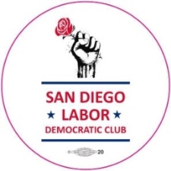
May 16th 2:00 pm Meeting Labor Democratic Club
Labor Post Bessemer: The Way Forward /
With Harold Meyerson, Brigette Browning, Doug Moore
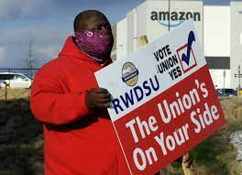
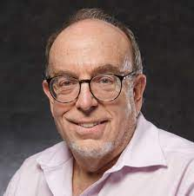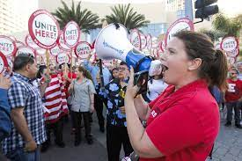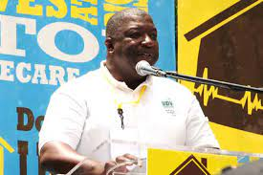
Harold Meyerson is editor-at-large of The American Prospect and writes about California politics in the Los Angeles Times.^{[2]} His articles on labor and politics have appeared in The New Yorker, The Atlantic, The New Republic, The Nation, and New Statesman. In 2009 The Atlantic Monthly named him one of "the most influential commentators in the nation" as part of their list "The Atlantic 50."
Brigette Browning is the former head of UNITE/HERE 30 and the new leader of the San Diego and Imperial Counties Labor Council.
Doug Moore is the current head of UDW and president of the SD Labor Council
We are honored to have Harold Meyerson as our guest speaker who will discuss the role Labor should be playing after Bessemer. Following his talk we will have a panel discussion with the leaders of the Labor Council focusing on the direction of the local labor movement in the next few years.
Here is the Zoom link: https://cccconfer.zoom.us/j/96336732631

