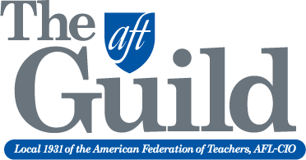
Continuing Education Adjunct Faculty
San Diego Community College District
Union Negotiated Adjunct Faculty Benefits

Job Security – Priority of Assignment (reference Article V of CBA at aftguild.org, click on “Collective Bargaining Agreements”)

- Eligibility: must complete eight semesters (fall and spring only) within eight year period.
- Make a request in writing to chair and dean (cc dean’s secretary) during semester six.
- Takes effect semester nine.
- Load maintained at FTEF level (average of last two semesters) when requesting POA.
- Load can increase as new sections offered or sections become vacant.
- Seniority based on date of request to join POA.
- All classes taught since 1990 without a negative evaluation go on seniority list.
- Termination only after two consecutive negative evaluations or if budget cuts reduce program.
For more information or support contact our union!

Call: AFT Guild Office 619-640-1155

www.aftguild.org

